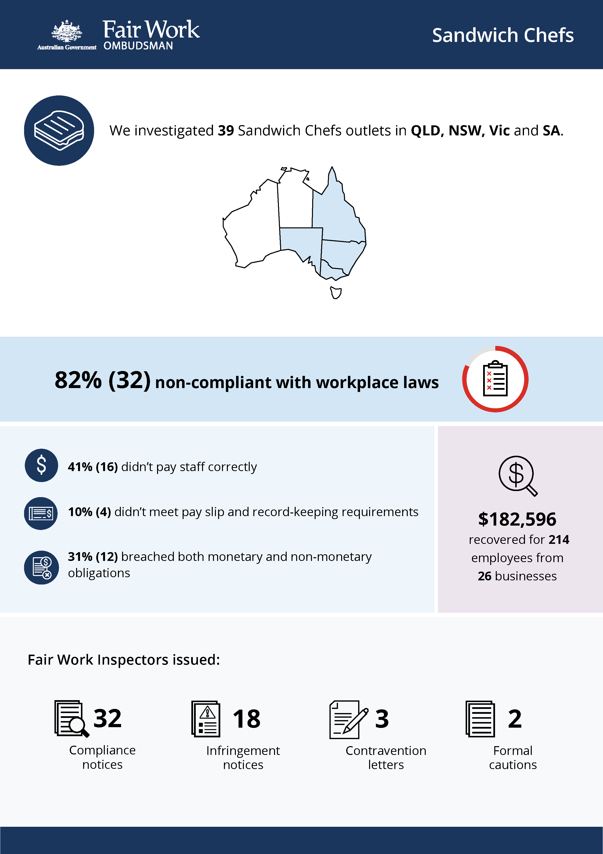

# Sandwich Chefs

## What we did & why

The Fair Work Ombudsman investigated 31 Sandwich Chefs outlets located in Queensland, New South Wales, Victoria and South Australia in February 2020. At the time, Sandwich Chefs (formerly Fancy Fillings) franchises were expanding rapidly with 53 outlets across Australia and plans for more stores.

Sandwich Chefs first came to our attention during our Regional University Towns – Geelong activity.[1] Two Sandwich Chefs outlets were investigated as part of that activity, with non-compliance including significant underpayments and record-keeping failures found.

Fair Work Inspectors conducted unannounced site visits over two days. They:

* requested employment and payroll records
* interviewed employers, managers and workers
* observed work practices
* noted staff numbers to validate business records.

Pay slips and record-keeping practices were assessed against the requirements of the *Fair Work Act 2009*, the *Fair Work Regulations 2009*, and the *Fast Food Industry Award 2010/2020*.

A further eight outlets were investigated in a second round of audits in 2021.

## Our findings

32 (82%) of the 39 businesses examined during the 2020 and 2021 audits were non-compliant with Australian workplace laws.

* 16 (41%) were not paying staff correctly.
* 4 (10%) were non-compliant with pay slip and record-keeping requirements.
* 12 (31%) had breached both their monetary and non-monetary obligations.

The most common breaches were:

* underpayment of the minimum hourly pay rate (16 businesses)
* failure to make or keep employee records (10 businesses)
* failure to pay weekend penalty rates (10 businesses)
* failure to provide pay slips in the correct format (6 businesses)
* failure to pay annual leave loading (6 businesses).

## Actions taken & next steps

We recovered $182,596 for 214 employees from 26 businesses.

$98,912 was recovered for 118 workers from 12 businesses in Victoria, $34,189 was recovered for 32 workers from 6 businesses in New South Wales, $28,989 was recovered for 28 workers from 5 businesses in Queensland and $20,506 was recovered for 36 workers from 3 businesses in Adelaide.

Recoveries from individual businesses ranged from $165 for 4 employees in South Australia to $27,807 for 18 employees in Victoria.

Fair Work Inspectors issued:

* 32 compliance notices, recovering $182,596 for 214 employees from 26 businesses
* 18 infringement notices, resulting in $15,330 paid in fines
* 3 contravention letters
* 2 formal cautions.

The Fair Work Ombudsman wrote to the Sandwich Chefs franchisor:

* outlining the findings and our concerns about systemic non-compliance in their network
* reminding them of their obligations as a responsible franchisor.

The Fair Work Ombudsman will monitor the franchise on an ongoing basis.

1. FWO media release: <https://www.fairwork.gov.au/about-us/news-and-media-releases/2020-media-releases/august-2020/20200814-geelong-regional-university-cities-report-media-release>