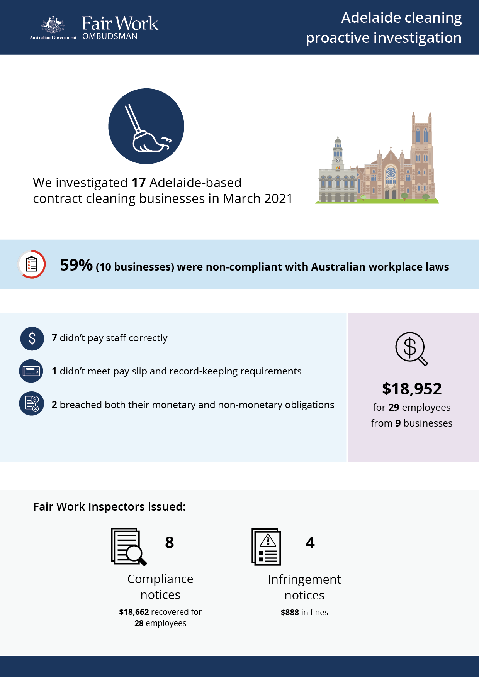

# Adelaide cleaning

## What we did and why

In March 2021, the Fair Work Ombudsman (FWO) audited 17 contract cleaning businesses in Adelaide.

The contract cleaning sector typically employs a high proportion of low paid young and migrant workers. These workers can be vulnerable to exploitation, due to a lack of awareness or understanding of their entitlements, and an unwillingness to raise concerns with their employer or the FWO.

The businesses were selected for audit based on FWO intelligence, including anonymous reports, customer enquiries and requests for assistance.

Most businesses were covered by the *Cleaning Services Award* *2020* (the Award)*,* and 1 business was operating under an enterprise agreement.

Fair Work Inspectors:

* requested employment and payroll records
* interviewed employers, managers and workers
* observed work practices
* noted staff numbers to validate business records.

Pay slips and record-keeping practises were assessed against the requirements of the Fair Work Act 2009, the Fair Work Regulations 2009, the Award or enterprise agreement.

## Our findings

10 (59%) of the 17 businesses investigated had breached workplace laws. Of those:

* 7 (67%) were not paying staff correctly
* 1 (11%) was non-compliant with pay slip and record-keeping requirements
* 2 (22%) breached both their monetary and non-monetary obligations.

The most common breaches were:

* failure to pay penalty rates (4 businesses)
* underpayment of the minimum hourly rate (3 businesses)
* failure to make and keep employee records (3 businesses)
* failure to pay overtime (2 businesses).

## Action taken and next steps

We recovered $18,952 for 29 employees from 9 businesses.[1] The highest amount recovered from one business was $7,852 for 9 employees.

Fair Work Inspectors issued:

* 8 compliance notices, recovering $18,662 for 28 employees
* 4 infringement notices, with $888 paid in fines.

1. One business rectified an underpayment of $290 for 1 employee during the audit phase