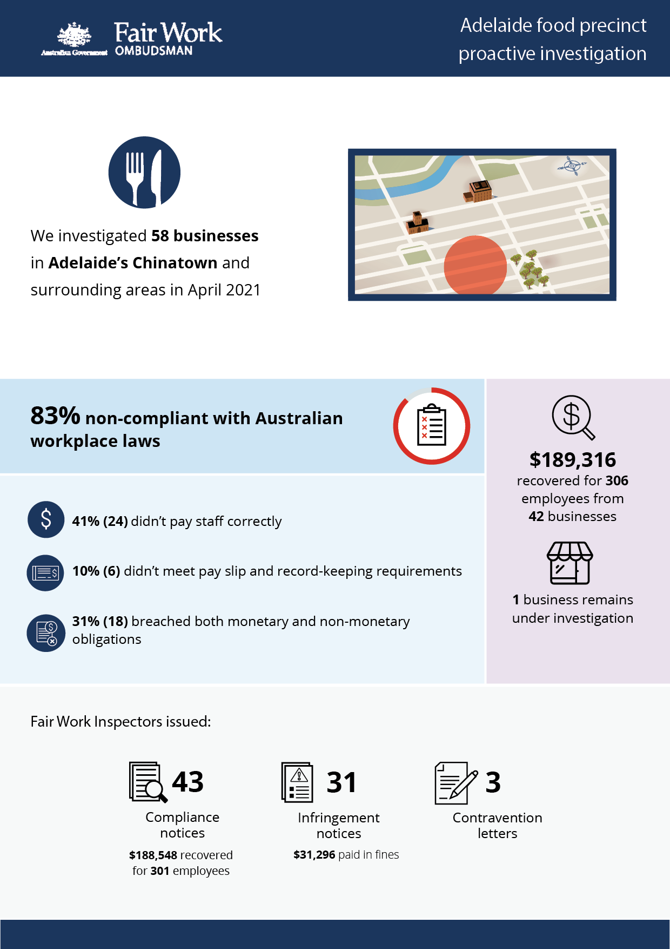

# Adelaide food precinct investigation

## What we did and why

In April 2021, we investigated 58 businesses in Adelaide’s Chinatown and surrounding areas. This proactive investigation was part of a program examining non-compliance in popular ‘cheap eats’ food precincts that commenced in 2016.[1][2][3][4]

Fast food, Restaurants and Cafés (FRAC) sector businesses within these precincts typically employ a high proportion of young and migrant (temporary visa holder) workers. These workers can be vulnerable to exploitation, due to a lack of awareness or understanding of their entitlements, and an unwillingness to raise concerns with their employer or the FWO.

Adelaide’s Chinatown has a diverse mix of businesses, employers and employees. Anonymous tip offs from workers suggested non-compliance in restaurants and fast food outlets in the area.

We targeted businesses deemed to be at risk of non-compliance, based on one or more of the following characteristics:

* a history of non-compliance with the FWO
* anonymous tip offs and/or customer enquiries received about the business
* employing vulnerable migrant workers (confirmed using Home Affairs data).

Fair Work Inspectors conducted unannounced site visits at 58 businesses over four days. They:

* requested employment and payroll records
* interviewed employers, managers and workers
* observed work practices
* noted staff numbers to validate business records.

Pay slips and record-keeping practises were assessed against the requirements of the *Fair Work Act 2009*, the *Fair Work Regulations 2009*, and applicable awards or registered agreements. Most businesses were covered by the *Restaurant Industry Award 2010* or *Fast Food Industry Award 2010*.

## Our findings

48 (83%) of the 58 businesses investigated had breached workplace laws. Of those:

* 24 (41%) were not paying staff correctly.
* 6 (10%) were non-compliant with pay slip and record-keeping requirements.
* 18 (31%) breached both their monetary and non-monetary obligations.

The most common breaches were:

* failure to pay penalty rates – 33 businesses (69%)
* underpayment of the minimum hourly rate – 25 businesses (52%)
* failure to make and keep employee records – 21 businesses (44%)
* payslips not containing the required information – 6 businesses (13%)
* failure to pay correct allowances – 3 businesses (6%)

## Action taken and next steps

We recovered $189,316 for 306 employees from 42 businesses.[5] The largest recovery was $32,835.50 from one business, for one employee, for an annualised salary issue.[6]

Fair Work Inspectors issued:

* 43 compliance notices (to 41 businesses), recovering $188,548 for 301 employees
* 31 infringement notices, with $31,296 paid in fines
* 3 contravention letters.

1 business is still under investigation for alleged non-compliance with workplace laws.

1. [Over-1.2-million-recovered-for-food-and-retail-workers– Media releases – Fair Work Ombudsman](https://www.fairwork.gov.au/about-us/news-and-media-releases/2020-media-releases/september-2020/20200904-food-precincts-melbourne-brisbane-and-food-retail-report-media-release)
2. [Over $300 000 returned to fast food, restaurant and café workers - Media releases - Fair Work Ombudsman](https://www.fairwork.gov.au/about-us/news-and-media-releases/2019-media-releases/december-2019/20191206-over-300-000-returned-to-fast-food-restaurant-and-cafe-workers)
3. [Over $580,000 recovered for Hobart workers - Fair Work Ombudsman](https://www.fairwork.gov.au/newsroom/media-releases/2021-media-releases/april-2021/210401-hobart-food-precincts-audits-media-release)
4. [More than $200,000 recovered for Gold Coast workers - Fair Work Ombudsman](https://www.fairwork.gov.au/newsroom/media-releases/2021-media-releases/september-2021/20210907-gold-coast-food-precincts-report-media-release)
5. One business rectified underpayments of $768 to 5 employees at the time of our site visits, without Fair Work inspectors needing to investigate further
6.