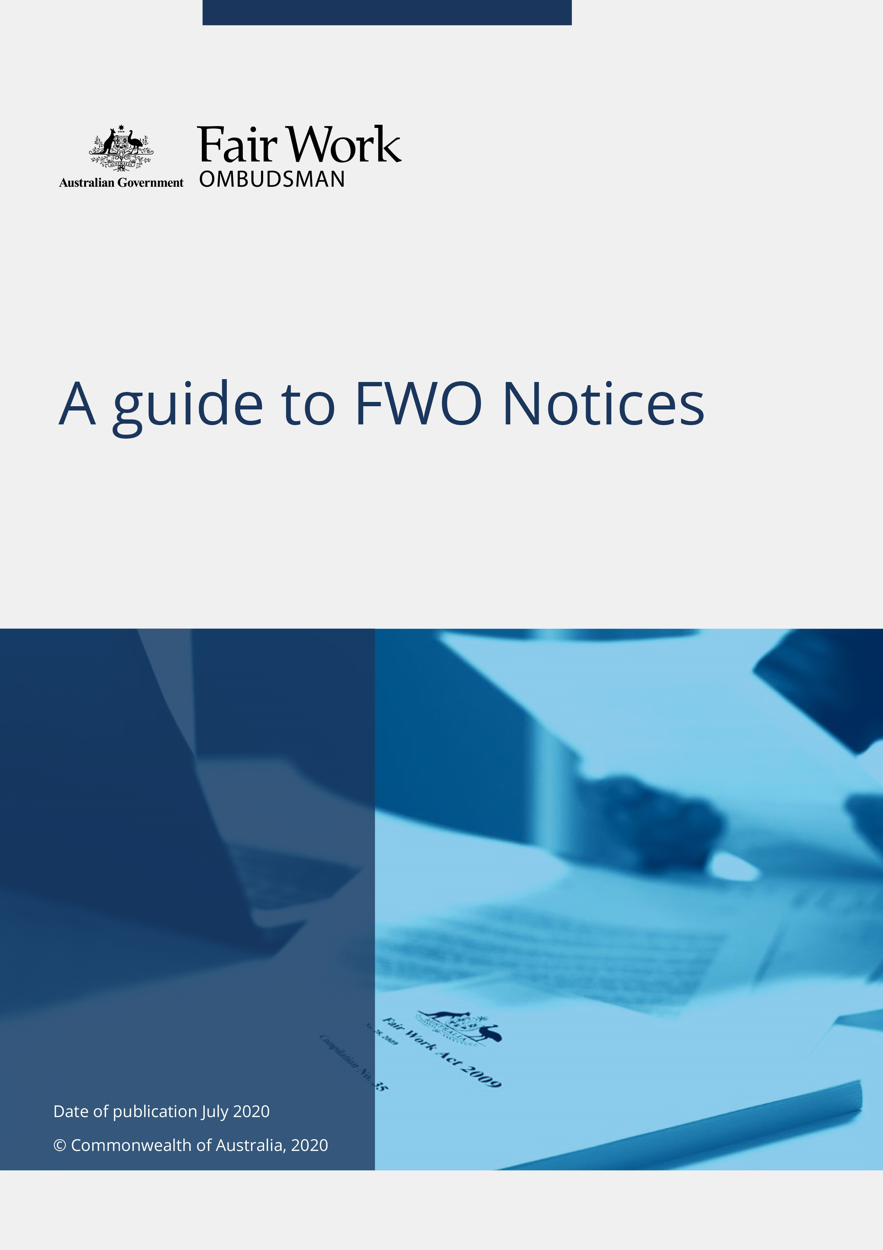A guide to FWO Notices

Introduction

The Fair Work Ombudsman (FWO) is an independent statutory agency created by the Fair Work Act 2009 (the Act). The role of the FWO is to promote harmonious, productive and cooperative workplace relations, and to monitor, inquire into, investigate, and enforce compliance with relevant Australian workplace laws. Our approach to compliance is outlined in our [Compliance and enforcement policy.](https://www.fairwork.gov.au/about-us/our-policies)

This guide has been prepared to assist individuals and businesses to understand the FWO’s information gathering powers under section 712A of the Act. It aims to assist you in understanding our processes and what you should do if you receive a FWO Notice.

When requesting information, records and various documents as evidence from parties during an investigation, the FWO may do so by applying to the Administrative Appeals Tribunal (AAT) to issue a written notice (a FWO Notice).

The FWO will only consider requesting the AAT to issue a FWO Notice if we reasonably believe a person:

* can give information relevant to an investigation
* can produce documents relevant to an investigation
* is capable of answering questions relevant to an investigation
* all other evidence gathering means have been exhausted or are not appropriate.

If you receive a FWO Notice, it means the FWO considers you are a person who is capable of assisting and providing material relevant to an investigation as outlined in the FWO Notice.

Refusal or failure to comply with the FWO Notice by the due date, unless a variation is granted, is a civil remedy provision which attracts a maximum penalty of 600 penalty units for individuals and 3,000 penalty units for bodies corporate. This is equivalent to $187,800 for individuals and $939,000 for bodies corporate.

Overview

When assessing or investigating an allegation of non-compliance with Australian workplace laws, the FWO initially considers whether evidence can be obtained without using the powers under the Act.

In general, the FWO initially requests information without relying on statutory powers. This approach follows a report from the Administrative Review Council containing 20 best practice principles, and a review by the Commonwealth Ombudsman commenting on the FWO’s performance against these principles.

There are three main methods to obtain evidence used by the FWO and its Fair Work Inspectors:

* verbal requests, emails or letters that do not rely on the statutory powers of a Fair Work Inspector under the Act
* a request (or requirement) by a Fair Work Inspector when on premises under section 709(d) of the Act
* a Notice to Produce records or documents issued by a Fair Work Inspector under section 712 of the Act.

Where these avenues have been exhausted, are inappropriate, or an investigation is impeded, the Fair Work Ombudsman (or a specified senior member of staff) may apply to the AAT to request the issuing of a FWO Notice under section 712A of the Act. A FWO Notice requires a person to provide information, produce documents or answer questions about certain allegations of non-compliance that are part of an investigation.

The FWO will only apply to the AAT to issue a FWO Notice if we are satisfied all other evidence gathering means are exhausted or not appropriate, and there are reasonable grounds to believe the person to whom the application relates has information or documents that would assist with a current investigation within the scope of subsection 712AA(1)(a). This kind of investigation is one which relates to a suspected contravention of a provision of the Act, a fair work instrument or a safety net contractual entitlement that relates, directly or indirectly, to:

* the underpayment of wages, or other monetary entitlements, of employees
* the unreasonable deduction of amounts from amounts owed to employees
* the placing of unreasonable requirements on employees to spend or pay amounts paid, or payable to employees
* the unfair dismissal of an employee
* the bullying of a worker at work
* the unlawful discrimination of a person in relation to employment
* a contravention of a provision of the National Employment Standards, or
* the coercion of an employee by an employer.

Exercising our powers

Before deciding to apply for a FWO Notice, the FWO will take into account the impact of the FWO Notice on you and where applicable, your business. You will also be given reasonable time to respond to the FWO Notice and we will try to minimise the cost to you or your business.

The FWO’s evidence gathering powers are subject to certain safeguards.

Some of these safeguards include:

* the FWO must have reasonable grounds to believe a person has information or documents relevant to an investigation
* the investigation must relate to one or more of the suspected contraventions as listed in subsections 712AA (1)(a)
* the FWO must apply to the AAT to issue a FWO Notice
* the FWO must notify the Commonwealth Ombudsman once a FWO Notice is issued and following an examination
* a FWO Notice must be in writing
* you have a guaranteed minimum of 14 days to comply with the FWO Notice
* if you attend a place to answer questions in accordance with a FWO Notice, you may be legally represented
* you have protection from liability in relation to documents, records or information given in accordance with FWO Notices
* self-incriminating information, documents or answers you give in response to a FWO Notice cannot be used against you in most civil or criminal proceedings. An exception arises if you give the FWO false or misleading information or documents.

When requesting a FWO Notice be issued, the FWO will consider the value of the information to an investigation and the impact of the FWO Notice on the recipient. The decision to apply for a FWO Notice is not taken lightly and this power is used in good faith and not for any other purpose but to advance an investigation, including gathering evidence that may be used in court proceedings.

Factors we may consider prior to an application being made to the AAT for a FWO Notice to be issued include:

* earlier requests for information were not responded to in full
* a person’s concerns about restrictions on ability to cooperate with the FWO because of legal or confidentiality restrictions on disclosure
* whether a formal request from the FWO for evidence is needed in order for the party to avoid being seen to be cooperating freely with the FWO
* whether information obtained from other sources is inconsistent with the information voluntarily provided by the party under investigation
* the extent to which requests for information made without using statutory powers are likely to be met with delays or protracted negotiations impacting on the FWO’s ability to carry out our functions and appropriately act to address or minimise any further non-compliance
* the extent to which a party has cooperated with the FWO
* whether information required by the FWO will be most efficiently sought through the use of a FWO Notice.

The exercise of the powers under section 712A is subject to the general jurisdiction of the Commonwealth Ombudsman and judicial review under the Judiciary Act 1903.

The powers can only be exercised by the Fair Work Ombudsman personally, by specified Senior Executive Staff (SES), or by acting SES of the FWO. Restrictions on who can perform these powers promotes consistency in decision making, as only a small number of people are able to exercise these powers.

Receiving a FWO Notice

There are three types of FWO Notices:

* form 1 – FWO Notice to give information - this FWO Notice requires you to give information to the Fair Work Ombudsman or a nominated staff member at a specified date and time as detailed on the FWO Notice
* form 2 – FWO Notice to produce documents - this FWO Notice requires you to produce documents to the Fair Work Ombudsman or a nominated staff member at a specified date and time as detailed on the FWO Notice
* form 3 – FWO Notice to attend and answer questions - this FWO Notice requires you to attend before the Fair Work Ombudsman personally or a specified SES or acting SES member of staff to answer questions (an examination).

Once a FWO Notice has been issued by the AAT, a Fair Work Inspector will then typically arrange for service of the FWO Notice on you and/or your business in person at the relevant address, which is often a registered office or principal place of business. A FWO Notice can also be given to your lawyer if you have given your lawyer instructions to accept the FWO Notice on your behalf and this has been communicated to the FWO.

You may also receive a FWO Notice by registered post or, if you have agreed to it, by email at your email address or your lawyer’s email address (if provided to the FWO).

If you receive a FWO Notice it is important you read the covering letter and the entire notice very carefully as they contain information about your legal obligations. They will also set out:

* the matter to which the FWO Notice relates
* the information or documents you are required to provide
* the FWO office where the response must be delivered
* FWO contact details if you have any questions in relation to the FWO Notice
* the time and date the response is due, or the place, date, and time you are required to appear, and
* the documents you are required to produce at an interview (if any).

Responding to a FWO Notice

The FWO Notice will state your requirement to provide information, produce documents or attend to answer questions on a specified day(s), at a specified place and a specified time.

The information and documents required to be provided will be detailed in the FWO Notice, and a timeframe of at least 14 days after the FWO Notice is given to you will be provided for you to produce the information.

It is your responsibility to comply with the FWO Notice to the extent you are capable of doing so within the relevant timeframe. This does not involve providing any documents created after the date of the FWO Notice.

You may engage a lawyer to assist with responding to a form 1 or form 2 FWO Notice (where information or documents are requested). You are responsible for any legal costs or other costs associated with your response to a form 1 or form 2 FWO Notice.

If you receive a form 3 FWO Notice (which requires you to attend to answer questions at an examination) you may choose to be represented by a lawyer at the examination and apply for reimbursement of reasonable expenses (including legal expenses) incurred during the examination. Please refer to our Examinee expenses guide and claim form on our [Workplace investigations page](https://www.fairwork.gov.au/about-us/our-role/enforcing-the-legislation/workplace-investigations) for further guidance.

You must not:

* refuse or fail to comply with the FWO Notice to the extent that you are capable of complying with it, doing so may attract a maximum penalty of $187,800 for individuals and $939,000 for bodies corporate, or
* knowingly provide information or give evidence that is false or misleading, doing so may attract a maximum penalty of $18,780 for individuals, $93,900 for bodies corporate with less than 15 employees, and $469,500 for bodies corporate with 15 or more employees.

Attending to answer questions (examination)

A form 3 FWO Notice requires you to attend to answer questions at an examination. An examination is a formal process where you are asked questions by the Fair Work Ombudsman or SES delegate (assisted by the FWO’s legal representative) relevant to the investigation. You are also able to ask questions during the examination to clarify a question or issues. An examination is audio and video recorded. You may also be required to bring documents to the examination if you are given a FWO Notice requesting you to do so.

You can have the assistance of a lawyer during the examination. You should carefully consider your choice of lawyer, as your lawyer must be able to maintain confidentiality and must not have any conflict of interest. Difficulties with maintaining confidentiality and a conflict of interest may arise, for example, if a lawyer represents more than one person who is being examined in relation to the same investigation. Employer in-house lawyers or other representatives may also have a conflict of interest.

Your legal adviser will be permitted to:

* object to questions asked as being unclear, unfair, likely to reveal information over which a claim of legal professional privilege could properly be made, or irrelevant to the subject matter of the examination
* ask you to clarify any response to an earlier question, or
* make submissions on any relevant matter at the completion of the examination.

Your lawyer cannot answer questions on your behalf. A lawyer who prejudices the examination—for example, by continually objecting on minor issues to the extent of being obstructive—may be excluded.

After the examination

Information relating to your examination should be kept strictly confidential. In particular, information concerning your examination should not be shared or distributed, including with your employer (if applicable).

As soon as practicably possible after your examination you will be provided a copy of the audio transcript. You should review this transcript and inform the FWO of any errors or inaccuracies. In exceptional circumstances, depending on the nature of the investigation and the evidence provided, you may not receive a copy of the transcript until after the investigation is complete.

You can claim reimbursement of reasonable expenses incurred in connection with attending an examination, such as use of your personal vehicle or public transport expenses.

To recover expenses, you must apply in writing to the FWO within three months after your examination and provide sufficient evidence to justify your claim for expenses.

Guidance on what is considered a reasonable expense incurred if you are required to attend an examination and how to apply for reimbursement can be found within the Examinee expenses guide and claim form on our [Workplace investigations page](https://www.fairwork.gov.au/about-us/our-role/enforcing-the-legislation/workplace-investigations).

For further information, please visit us at the Fair Work Ombudsman website [www.fairwork.gov.au](http://www.fairwork.gov.au/).

Feedback

We encourage feedback on staff conduct or behaviour during the exercise of a FWO Noticeand invite people to visit our [Feedback](https://www.fairwork.gov.au/contact-us/online-enquiries/feedback) page.