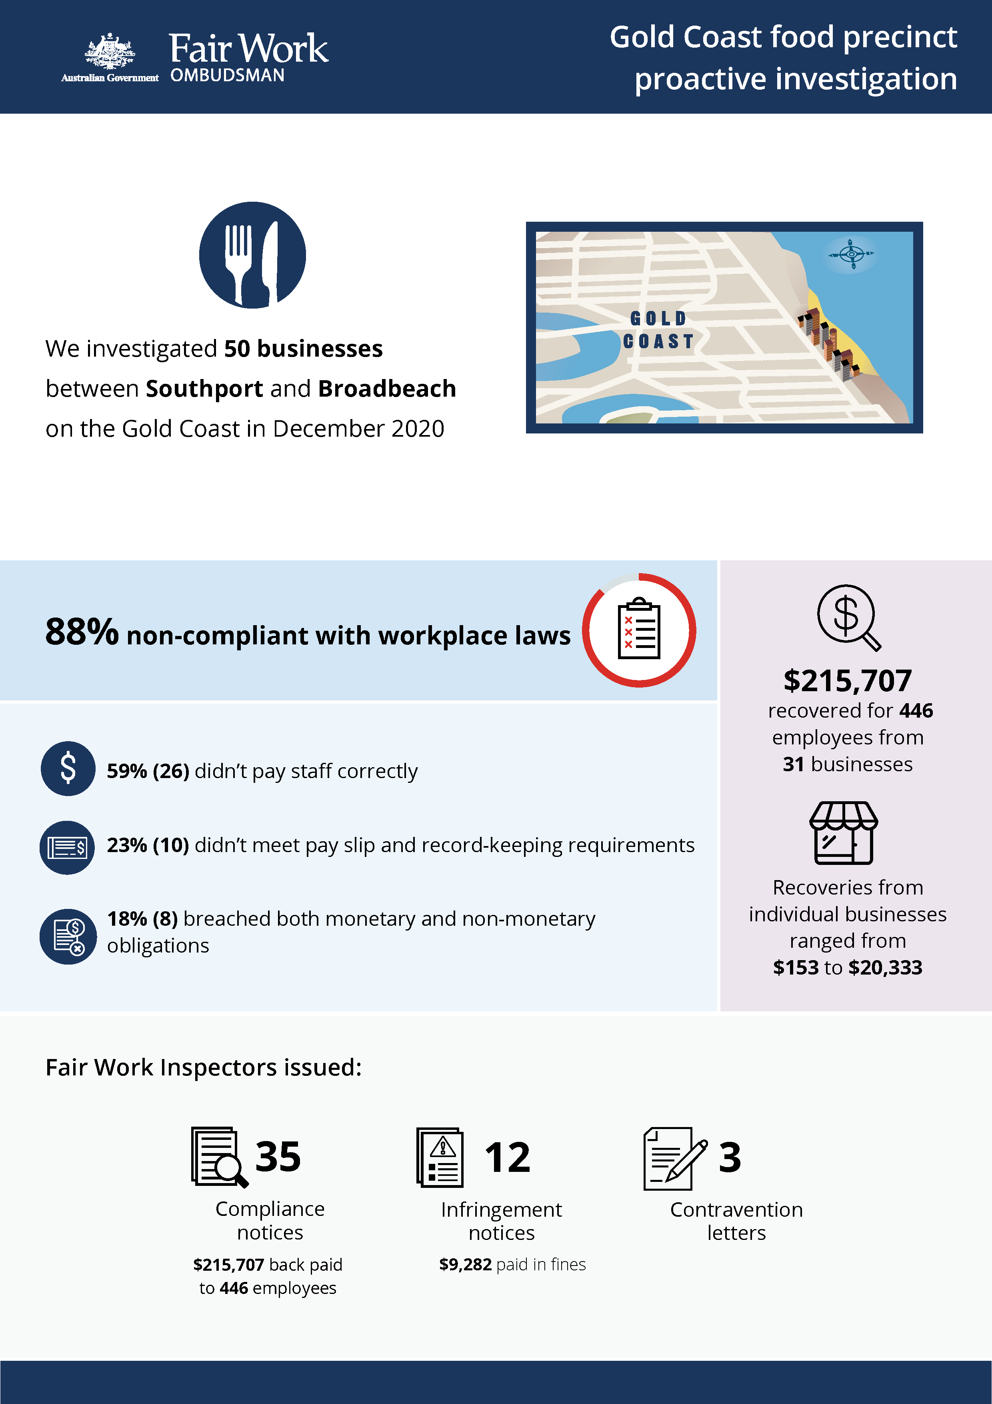+-

# Gold Coast food precinct

## What we did & why

In December 2020, the Fair Work Ombudsman (FWO) investigated 50 businesses operating mostly between Southport and Broadbeach on the Gold Coast.[1]

This activity formed part of a program examining non-compliance in popular ‘cheap eats’ food precincts that commenced in 2016.[2][3][4] Fast food, Restaurants and Cafés (FRAC) sector businesses within these precincts typically employ a high proportion of young and migrant (temporary visa holder) workers. These workers can be vulnerable to exploitation, due to a lack of awareness or understanding of their entitlements, and an unwillingness to raise concerns with their employer or the FWO.

We targeted businesses deemed to be at risk of non-compliance, based on one or more of the following characteristics:

* a history of non-compliance with the FWO
* anonymous tip offs received about the business
* employing vulnerable migrant workers (confirmed using Home Affairs data).

Fair Work Inspectors conducted unannounced site visits over 4 days. They:

* requested employment and payroll records
* interviewed employers, managers and workers
* observed work practices
* noted staff numbers to validate business records.

Pay slips and record-keeping practises were assessed against the requirements of the *Fair Work Act 2009*, the *Fair Work Regulations 2009*, and applicable awards or registered agreements. Most businesses were covered by the *Restaurant Industry Award 2010* or *Fast Food Industry Award 2010*.

## Our findings

44 (88%) of the 50 businesses investigated had breached workplace laws. Of those:

* 26 (59%) were not paying staff correctly
* 10 (23%) were non-compliant with pay slip and record-keeping requirements
* 8 (18%) breached both their monetary and non-monetary obligations.

The most common breaches were:

* failure to pay penaly rates – 22 businesses (50%)
* underpayment of the minimum hourly pay rate – 8 (18%)
* failure to make and keep employee records – 4 (9%)
* failure to pay correct allowances – 2 (5%).

35 businesses (70%) were found to be employing migrant workers.

## Actions taken & next steps

We recovered $215,707for 446 employees from 31 businesses. Recoveries from individual businesses ranged from $153 to $20,333.

Fair Work Inspectors issued:

* 35 compliance notices (to 31 businesses) recovering $215,707for 446 employees
* 12 infringement notices, resulting in $9,282 paid in fines
* 3 contravention letters to businesses that did not issue part-time staff with written agreements.

1. [Gold Coast eateries face workplace audits - Media releases - Fair Work Ombudsman](https://www.fairwork.gov.au/about-us/news-and-media-releases/2020-media-releases/december-2020/20201207-gold-coast-frac-audits-media-release)
2. [Over-1.2-million-recovered-for-food-and-retail-workers– Media releases – Fair Work Ombudsman](https://www.fairwork.gov.au/about-us/news-and-media-releases/2020-media-releases/september-2020/20200904-food-precincts-melbourne-brisbane-and-food-retail-report-media-release)
3. [Over $300 000 returned to fast food, restaurant and café workers - Media releases - Fair Work Ombudsman](https://www.fairwork.gov.au/about-us/news-and-media-releases/2019-media-releases/december-2019/20191206-over-300-000-returned-to-fast-food-restaurant-and-cafe-workers)
4.