Australian Government crestAustralian Government Fair Work Ombudsman logo

Annual Report

**2012–13**



## ENQUIRIES AND COMMENTS

The FWO welcomes comment on this report. Enquiries and feedback may be directed to: Annual Report Coordinator

FAIR WORK OMBUDSMAN LOCATIONS*

**ACT**   
Canberra   
Level 11, 208 Bunda Street and  
cnr Akuna Street Canberra ACT 2600

Fair Work Ombudsman  
GPO Box 9887  
Melbourne VIC 3001  
Telephone: (03) 9954 2583  
[Email: communications@fwo.gov.au](mailto:communications@fwo.gov.au)  
Visit [www.fairwork.gov.au](http://www.fairwork.gov.au/) for more information about the Fair Work Ombudsman or go to [www.fairwork.gov.au/annualreport](http://www.fairwork.gov.au/annualreport) to download a copy of this report.

© Commonwealth of Australia 2013

ISSN: 1837-9079

The *Fair Work Ombudsman Annual Report 2012–13* is protected by copyright.

Creative Commons License.

Creative Commons License logo

With the exception of the Commonwealth Coat of Arms, the Fair Work Ombudsman logo and the other material expressly excluded below (including photographs protected by copyright), all material included in the *Fair Work Ombudsman’s Annual Report 2012–13* is licensed under a Creative Commons Attribution 3.0 Australia [licence (http://creativecommons.org/licenses/b](http://creativecommons.org/licenses/by/3.0/au/)y/3.0/au/).

The CC BY 3.0 AU Licence is a standard form license agreement that allows you to copy, distribute, transmit and adapt material in this publication provided that you attribute the work.

The details of the relevant licence conditions are available on the Creative Commons website (accessible using the links provided) as is the full legal code for the CC BY 3.0 AU licence (http://creativecommons.org/licenses/b

The report should be attributed as the *Fair Work Ombudsman* *Annual Report 2012–2013*.

All rights in the materials listed below are reserved. If you wish to use any of these materials in a way that is not permitted by the *Copyright Act 1968*, you should contact the Annual Report Coordinator (see above).

Materials where rights reserved.

Commonwealth Coat of Arms and the Fair Work Ombudsman logo – Cover, Title Page and Letter of Transmittal (page 1)

Photographs on pages 17, 20, 27.

NSW   
Sydney  
Coffs Harbour  
Newcastle  
Orange  
Wagga Wagga  
Penrith

QLD   
Brisbane  
Cairns  
Gold Coast  
Rockhampton  
Toowoomba

SA  
Adelaide  
Mount Gambier  
Whyalla

TAS   
Hobart  
Launceston

VIC   
Melbourne  
Bendigo   
Traralgon  
Warrnambool

WA   
Perth  
Bunbury

*At 30 June 2013

Level 12, 255 Elizabeth Street  
Sydney NSW 2001

Level 17, 200 Mary Street Brisbane QLD 4000

Level 2, 148 Frome Street Adelaide SA 5000

Level 3, 142 - 146 Elizabeth Street Hobart TAS 7000

Level 6, 414 La Trobe Street Melbourne VIC 3000

Level 10, 140 St Georges Terrace Perth

Australian Government crestAustralian Government Fair Work Ombudsman logo

Annual Report 2012–13 title



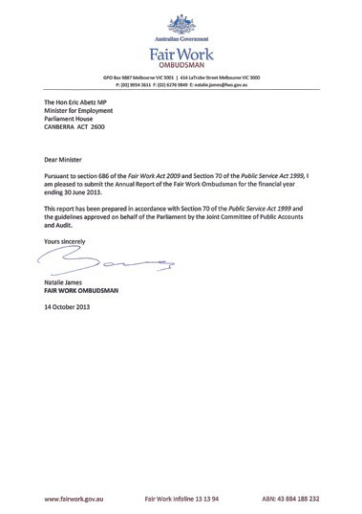

Contents

About this report 5

Structure 5

Acknowledgments 5

Performance snapshot 5

## FAIR WORK OMBUDSMAN’S REVIEW 6

New leadership 8

Outlook 8

## OVERVIEW OF SERVICES 9

About the Fair Work Ombudsman 10

Corporate and operational planning 10

Customer Service Charter 10

Outcome and output structure 10

Organisational structure 11

## REPORT ON PERFORMANCE 11

Program 1: Education services   
and compliance activities 12

Deliverable 1: Providing information, advice   
and education on the requirements and flexibilities of workplace laws to foster voluntary compliance 13

Deliverable 2: Investigating claims regarding   
alleged breaches of workplace laws and undertaking targeted activities 24

Deliverable 3: Litigating, where necessary,   
to enforce compliance with workplace laws 35

## MANAGEMENT & ACCOUNTABILITY 39

Corporate governance 40

External scrutiny 42

Management of human resources 43

Purchaser-provider arrangements 49

Consultants 50

Contracts 50

Grants programs 50

Analysis of financial performance 50

## FINANCIAL STATEMENTS 51

## APPENDICES 113

Appendix A: Staffing profile 114

Appendix B: Work health and safety 117

Appendix C: Information Publication Scheme 118

Appendix D: Ecologically sustainable  
development and environmental performance 118

Appendix E: Advertising and market research 119

Appendix F: Summary of resources 119

## REFERENCES 121

Glossary 122

Abbreviations and acronyms 123

List of requirements 123

Index 127

# ABOUT THIS REPORT

This annual report for the Fair Work Ombudsman (FWO)   
documents activities and performance from 1 July 2012 to   
30 June 2013. In preparing this report the Requirements for Annual Reports prepared by the Department of the Prime Minister and Cabinet and approved by the Joint Committee of Public Accounts and Audit have been followed.

# STRUCTURE

The report is presented in seven parts:

## FAIR WORK OMBUDSMAN’S REVIEW

A review of the operations of the agency in 2012–13 by the Fair Work Ombudsman.

## OVERVIEW OF SERVICES

An introduction to the agency and an overview of its structure and function.

## REPORT ON PERFORMANCE

The FWO performance measured against the outcome and program structure set out in the 2012–13 Portfolio Budget Statements.

## MANAGEMENT AND ACCOUNTABILITY

A report on the agency’s management practices, including  
its corporate governance framework, executive committee structure, human and financial resources, internal controls, external scrutiny, financial management and commentary on the agency’s financial performance.

## FINANCIAL STATEMENTS

The audited financial statements for 2012–13 and the audit report.

## APPENDICES

Statistics and other mandatory information.

## REFERENCES

A glossary, a list of abbreviations, a general index and an index of the agency’s compliance with the annual report requirements.

# ACKNOWLEDGMENTS

Annual Report Team: Sarah Strudwicke, Lynda McAlary-Smith.

Thank you to all FWO employees who contributed to this report.

Designed and typeset by: Bite Visual Communications Group.

PERFORMANCE SNAPSHOT

In 2012–13 the FWO achieved the following results through working with the community:

* Provided education, assistance and advice in response to more than 615 905 enquiries received through Fair Work Infoline services.
* Provided information and resources through [fairwork.gov](http://www.fairwork.gov.au/).au with more than 10.3 million visits, including 401 445 industry section visits and more than 1 million fact sheet downloads.
* Informed the public of the agency’s role and broadcast compliance outcomes through a strong media and social media presence.
* Undertook education campaigns targeting:
* specific industries such as retail, hair and beauty, hospitality
* compliance issues such as disguised employment relationships
* vulnerable employee groups, including young and migrant workers.
* Received more than 852 400 visits to PayCheck Plus for wage rate information.
* Finalised 26 574 complaints and 5 675 audits, recovering more than $24 million for 17 434 employees.
* Entered into 12 enforceable undertakings.
* Entered into one Pro-active Compliance Deed, a tailored agreement aimed at building a business’s compliance capacity.
* Achieved court ordered penalties of more than $1.6 million in 45 decided matters.
* Expanded the suite of self-service online resources, including launching an online learning centre and a secure workplace relations workspace that users can tailor to suit their needs called MyPortal.

### Fair Work Ombudsman’s review

**SECTION 1**



The past year, the FWO’s fourth year of operation, has been one of continuing success. We have delivered on our core functions of advice, assistance, and where necessary, enforcement within the workplace community. It was also a year of transformation. We are reframing our services to deliver greater public value.

In 2012–13 we met all key performance indicator targets. Most significantly, we exceeded the target of 80 per cent set for investigation into complaints completed within 90 days. We achieved a record 84 per cent during the reporting period, up from 68 per cent in 2011–12.

Our greater use of alternative and less formal dispute resolution services helped us resolve matters more quickly and constructively with workplace participants. Of the 26 574 complaints finalised in 2012–13, more than 65 per cent were resolved through alternative dispute resolution services. For more information on these measures, see page 26 of this report.



Natalie James, Fair Work Ombudsman

The steps taken to strengthen our focus on voluntary resolution included greater integration of our operational functions, and more targeted investment in training of our frontline service staff. This improved our capacity to effectively assess matters and select the most appropriate path to resolution from the outset.

Building on the success of our mediation pilot in 2011–12, which demonstrated how effective this method can be in resolving workplace issues, mediation services were also boosted with our specialist team of mediators more than doubling during the year. For more information, see page 26.

Encouraging conversation in the workplace and equipping people with the information they need to resolve workplace issues was a key focus in 2012–13. By providing people with accessible, reliable and credible tools and resources, we are helping them understand their workplace rights, obligations and their options for resolution.

We introduced an online learning centre with self-paced courses, the first providing practical steps on *Difficult conversations in the workplace*, to give employers and employees skills to work cooperatively and productively. MyPortal, a self-service online tool that acts as a personal doorway into our website’s information and services, including our self-service pay tools, was also introduced during the year.

Greater use of self-help technologies and a focus on resolving matters early with workplace participants is also allowing us to use our interventions and compliance tools in a targeted and proportionate way.

This means we can identify the issues likely to involve substantial detriment to vulnerable employees. Issues of concern have included confusion about the legitimacy of unpaid work practices (see page 20), the need for those responsible to take action to prevent underpayments through their contracting practices (see page 34), disguised employment relationships (see page 37) and the exploitation of vulnerable groups such as migrant workers (see pages 22, 33, 37).

# NEW LEADERSHIP

Leadership of the FWO changed on 15 July 2013. Under the inaugural and outgoing Fair Work Ombudsman, Nicholas Wilson, the FWO developed a reputation as a responsive and high performing agency.

The FWO has an impressive record of promoting compliance and achieving strong enforcement outcomes. More than $200 million in unpaid wages have been recovered for Australian workers since the Commonwealth workplace relations regulator became an independent agency in March 2006.

Beyond recovering wages, we have succeeded in embedding good workplace practices. Businesses that we’ve monitored through targeted education and compliance campaigns show that systemic behaviour change is possible with the right information and assistance.

The achievements and high standing in the Australian community, and the increasing government and community demands placed on the FWO, are a tribute to the professionalism and work ethic Nicholas Wilson instilled in the staff of the FWO during his tenure.

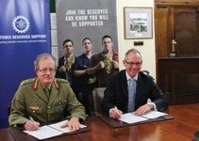

*Nicholas Wilson, former Fair Work Ombudsman, signs MOU with Defence in support of reservists:*

‘Diversity Champion (CEO)’ finalist, Nicholas Wilson’s commitment to developing and maintaining a workplace culture in which the diverse backgrounds, skills, talents and views of all employees are valued and encouraged, saw the agency awarded ‘Inclusive Workplace of the Year’ by the Australian Human Resources Institute in 2013. For more information see pages 44 and 47.

We will build on this position and find more efficient ways to achieve fair and productive workplaces. We will also continue to transform our services to ensure they are directed to where they are most needed.

# OUTLOOK

Our ultimate goal is to equip workplace participants to manage their workplace relationships and make decisions about their businesses and their jobs without the need for intervention. Providing accessible, credible and reliable information to the Australian community will play a critical role in enabling workplace participants to resolve matters that arise in their workplace.

This requires us to dedicate some thought, energy and resources to tackling tomorrow’s challenges and seizing tomorrow’s opportunities. Preparing ourselves and the community for the end of phasing to modern awards presents an opportunity to deliver more simplified resources and self-help tools through a transformed website in 2013–14.

We must also continue to find better ways of working to achieve results efficiently for the Australian taxpayer. Immediate savings are being made in areas such as travel expenditure, accommodation and office consumables. Inter-department and agency collaboration, including shared accommodation and services, are also helping reduce costs and improve efficiencies.

In driving these efficiencies, we will remain focused on promoting productivity and compliance in workplaces. We will reframe our services to deliver accessible, credible

and reliable advice and assistance to those who need it most, taking into consideration barriers to compliance. We will also use our compliance tools in an appropriate and proportionate way and where there is a public need to intervene.

Natalie James signature

**Natalie James**

***Fair Work Ombudsman***

Overview of services

**SECTION 2**



# ABOUT THE FAIR WORK OMBUDSMAN

The Fair Work Ombudsman (FWO) is an independent statutory agency, created by the *Fair Work Act 2009*. The agency forms part of the Education, Employment and Workplace Relations portfolio.

FWO has a vision to achieve fair Australian workplaces, and a mission to work with Australians to educate, promote fairness and ensure justice in the workplace.

The agency works to achieve this by:

* providing advice and assistance to the Australian public about their workplace rights and obligations
* investigating complaints or suspected contraventions of workplace laws, awards and agreements and litigating, where necessary, to ensure compliance
* maintaining an active awareness of the wider political, social and economic landscape to inform strategy
* building a model workforce that is harmonious, cooperative and productive.

The FWO is impartial, and provides services to workplace participants and registered organisations throughout Australia free of charge through the Fair Work Infoline and [fairwork.gov.au](http://www.fairwork.gov.au/). The agency also engages in other education and compliance activities such as campaigns, audits, investigations, mediation and litigation.

Natalie James was appointed Fair Work Ombudsman and Agency Head on 15 July 2013.

Michael Campbell was Acting Fair Work Ombudsman from 29 April to 12 July 2013. Nicholas Wilson held the position from 1 July 2009 until 28 April 2013.

# CORPORATE AND OPERATIONAL PLANNING

## STRATEGIC PLAN

The 2012–16 FWO Strategic Plan outlines the agency’s role in promoting harmonious, productive and cooperative workplace relations and ensuring compliance with Commonwealth workplace laws.

The plan sets out the FWO’s key priorities for operational activities. They are:

* empower people with information on which they can act
* educate individuals and organisations about better ways of working and resolving disputes
* give confidence to citizens that their rights will be observed
* hold those responsible to account for their workplaces.

The plan also identifies seven objectives to improve how the FWO operates within its environment:

* make a positive and quantifiable contribution to workplace productivity
* improve waiting times so clients don’t wait unreasonably for service
* produce work that is valued by our clients
* ensure that our people at work are as diverse as the Australian workplace we serve
* employ the most engaged staff in the APS
* balance budget outcomes
* quantifiably reduce carbon emissions.

# CUSTOMER SERVICE CHARTER

The FWO is held accountable through Parliament, the courts and tribunals and the Commonwealth Ombudsman. The agency is also bound by the Australian Public Service Code of Conduct. The FWO Customer Service Charter sets out the standards of service and the values to which the agency is committed.

It states the FWO’s role, the standard of service the public can expect and what steps may be taken if standards are not met. The charter outlines the procedure for contact, communication, feedback and lodging of complaints.

The FWO Customer Service Charter is available on the FWO website[, fairwork.gov.au](http://www.fairwork.gov.au/).

# OUTCOME AND OUTPUT STRUCTURE

The 2012–13 Portfolio Budget Statements for the Education, Employment and Workplace Relations portfolio set out one planned outcome and program for the FWO. The agency’s performance against this outcome and program is outlined in the Report on performance section, page 11.

The Fair Work Ombudsman’s outcome and program structure is shown in Table 1.

#### Table 1: Fair Work Ombudsman outcome and output structure

**Outcome 1**

Compliance with workplace relations legislation by employees and employers through advice, education and, where necessary, enforcement.

**Contributions to Outcome 1**

Program 1: Education services and compliance activities

Program objective: To educate employers, employees, organisations and contractors about the workplace relations system and to ensure compliance with workplace laws.

**Program 1: deliverables**

The deliverables of the Fair Work Ombudsman are to:

* provide information, advice and education on the requirements and flexibilities of workplace laws to foster voluntary compliance
* investigate claims regarding alleged breaches of workplace laws and undertake targeted activities
* litigate, where necessary, to enforce compliance with workplace laws.

# ORGANISATIONAL STRUCTURE

At 30 June 2013 the FWO was organised into four clusters:

* Infoline and Dispute Resolution and Compliance
* Corporate, IT and Project Delivery
* Education, Knowledge Management and Communications
* Legal Group and Policy and Media Group.

#### Figure 1: Organisational structure at 30 June 2013

1. Michael Campbell, Acting Fair Work Ombudsman. Michael Campbell resumed substantive position as Group Manager Operations on 15 July 2013.
2.  Infoline and Dispute Resolution and Compliance.
3. Steve Ronson, Acting Group Manager Operations. Michael Campbell resumed substantive position as Group Manager Operations on 15 July 2013.
4. Michael Clark, Executive Director Fair Work Infoline.
5. Carey Trundle, Acting Executive Director Dispute Resolution and Compliance. Steve Ronson resumed substantive position as Executive Director Dispute Resolution and Compliance  on 15 July 2013. Carey Trundle resumed substantive position as Director Overseas Workers on 15 July 2013.
6. Corporate, IT and Project Delivery.
7. Mark Scully, Group Manager Finance & Corporate.
8. Leanne Fry, Chief Information Officer Information Management.
9. Giorgina Strangio, Executive Director Human Resources.
10. Karsten Lehn, Executive Director Major Project Management.
11. Education, Knowledge Management and Communications.
12. Alfred Bongi, Group Manager Knowledge Services Group.
13. Naomi Bleeser, Executive Director Knowledge Services.
14. Bill Loizides, Group Manager Education, Communications and Partnership.
15.  Lynda, McAlary-Smith Executive Director Education and Major Employers.
16. Sandra Scalise Executive Director Communications.
17. Office of the FWO.
18. Janine Webster, Chief Counsel Legal Group.
19. Tom O’Shea, Executive Director Policy and Media.

### Report on performance

**SECTION 3**



# PROGRAM 1: EDUCATION SERVICES AND COMPLIANCE ACTIVITIES

In 2012–13 the FWO continued to augment the delivery of its education, compliance and litigation services to progress towards the government’s planned outcome of achieving workplace compliance.

## RESULTS

The agency met or exceeded all key performance indicator (KPI) targets prescribed in the Portfolio Budget Statements for 2012–13. This was a significant achievement, and in the case of investigations into complaints a 16 per cent and 23 per cent improvement on respective preceding years. For more information, see Table 16 on page 32.

The Fair Work Infoline met all targets for KPIs, offering 99 per cent availability during advertised hours, with email and Live Chat services at 99 per cent availability. For more information, see pages 16, 18-19.

The agency met KPIs for national campaigns and state campaigns, with four delivered nationwide and two delivered in each state and territory in 2012–13. Of the state and territory campaigns, seven joint campaigns were held across New South Wales/the Australian Capital Territory, Victoria, Queensland, the Northern Territory, South Australia and Western Australia.

These have been included in the total number of state and territory campaigns undertaken in each of these locations. For more information on these measures, see page 28.

These results were achieved through workflow re-engineering, the agency’s increasing use of innovative technological solutions, and the expanded use of client focused dispute resolution services.

An organisational restructure was undertaken in January 2013 to bring the FWO’s contact centre and inspectorate into one cluster called Infoline, Dispute Resolution and Compliance.

See Figure 1 on page 10. The consolidation of the agency’s primary direct client facing service delivery areas has improved performance outcomes of both the Fair Work Infoline and the inspectorate through greater collaboration, innovation and tailored services.

The agency’s technical knowledge development, education and communication services were also consolidated into a single cluster.

Work will continue in 2013–14 to ensure the FWO’s organisational structure supports the government’s program deliverables with agility and efficiency.

The agency’s actions and progress towards achieving the government’s planned outcome are outlined in the following section. Activities and achievements are reported against KPIs and program deliverables.

The FWO’s results against the KPIs, as set out in the Portfolio Budget Statements for the 2012–13 reporting period, are outlined in Table 2.

#### Table 2: FWO’s performance against key performance indicators

|  |  |  |  |  |
| --- | --- | --- | --- | --- |
| Key performance indicator | **Target**  **2012–13** | **Actual results**  **2012-13** | **Actual results**  **2011-12** | **Actual results**  **2010-11** |
| Number of targeted campaigns national  state (number of campaigns in each state and territory) | 4  2 | 4  2 | 4  At least 2 in  each state | 4  At least 2 in  each state apart  from NSW |
| Investigations into complaints about breaches of federal agreements or awards completed within  90 days (% of total complaints) | 80% | 84% | 68% | 61% |
| Calls to the Contact Centre resolved at the first point of contact (% of total calls) | 80% | 99% | 98% | 97% |
| Availability of Contact Centre services  (% of availability during advertised hours) | 99% | 99% | 99% | 95% |
| Availability of website  (time available as a % of total time) | 99% | 99% | 99% | 99% |

# DELIVERABLE 1: PROVIDING INFORMATION, ADVICE AND EDUCATION ON THE REQUIREMENTS AND FLEXIBILITIES OF WORKPLACE LAWS TO FOSTER VOLUNTARY COMPLIANCE

## SNAPSHOT OF ACTIVITIES IN 2012–13

* Responded to 615 905 written, telephone and online enquiries.
* Received more than 10 million visits to [fairwork.gov.au](http://www.fairwork.gov.au/) and 1 557 974 downloads of educational fact sheets, best practice guides and templates.
* Sent eNewsletters and email updates to more than 29 600 subscribers.
* Partnered with 75 employers and six national franchisors employing a combined total of over 599 000 employees through the National Employer Program and National Franchise Program.
* Developed an online learning centre for employers and employees.
* Launched MyPortal, a secure workplace relations workspace users can tailor to suit their needs.
* Created a suite of youth-focused educational videos on workplace relations, which have received over 221 000 views on YouTube.
* Implemented strategies to educate specific groups of vulnerable workers including working parents, migrants and young workers.
* Provided advice, assistance and education at targeted events around Australia.
* Engaged with the public via social media through
* 700 tweets and 300 Facebook posts.

In 2012–13 the FWO delivered education products and initiatives to give workplace participants a greater understanding of their workplace rights, obligations and options to help them make well-informed decisions.

The FWO’s education products and initiatives, in combination with compliance activities, were targeted to the industries and regions with the greatest compliance issues or the employees with the most vulnerable employment profile and employers with minimal workplace relations support or expertise.

To cater for the varying needs and learning styles of workplace participants, education was delivered in different formats, with different levels of complexity and through a number of channels.

Tailored assistance for complex enquiries was provided over the phone and answers to the community’s most common questions wer[e accessible on fairwork.gov.au](http://www.fairwork.gov.au/). Targeted information was distributed to the industries needing it most. New self-service tools and resources were created with the time-poor in mind, including an online learning centre and interactive website portal.

Research informed the agency’s four-year education strategy, developed and implemented in 2013. The strategy is founded on three principles:

* Building products – the FWO will continue to develop cost effective and useful tools and products to equip Australian businesses and their employees with the skills to prevent and resolve disputes within their workplaces.
* Building relationships – the FWO will build and strengthen its relationships with peak bodies, employer organisations, unions, community groups, government and directly with small businesses to deliver the FWO’s education program.
* Building connections – the FWO will inform and support good workplace practices by facilitating connections between employers, employees and the services and resources of relevant organisations including government.

The 2013–16 Education Strategy intentionally moves the focus of FWO’s education offerings from technical compliance with the Fair Work Act, to informing and supporting employees and businesses creating compliant and productive workplaces.

The strategy is focused on influencing long-term behaviour change within individual workplaces, industries and with market leaders.

The FWO’s Education Strategy will continue to evolve in 2013–14, as the agency anticipates and responds to the needs of businesses and employees.

## FAIRWORK.GOV.AU

The FWO websit[e (fairwork.gov](http://www.fairwork.gov.au/).au) is the agency’s primary communication and education channel.

Through the website, the FWO continued to encourage businesses to be proactive with workplace compliance, providing a range of self-service information, tools and assistance to help businesses understand their obligations and options.

By providing tailored tools and resources, the FWO empowers workplace participants to make well-informed decisions and minimises unintentional non-compliance with the Fair Work Act.

User participation grew significantly in 2012–13, with visits up by 57 per cent – an average of around 28 000 visits a day.

#### Table 3: Visits t[o fairwork.gov.au](http://www.fairwork.gov.au/)

|  |  |  |
| --- | --- | --- |
|  | 2012–13 | 2011–12 2010–11 |
| Visits t[o fairwork.gov.au](http://www.fairwork.gov.au/) | 10 327 287 | 6 595 855 4 576 336 |
| Unique visitors t[o fairwork.gov.au](http://www.fairwork.gov.au/) | 5 949 628 | 3 683 873 2 436 016 |
| Visits to industry pages | 401 445 | 261 892 159 000 |

Consistent with 2011–12 the retail, hair and beauty and clerical industry pages had the highest number of page views of all industry pages with 146 816 page visits in 2012–13.

#### Table 4: Most visited website pages in 2012–13

**Visits**

|  |  |
| --- | --- |
| List of 2013 public holidays page | 1 014 263 |
| Award Finder launch page | 865 823 |
| Finding the right pay page – links to various pay calculation tools | 809 658 |
| National minimum wage page | 785 521 |
| PayCheck Plus launch page – links to modern award pay rates calculator tool1 | 670 081 |

1 PayCheck Plus was also accessible fr[om other pages on fairwork.gov.au](http://www.fairwork.gov.au/). For usage of the tool by month see Figure 2 on page 15.

#### Listening and finding better ways to assist

User feedback was sought through the website’s ‘Helpful’ or ‘Not helpful’ page rating mechanism as part of an agency- wide commitment to customer service and quality assurance.

Information collected was used to revise and refine the information and structure of cont[ent on fairwork.gov](http://www.fairwork.gov.au/).au and will assist in the redevelopment of the website in 2013–14.

Web-based answers to the most popular questions asked by callers to the Fair Work Infoline were updated fortnightly and made available via the ‘Top 5 Questions’ section of [fairwork.gov.au](http://www.fairwork.gov.au/). Maintaining an active environmental awareness and surfacing topical information to the website’s homepage enabled the FWO to respond promptly to the needs of the Australian community.

The agency commenced planning in 2012–13 for the redev[elopment of fairwork.gov](http://www.fairwork.gov.au/).au in 2013–14. A critical component of the website redevelopment will be consulting with clients and stakeholders to better understand and respond to their needs.

This will ensure that Australian workplace community and particularly employees, small businesses and workplace relations practitioners continue to have access to credible and reliable information.

#### Resources to help small to medium-sized businesses

I[n 2012–13 fairwork.gov](http://www.fairwork.gov.au/).au provided an expanded, improved and easily accessible suite of tools and resources as part of the FWO’s commitment to   
equipping workplace participants with information on which they can act.

These tools are free and can be easily customised   
by businesses, especially time-poor small business owners, to simplify employment and record keeping practices.

#### Table 5: Educational resources, downloads and subscription services

|  |  |  |  |
| --- | --- | --- | --- |
|  | **2012–13** | **2011–12 2010–11** | **2010–11** |
| Fact sheets available | 40 | 38 | 32 |
| Fact sheet downloads | 1 115 282 | 642 697 | 633 000 |
| Best Practice Guides available | 13 | 12 | 12 |
| Best Practice Guides downloaded | 93 882 | 68 699 | 65 888 |
| Templates available | 59 | 51 | 44 |
| Templates downloaded | 438 810 | 373 963 | 448 000 |
| eNewsletter subscribers | 6 128 | 2 3011 | – |
| Email update subscribers | 22 4871 | – | – |

1 Service introduced.

#### At 30 June 2013 the FWO’s education products included:

* 40 fact sheets explaining the key provisions of the workplace relations legislation
* 59 template letters and documents designed to simplify the work involved in keeping employment records and recording agreements between employees and employers
* 13 Best Practice Guides on areas such as work and family, and individual flexibility arrangements
* checklists to help employers and employees understand their rights and responsibilities and identify any knowledge gaps
* a subscription-based bi-monthly eNewsletter sent to 6 128 employers to help them stay on top of their workplace relations obligations
* an email update subscription-based service sent to 22 487 workplace participants, as required, to keep them up-to- date on employment issues and news
* a suite of pay tools to help clients locate awards and calculate pay rates
* an online learning centre with courses to teach people skills and strategies to help them at work.

#### Delivering rates of pay around the clock

In 2012–13 PayCheck Plus, an online self-service tool   
that calculates modern award pay rates, enabled the   
FWO to serve the community 24 hours a day, seven days   
a week, in a matter and time of workplace participants’ choosing.

PayCheck Plus formed an integral part of the Fair Work Infoline’s customer services. Advisors regularly used PayCheck Plus during calls with employers and employees to explain pay rate calculations and demonstrate how callers could calculate wage rates and entitlements themselves.

Social media, including Facebook and Twitter, was also   
used during 2012–13 to promote PayCheck Plus as a credible alternative to calling the Fair Work Infoline.

#### Figure 2: PayCheck Plus usage by month

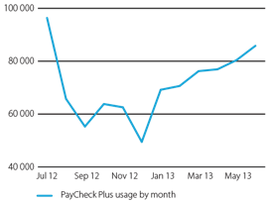

In 2012–13 visitors to PayCheck Plus increased by around 45 per cent with an average of 71 000 visits per month compared to an average of 49 000 visits per month in 2011–12.

PayCheck Plus visits escalated by about 36 per cent in July 2012, the month Fair Work Australia’s increase to the minimum wage took effect.

Work began in 2012–13 to modify PayCheck Plus in readiness for the end of transitional arrangements from 1 July 2014, when pre-modern award information will no longer be required to calculate rates of pay.

#### Expanding the suite of online resources

User feedback and the increase in download volumes of the online resources and tools demonstrated that the agency’s customers continued to value and use practical examples, templates and tailored, accessible guidance.

In response, in 2012–13 the FWO expanded and promoted the agency’s suite of online tools and resources, including:

* the launch of MyPortal, a self-service online tool where registered clients are given a secure profile and login that allows them to find their award, calculate pay rates and save their search results. Users also have access to tailored information and resources recommended by the FWO based on their industry and location. They can ask the FWO questions, save advice given and bookmark favourite [fairwork.gov](http://www.fairwork.gov.au/).au pages
* the launch of an online learning centre with courses to teach people skills and strategies to help them at work. The course about conducting difficult conversations will be supplemented by another three modules to be developed in 2013–14 (see *Helping make difficult conversations at work easier* on page 17)
* the development of a Fair Work Handbook – a quick reference guide for employers and managers to help them better understand their workplace relations obligations
* the publication of a Pharmacy Industry Handbook, in partnership with the Pharmacy Guild of Australia, tailored for employers and managers in the industry
* the release of three videos for young workers on public holiday and penalty rate entitlements
* a webinar program on current workplace relations topics and campaigns.

## FAIR WORK INFOLINE

The Fair Work Infoline was the front-line for customised and more complex advice and enquiries in 2012–13. A team of dedicated Fair Work Advisers answered 615 905 enquiries, providing tailored assistance on the telephone and in writing (post or email).

In recognition of these successful outcomes, the Fair Work Infoline received an honourable mention at the 2012 Government Contact Centre Excellence Awards, part of the Government Contact Centre Summit.

As in previous years, wages were the most common reason workplace participants sought advice and information from the Fair Work Infoline in 2012–13, making up more than one-third of all enquiries. Conditions of employment were also of great interest to callers, followed by termination of employment.

#### Figure 3: Nature of calls to the Fair Work Infoline 2012–13

Pie chart showing the nature of calls to the Fair Work Infoline in 2012–13. Table 6 shows this information by percentage over three years.


1 Referred to as ‘Outside of scope of FWO’ in previous FWO annual reports.

Case study

Helping make difficult conversations at work easier

The FWO’s Online Learning Centre, launched in 2012–13, is delivering the agency’s education message using self-paced courses designed especially for employers, managers and employees.

Key industry stakeholders provided input into the development of the online learning courses to help ensure they were relevant to the issues employers and workers face.

The first course offered, *Difficult conversations in the workplace*, provides practical steps for employers and employees to ensure conversations are effective at resolving problems.

Most employers and workers will be part of a difficult conversation at some stage during their working lives.

If difficult conversations are handled well in the workplace, conflicts can be resolved more quickly – or even avoided – and relationships at work can be improved. This can lift staff engagement and performance, creating a happier, more productive workplace.

*Difficult conversations in the workplace* contains various scenarios – such as a sales assistant asking for leave over Christmas/New Year or a waitress asking for more money – and explores the right and wrong ways to tackle the issue. For example, a waitress could ask for more money in two ways:

I get $15 an hour. I check[ed fairwork.gov](http://www.fairwork.gov.au/).au and it looks like I should be getting more than that for my role. Can we talk about this?

You are underpaying me. You’re ripping me off. Pay me what you owe me or I’m quitting.



The course then demonstrates through video the likely responses to both requests. It provides tips on various aspects of these discussions, such as preparing for the conversation and managing your emotions, and links to further information.

In the two weeks after its launch, the manager course was accessed 700 times and the employee course 590 times.

Courses on the Online Learning Centre are free. By registering, users gain access to many extra features such   
as completion certificates, assessments and the ability to   
exit and resume courses.

The FWO will launch more courses via the Online Learning Centre throughout 2013 and 2014. Courses will cover topics such as hiring staff, starting a new job and managing employee performance. Each will contain interactive learning activities, practical scenarios and video content.

Employers, managers and employees can directly access   
the online courses from a desktop, mobile or tablet by   
visiting [www.fairwork.gov.au/learning](http://www.fairwork.gov.au/learning)

**If difficult conversations are handled well in the workplace, conflicts can be resolved more quickly – or even avoided – and relationships at work can be improved.**

#### Table 6: Nature of calls to the Fair Work Infoline by percentage

|  |  |  |
| --- | --- | --- |
| Enquiry type | **2012–13**  **%** | **2011–12 2010–11**  **% %** |
| Wages | 35 | 38 37 |
| Conditions of employment | 21 | 20 21 |
| Termination of employment | 14 | 13 11 |
| Leave | 10 | 9 9 |
| Claims | 6 | 8 8 |
| Referrals to other agencies1 | 7 | 5 51 |
| Entitlements | 5 | 5 5 |
| Other | 1.4 | 1.3 2 |
| Workplace complaint | 0.8 | 0 0 |
| Independent contractors | 0.5 | 0.4 1 |

1 Referred to as ‘Outside of scope of FWO’ in previous FWO annual reports.

#### Table 7: Fair Work Infoline assistance and advice

|  |  |  |
| --- | --- | --- |
|  | **2012–13** | **2011–12** **2010–11** |
| Calls for advice and assistance answered | 522 782 | 683 992 825 218 |
| Assistance offered through Live Help sessions | 31 9371 | 48 665 54 743 |
| Responses to written requests for assistance | 61 186 | 39 752 36 443 |
| **Total** | **615 905** | **772 409 916 404** |

1 Live Help ceased in March 2013.

In 2012–13 calls for advice and assistance answered by the Fair Work Infoline decreased by 31 per cent, compared to a 54 per cent increase in responses provided to email and written enquiries through post.

The decrease in Live Help chat sessions was the result of a decision to stop the service in March 2013. An analysis of customer feedback collected through surveys at the end of chat sessions found that closing Live Chat to casual enquirers would greatly increase the Infoline’s call handling capacity. Results showed that most Live Chat users who were unsuccessful in resolving their enquiry would subsequently call.

The service has been repositioned and reopened specifically for MyPortal registered users. For more information on MyPortal, see page 16.

#### Table 8: Callers to the Fair Work Infoline

|  |  |  |
| --- | --- | --- |
|  | **2012–13**  **%** | **2011–12 2010–11**  **% %** |
| Callers who identified themselves as employers | 30 | 3337 |
| Callers who identified themselves as employees | 65 | 6162 |
| Callers who did not identify as employers or employees | 5 | 61 |
| **Total** | **100** | **100 100** |

#### Figure 4: Fair Work Infoline assistance and advice provided by month

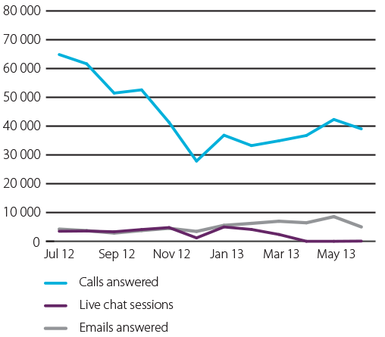

#### Ensuring quality advice

The FWO met and exceeded its two KPIs used to measure the success of its Fair Work Infoline services:

* The ‘First call resolution’ KPI was exceeded by 19 per cent, with a one per cent increase on the previous year. This measured whether an enquiry was resolved within 48 hours without extra client contact being required.
* The 99 per cent ‘Availability’ KPI was also met.

#### Table 9: Performance against Infoline key performance indicators

|  |  |  |
| --- | --- | --- |
| **KPI** | 2012–13 | 2011–12 |
| First call resolution (KPI = 80%) | 99% | 98% |
| Availability (KPI = 99%) | 99% | 99% |

## MAXIMISING REACH AND ENGAGEMENT THROUGH COLLABORATION

In 2012–13 the FWO’s collaborative relationships with stakeholders from the workplace relations community continued to assist in developing innovative solutions for implementing the FWO’s education strategies.

Working with representatives from employers, government agencies, universities, unions and industry associations enabled the FWO to maximise its reach and relevance in the workplace community.

Successful examples of the agency’s collaborative approach to achieving workplace education and compliance in 2012–13 include:

* worked cooperatively with 117 large employers as part of the National Employer Program, providing workplace relations advice affecting more than 550 000 employees
* provided tailored advice and information about workplace relations practices and policies affecting more than 48 000 employees through collaborating with 14 franchisors as part of the National Franchise Program
* provided tailored advice to over 1 300 enquiries by employer organisations and unions through a dedicated telephone and email service called Practitioner Assist
* developed education and compliance strategies to address the legality and legitimacy of unpaid work practices and internships in consultation with stakeholders, including unions and industry associations. The FWO also commissioned specific research into the nature, prevalence and regulation of unpaid work in Australia. The report and FWO’s r[esponse is published on fairwork.gov.au](http://www.fairwork.gov.au/). (see Experience or exploitation? on page 20)
* continued to work collaboratively with other government agencies including the Australian Taxation Office and the Australian Securities and Investments Commission on phoenix activity
* consulted widely with industry associations and organisations to develop and deliver four national and 21 state and territory education and compliance campaigns (see Conducting audits on page 28).

The FWO will continue to work closely with stakeholders in 2013–14. There will be an increased focus on building connections with and tailoring services for the small business community.

Case study

Experience or exploitation

In late 2011 the FWO identified unpaid work in Australia as an emerging issue. A newspaper article advocating the value to businesses of the ‘free labour’ on offer from young interns triggered concern.

In consultation with major stakeholders, the FWO published infor[mation on fairwork.gov](http://www.fairwork.gov.au/).au detailing the nature and risks of different types of unpaid work arrangements.

Recognising the complexity of the issues involved with unpaid work arrangements and the lack of consensus in the community about the legality of such arrangements, the FWO engaged Professors Andrew Stewart and Rosemary Owens from the University of Adelaide in April 2012 to conduct research.

The report from the research, titled Experience or exploitation? *The nature, prevalence and regulation of unpaid work experience, internships and trial periods in Australia*, was published in February 2013.

The report examines three categories of unpaid work - unpaid work experience, unpaid trial work and unpaid internships. It does not consider unpaid work performed at home within familial relations, in a family business, or volunteer work in the not-for-profit sector. The report also acknowledges the importance and legitimacy of unpaid work within formal vocational placements.

While the report acknowledges that it is difficult to accurately quantify the number of workers undertaking unpaid work, it concludes that such arrangements are a growing feature of the Australian labour market.



The report identifies that a significant number of workers, particularly young workers, are asked or required to undertake unpaid job trials or unpaid training which go beyond what is reasonably required to assess an applicant’s ability or suitability. It also concludes that there is reason to suspect that a growing number of businesses are choosing to engage unpaid interns to perform work that might otherwise be done by paid employees.

The report makes a series of recommendations about how the FWO might improve education and compliance in this area, in particular by working with stakeholders and encouraging greater community debate.

A summary of the findings and the intended responses to the report’s recommendations are available from [fairwork.gov.au](http://www.fairwork.gov.au/). Responses include expanding guidance and education activities to support lawful unpaid work arrangements, such as formal vocational placements, and prioritising the initiation of legal proceedings in matters involving exploitative unpaid work arrangements.

**FWO recognised the complexity of the issues involved with unpaid work arrangements and the lack of consensus within the community around the legality of such arrangements.**

## NATIONAL EMPLOYER AND FRANCHISE PROGRAMS

In 2012–13, 75 large enterprises took part in the FWO’s National Employer Program, gaining assistance in understanding and correctly applying Australian workplace laws in their organisations.

The National Employer Program is tailored to the specific needs of the business and can include:

* providing guided instruction on the agency’s tools and resources
* reviewing workplace policies, procedures, contracts or agreements for consistency with the Fair Work Act and identifying areas where the business can improve or strengthen its workplace practices
* providing training to human resource staff and line managers   
  on the application of the Fair Work Act.

Since it began in mid-2010, the National Employer Program has worked with 117 employers employing 551 312 employees across industries including retail, manufacturing, health and community services, and the public sector.

The National Employer Program was tailored for the franchise sector in early 2012. The National Franchise Program works directly with franchisors to support compliant workplaces throughout their franchise network.

The National Franchise Program has assisted 3 918 small businesses in the franchise sector employing more than 48 230 employees.

Work commenced in 2012–13, and will continue into 2013–14, to further develop the valuable resources and insights gained as part of these programs into offerings specifically targeted for the small business community.

## GETTING THE RIGHT INFORMATION TO THE RIGHT PEOPLE AT THE RIGHT TIME

To avoid workplace issues arising in the future, the FWO undertook education activities targeting specific industries and employee groups to raise awareness of the agency’s role and increase awareness of workplace rights, obligations and options. These included the following initiatives:

#### Reaching working parents

In 2013 the FWO ran an education program aimed at working parents and their employers about workplace parental leave, carer’s leave, return to work and flexible work rights. This program built on the agency’s work to support compliance with parental leave entitlements and workplace flexibility that had commenced in 2011–12. The education program included:

* establishing a Working Parents sec[tion on fairwork.gov.au](http://www.fairwork.gov.au/)
* distributing ‘Working parents: Spelling out your rights at work’ information flyers at pregnancy and parenting events and through the Australian Government Parent Pack provided to   
  all new parents nationally
* sharing messages via social media
* digital advertising activity
* participating in online chats on parenting websites
* encouraging general deterrence by highlighting pregnancy discrimination cases and complaints in the media (see Educating working parents page 22 and Protecting the vulnerable from pregnancy discrimination page 33).

#### Influencing first time job seekers

Young people entering the workforce for the first time were alerted to the pitfalls of cash-in-hand jobs, participating in unpaid job trials and underpaid public holiday work via a viral video communications campaign. Social media and public events, including attendance at 18 university orientation weeks, were used to promote the videos and associated infor[mation on fairwork.gov.au](http://www.fairwork.gov.au/). Information on workplace rights and obligations was also published in youth magazines such as *Dolly, Girlfriend, Cleo* and *Cosmopolitan*.

The agency will continue to support first time job seekers in 2013–14 with the launch of the Starting a new job online learning course and through the dedicated Young Workers compliance team, which commenced operation in 2012–13. For further information on the FWO’s specialist subject-based national compliance teams, see page 30.

#### Tailored support available 24/7

The FWO released its first online learning course in June 2013. *Difficult conversations* in the workplace provides practical steps for employers and employees to ensure these conversations are effective. This course will be supplemented by another three modules to be developed in 2013–14 (see Helping make difficult conversations at work easier on page 17).

The FWO’s primary wage calculator, PayCheck Plus, was also available for the general public to access 24 hours a day, seven days a week during 2012–13.

#### Engaging with intermediaries

The FWO’s community presentation for culturally and linguistically diverse communities was made available in [12 languages on fairwork.gov.au](http://www.fairwork.gov.au/). The presentation, targeted at community leaders, educates people about basic workplace rights and obligations. The presentations are part of a package of translated resources that include ‘Working in Australia’ and ‘Employing staff in Australia’ videos, the Fair Work Information Statement and My Employment Checklist.

The FWO also worked with business advisers and industry representatives during 2012–13. The agency will continue to work closely with intermediaries in 2013–14, recognising that advisers are a trusted source of information and support for the business community.

Case study

Educating working parents

According to the FWO’s internal data and external research, working parents can lack awareness and understanding of their workplace rights. They are also vulnerable to missing out on entitlements, especially those from a culturally and linguistically diverse background.

Working parents can face discrimination, barriers to accessing leave, including parental and carer’s leave, and difficulty with requesting and using flexible work arrangements.

The FWO ran an education campaign for working parents and parents-to-be in 2012–13, sharing key messages through channels popular with working parents.

The FWO attended parent expos in Sydney and Brisbane, worked with parenthood bloggers, generated discussions through social media, including hosting online forums, received national radio coverage and connected with other government networks that contact parents directly.

A dedicated webpage for working parents on [fairwork.gov](http://www.fairwork.gov.au/).au and a flyer titled ‘Working parents: Spelling out your rights at work’ provide key workplace rights information and direct clients to other resources and tools on the website.



About 5 400 flyers were handed out at the parent expos and 200 000 will be delivered to new and expecting parents through the Australian Government ‘Parent Pack’.

Digital advertising and articles on parenting websites also extended the reach of the campaign’s messages and encouraged more people t[o visit fairwork.gov.au](http://www.fairwork.gov.au/).

Downloads of Chinese, Vietnamese and Korean translated versions of the ‘Working parents: Spelling out your rights at work’ flyers were high with more than 2 750 downloaded by the end of the advertising period.

**Working parents can face discrimination, barriers to accessing leave, including parental and carer’s leave, and difficulty with requesting and using flexible work arrangements.**

## BUILDING AWARENESS THROUGH THE MEDIA

The FWO has a strong media engagement approach. This plays an important role in raising awareness about workplace relations and educating the community about the rights, obligations and options of workplace participants.

In 2012–13 the FWO actively promoted through the media:

* voluntary recoveries by employers in response to complaints lodged by employees
* national, state and local education and compliance campaigns
* litigation and court judgments.

Complementing this activity is engagement targeted at niche media outlets such as employer representative magazines, newsletters and websites, to ensure important educative and compliance messages reach key audiences.

Use of social media also played an integral role in raising awareness and creating more ways for workplace participants to access the services of the FWO.

The FWO significantly increased its social media presence in 2012–13, remaining involved in online conversations and working with key social media influences to increase the reach of education messages to the Australian public.

Social media monitoring activity allowed the FWO to quickly identify emerging issues, correct misinformation and respond widely to enquiries and concerns.

In April 2013 the FWO joined a blog conversation about the legality of dismissing a worker on maternity leave, called ‘Did you just make me redundant while I was on maternity leave?’ The agency provided advice, pointed to relevant content on [fairwork.gov.au](http://www.fairwork.gov.au/), and explained the FWO’s role.

The FWO will continue to use social media to remain transparent, responsive and effective.

#### FWO’s Facebook

The FWO’s content was seen 19 million times on Facebook in 2012–13, with the agency generating more than 300 posts and receiving more than 4 500 ‘likes’, increasing its Facebook fans by over 130 per cent to 30 June 2013.

Posts on Facebook in support of the agency’s education and compliance activities proved extremely effective in communicating with workplace participants.

In one week in June 2013, a FWO Facebook post relating to the Annual Wage Review appeared in the newsfeed of 19 200 Facebook users. Almost 1 000 people clicked through to more infor[mation on fairwork.gov.au](http://www.fairwork.gov.au/), and most registered to receive the FWO’s Annual Wage Review email updates.

#### FWO’s tweets

Followers of the FWO’s Twitt[er account (@fairwork_go](http://twitter.com/fairwork_gov_au)v_au) more than doubled in 2012–13, reaching over 3 600.

The FWO issued more than 700 tweets providing updates on workplace relations news and helpful resources available from [fairwork.gov.au.](http://www.fairwork.gov.au/)

In April 2013, the FWO’s Twitter account was verified. The FWO’s verification is part of the Australian Government Information Management Office’s (AGIMO) aim to have all Australian Government Twitter accounts officially verified by Twitter.

This recognition is especially important for the significant proportion of human resource and workplace relations professionals who access the FWO’s Twitter channel to receive timely, reliable updates on workplace regulations and the agency’s activities, and who regularly share the information with their own networks.

#### FWO’s YouTube

In 2012–13 the FWO’s 73 workplace relations YouTube videos were viewed 264 266 times

‘Job Trial Fails’, one of a three part ‘Summer Job Fails’ animation series received the most views. Viewed 86 468 times, the video encourages young workers to check they are being paid correctly and are receiving all their workplace entitlements. The series was collectively viewed 221 356 times, with young people aged 13 to 17 years old making up two-thirds of total viewers.

The FWO’s YouTube channel also has translated and Auslan videos containing information on workplace rights and obligations for employees and employers from culturally and linguistically diverse backgrounds.

# DELIVERABLE 2: INVESTIGATING CLAIMS REGARDING ALLEGED BREACHES OF WORKPLACE LAWS AND UNDERTAKING TARGETED ACTIVITIES

#### SNAPSHOT OF ACTIVITIES IN 2012–13

* Finalised 26 574 complaint investigations recovering   
  a total of $20.5 million for 12 134 Australian employees.
* Finalised 5 675 targeted campaign audits recovering a total of $3.9 million for 5 209 Australian employees.
* More than 23 per cent of the money recovered for underpaid workers was through voluntary compliance measures.
* Encouraged large enterprises to be proactive about workplace law compliance with the negotiation of one   
  Pro-active Compliance Deed.
* Achieved voluntary compliance via 12 enforceable undertakings.

The FWO continued to assess and modify its approach to dealing with issues of non-compliance in 2012–13.

The agency adopted a more tailored approach of enforcement, shifting further from the traditional means of addressing potential workplace breaches through reactive and formal investigation of complaints.

This revised approach to workplace compliance is built on developing an understanding of how major sectors of the economy, employing large numbers of vulnerable workers, operate and then using those insights to guide tailored, appropriate and proportionate proactive compliance activities.

Integration of the Fair Work Infoline and inspectorate was key to the success of this approach. Workflow re-engineering and the expanded use of alternative dispute resolution methods also contributed to the agency’s achievements. Results for the FWO’s investigation KPI increased substantially from 68 per cent in 2011–12 to 84 per cent in 2012–13. For more information, see Table 16 on page 32.

The FWO received requests for assistance on, and proactively identified, a wide range of workplace issues – from underpayment of wages and non-provision of leave entitlements, through to disguised employment relationships, unpaid work, supply chain regulation, and general protections including discrimination.

Each matter required the use of different resources or statutory powers to efficiently achieve a quality outcome.

The first step to rectifying a matter was through collaborative and educative methods including an assisted voluntary resolution approach and mediation, designed to facilitate behaviour change and enhance commitment to long-term compliance.

Of the 26 574 complaints finalised in 2012–13, more than 65 per cent were resolved through alternative dispute resolution services (services include those illustrated in Figure 6 on page 26).

Incorporating education with compliance measures encouraged increased adherence to workplace laws across Australia and protected vulnerable groups from exploitation in the workplace. For information on the agency’s education activities, see Deliverable 1 on page 13.

The FWO targeted specific industries with national, state and territory-based education and compliance campaigns to help employers improve workplace practices and protect workers in industries with high levels of non-compliance.

The FWO also pursued compliance using enforcement tools, designed to more broadly deter non-compliance, when deliberately unlawful behaviour was detected.

In 2012–13, the FWO focused on using the full suite of compliance and enforcement options available on the spectrum – from persuasion to insistence. These activities included:

* resolving disputes – the FWO works with employers and employees to help resolve complaints, which includes ensuring all parties are aware of their rights and obligations (see page 25)
* conducting audits – the FWO targets industries or areas where there has been a history of non-compliance, running information and education campaigns, followed by a period of auditing. During this time employers are encouraged to improve their business practices and rectify any issues (see page 28)
* carrying out investigations – the FWO investigates alleged contraventions and applies the appropriate resolution pathway (see page 30)
* enforcing compliance – the FWO takes legal action in response to serious, wilful or repeated non-compliance and to deter further contraventions of Australia’s workplace laws (see Deliverable 3 on page 35).

## RESOLVING DISPUTES

#### Requesting assistance

Employees can either download a request for assistance form fr[om fairwork.gov](http://www.fairwork.gov.au/).au or call the Fair Work Infoline (13 13 94). These requests can be lodged by post, fax or in person.

At the end of April 2013, the FWO amended its complaint form to advise complainants that a copy of their complaint would be provided to their employer or former employer. Confidential complaints are an exception. Previously, Fair Work Inspectors gave employers a verbal and written summary of the allegations in question.

This change reinforces the transparency and neutrality of the FWO and encourages the parties to consider and discuss the issues in dispute.

–13 the FWO received 24 678 complaints and

#### Table 10: Complaints received and complaints finalized 2009–13

|  |  |  |
| --- | --- | --- |
|  | **2012–13** | **2011–12 2010–11** |
| Complaints received | 24 678 | 26 366 21 890 |
| Complaints finalised | 26 574 | 28 412 22 523 |

Note: The number of complaints resolved was higher than the number of complaints received as some complaints lodged in 2011–12 were resolved in 2012–13.

#### Table 11: Complaints finalised by state and territory

|  |  |  |
| --- | --- | --- |
|  | **2012–13**  **%** | **2011–12 2010–11**  **% %** |
| Australian  Capital Territory | 1 | 1 1 |
| New South Wales | 29 | 30 28 |
| Northern Territory | 1 | 1 1 |
| Queensland | 24 | 24 26 |
| South Australia | 7 | 8 7 |
| Tasmania | 2 | 2 2 |
| Victoria | 28 | 26 27 |
| Western Australia | 8 | 8 8 |
| **Total** | **100** | **100 100** |

Complaints within the FWO’s jurisdiction are addressed through

a staged process of assisted voluntary resolution and mediation. 2012

In 2012–13 the FWO received 24 678 complaints and finalised

26 574. It recovered $24 463 693 million in back-pay for more   
than 17 400 workers nationally, and the average amount   
recovered per employee was $1 385.

#### Figure 5: Complaints received and complaints finalized 2009–13

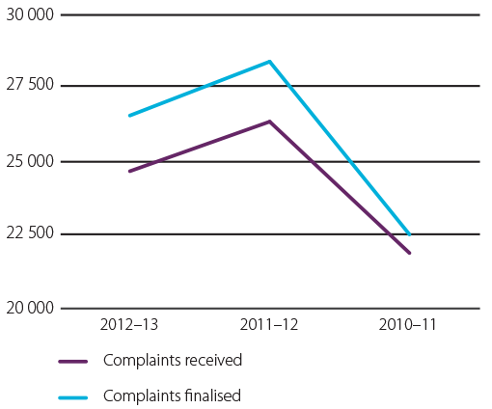

#### Table 12: Payments recovered from complaints and targeted audits

|  |  |  |
| --- | --- | --- |
|  | **2012–13** | **2011–12 2010–11** |
| Number of individuals receiving payments | 17 434 | 18 497 17 360 |
| Total monies recovered | $24 463 693 | $39 809 501 $26 755 817 |

Note: The decrease of monies recovered can be largely attributed   
to two specific matters in 2011–12, which collectively recovered   
$8.2 million for 501 employees.

.

Figure 6: Dispute resolution process for complaints received from workers

**Assisted voluntary   
resolution**

FWO explains the complaint process   
to employees and employers and   
their rights/obligations

Complaint is discussed in neutral setting

They are given opportunity to reach agreed resolution and/or prepared   
for mediation

**Mediation**

Trained FWO mediator conducts mediation by phone

Focus on reaching a mutually acceptable solution

If solution reached the process ends here

**If complaint unresolved**

Fair Work Inspector provides a   
solution based on the evidence

May resort to using enforcement   
tools such as letters of caution,   
compliance notices, infringement   
notices, small claim litigations

**Complaint investigation**

(for serious non-compliance)

#### Registration and assessment

Complaint processes start with an assessment and decision about whether the complaint should be treated by the FWO and, if so, how.

#### Assisted voluntary resolution

Through assisted voluntary resolution (AVR), Fair Work Inspectors work directly with the employee and their employer, to reach a mutually acceptable resolution, without immediately resorting to a formal investigation.

In 2012–13 the role of AVR was enhanced as a forum for client engagement and education, particularly for small to medium-sized businesses.

Employers and employees were each given information about their entitlements and obligations under workplace laws, had aspects of the complaint explained to them and were guided through any matters in dispute. While parties were helped to reach a solution, the FWO did not make determinations about whether a contravention had occurred.

The FWO assisted in the self-resolution of 26 per cent of all complaints through the AVR process in 2012–13.

Most complaints not resolved using AVR in 2012–13 were referred to and resolved via mediation.

## MEDIATION

In 2012–13 the FWO increased its specialist team of workplace relations mediators from 6 to 15. This followed a successful 12-month Mediation Pilot Program during which 80 per cent of attempted mediations were successfully resolved.

Mediation is a voluntary and confidential process, conducted by an accredited FWO mediator usually by phone and can begin promptly after the FWO has received a complaint. Resolution is typically reached in around one-and-a-half to two hours. During the process parties are assisted to resolve the complaint in a non-adversarial manner and to take ownership of solutions.

Overall, 13 per cent of complaints received were resolved through meditation in 2012–13 – a substantial increase on 2011–12 when just 2 per cent of complaints were resolved this way. Of all complaints scheduled to be mediated, 82 per cent were resolved.

Because it is voluntary, most matters are suitable for mediation except those that involve deliberate and systemic non-compliance. These are referred to Fair Work Inspectors for assessment and decision.

Case study

##### Educating parties to reach agreed and appropriate solutions

The FWO received a complaint from an employee in NSW who alleged that they were being underpaid their hourly rate of pay. The assessment team identified the complaint as one that was suitable for assisted voluntary resolution.

During the assisted voluntary resolution process, an inspector helped each party tell their version of events and provide all relevant information.

Once all the relevant information had been gathered, the inspector was able to determine the appropriate industrial instrument and rate of pay. The inspector then gave both parties this information, explaining how the interpretation had been reached.

The employer then realised that they hadn’t understood their obligations correctly and were possibly underpaying all of their employees. The employer felt comfortable enough to bring this to the attention of the inspector, who offered to work with them to identify where they had not met their obligations.

Over several weeks, the inspector worked with the   
employer to resolve the initial complaint, as well as   
rectifying underpayments to other employees – pre- empting any future complaints about underpayments.

With the cooperation of the parties the complaint was resolved, the employer was educated about workplace obligations and the employee felt comfortable continuing to work for the employer – all without the need for a lengthy investigation or the use of the FWO’s statutory powers or enforcement mechanisms.

**With the cooperation of the parties the complaint was resolved, the employer was educated about their workplace obligations and the employee felt comfortable continuing to work for the employer.**



## CONDUCTING AUDITS

By conducting national, state and territory-based campaigns, the FWO focused on employers and industries considered a high compliance risk, especially those employing vulnerable workers. This included the hospitality and hair and beauty industries, known to employ migrants and young people.

In formulating campaigns in 2012–13, the FWO developed a four-year program, running from 2012–16. The strategy is evidence-based, taking into account industry research and analysis, including internal consultation, complaint analysis, Infoline statistics, IBISWorld market research reports, campaign evaluations and media reporting.

This is the FWO’s first long-term targeting strategy and is enabling better forward planning, while remaining flexible and adaptive. The program is reviewed and adapted every six months.

The FWO first engaged with industry associations and unions to incorporate their specific knowledge and to coordinate communication activities to maximise reach and impact.

For example, the FWO developed and published a Pharmacy Industry Handbook in partnership with the Pharmacy Guild of Australia, tailored for employers and managers in the industry. The handbook is available fr[om fairwork.gov.au](http://www.fairwork.gov.au/).

As well as traditional communications methods, the FWO also used innovative ways of reaching targeted sectors, such as webinars, social media and dedicated audits and campaigns [pages on fairwork.gov](http://www.fairwork.gov.au/).au that directed employers to relevant self-help tools and resources.

When contraventions of the law were identified, the FWO worked with employers to achieve voluntary compliance. In 2012–13 national and regional campaigns resulted in 5 675 audits being finalised and more than $3 900 000 recovered for 5 209 employees.

#### Table 13: Employer campaign audits finalised and money recovered for employees through campaigns

|  |  |  |
| --- | --- | --- |
|  | **2012–13** | **2011–12 2010–11** |
| Total audits completed | 5 675 | 6 547 6779 |
| National audits completed | 2 192 | 3 329 2 066 |
| Regional audits completed | 3 483 | 3 218 4 713 |
| Total monies recovered from audits | $3 948 401 | $6 158 875 $4 738 532 |
| Total employees monies  recovered for | 5 209 | 6 574 7 613 |

#### Table 14: Employer campaign audits finalised by state and territory

|  |  |  |
| --- | --- | --- |
|  | 2012–13 | 2011–12 2010–11 |
| New South Wales/ Australian Capital Territory | 1 618 | 1 846 1 892 |
| Northern Territory | 108 | 110 104 |
| Queensland | 1 879 | 1 969 1 934 |
| South Australia | 742 | 676 1 123 |
| Tasmania | 294 | 214 211 |
| Victoria | 639 | 1 211 906 |
| Western Australia | 395 | 521 609 |
| **Total** | **5 675** | **6 547 6 779** |

|  |  |  |
| --- | --- | --- |
|  | 2012–13 | 2011–12 2010–11 |
| New South Wales/ Australian Capital Territory | 1 618 | 1 846 1 892 |
| Northern Territory | 108 | 110 104 |
| Queensland | 1 879 | 1 969 1 934 |
| South Australia | 742 | 676 1 123 |
| Tasmania | 294 | 214 211 |
| Victoria | 639 | 1 211 906 |
| Western Australia | 395 | 521 609 |
| **Total** | **5 675** | **6 547 6 779** |

Case study

##### Maintaining an active awareness to improve compliance

More than $250 000 was repaid to workers in Canberra restaurants following a FWO audit campaign.

Fair Work Inspectors audited 179 restaurants across the capital in an extensive education and compliance campaign and as a result 482 workers received a total of $279 756.

The campaign was sparked by the high number of complaints from staff working in Canberra restaurants and cafés and FWO findings showing a high level of non-compliance with workplace laws.

The FWO especially focused on the restaurant sector as it, along with other sectors of the hospitality industry, attracted the largest number of complaints from employees and typically employs vulnerable workers such as migrants and young people.

In response, the FWO’s campaign focused on identifying underpayments and educating employers about ensuring they meet their obligations to employees.

The campaign was conducted between November 2011 and the end of March 2013.

Of the 179 restaurants and cafes audited, 105 (59 per cent) were found to be breaching workplace laws, while 74 (41 per cent) were compliant.

Of the restaurants breaching workplace laws, 50 (48 per cent) were not paying employees the correct wages,

34 (32 per cent) had technical contraventions of record- keeping or payslips, and 21 (20 per cent) had both wage and technical contraventions.



An investigation into one business is continuing.

A number of errors by employers led to the underpayments, including:

* enterprise agreement rates not increasing over time and falling below the award rate
* casual employees being paid part-time rates
* employees not receiving sick leave or annual leave
* employers paying ‘going rates’ or ‘industry rates’ that were below award rates
* employers paying flat rates for all hours worked, which were insufficient to compensate employees for penalty rates that should have been received
* casual employees working less than the minimum   
  casual engagement of three hours.

Seventy-one restaurants have repaid amounts ranging from just under $30 to more than $26 000 for six workers in one restaurant.

A key focus of these campaigns is to work with employers and steer them to tools and resources that are available for fr[ee on fairwork.gov](http://www.fairwork.gov.au/).au so they can check that they are meeting their obligations.

The second phase of a national compliance campaign in the hospitality sector is underway. It includes audits of cafés, restaurants and catering companies across Australia. ACT restaurants will be included in the campaign to allow the FWO to determine whether compliance levels in the capital have improved.

The ACT Restaurant Industry Audit Program report is a[vailable on fairwork.gov.au](http://www.fairwork.gov.au/).

**A key focus of these campaigns is to work with employers and steer them to tools and resources that are available for free on fairwork.gov.au so they can check that they are meeting their obligations.**

#### Table 15: Money recovered for employees through campaigns by state and territory

|  |  |  |
| --- | --- | --- |
|  | **2012–13**  **$** | **2011–12 2010–11**  **$ $** |
| New South Wales/ Australian Capital Territory | 904 087 | 974 761 751 885 |
| Northern Territory | 145 282 | 96 440 96 522 |
| Queensland | 704 383 | 2 233 379 796 103 |
| South Australia | 589 714 | 416 303 195 850 |
| Tasmania | 128 621 | 202 994 192 046 |
| Victoria | 733 268 | 1 281 277 2 303 699 |
| Western Australia | 743 046 | 953 721 402 427 |
| Total | 3 948 401 | 6 158 875 4 738 532 |

#### National campaigns

The four national campaigns in 2012–13, integrating advice, education and compliance audits, were in structural metal product manufacturing, hospitality, hair and beauty, and the pharmacy sector.

Information on the national campaigns, including campaign reports, is available fr[om www](http://www/)[.fairwork.gov.au](http://www.fairwork.gov.au/).

#### Regional campaigns

Regional campaigns responded to specific state or regional issues. When undertaking audits in regional areas the FWO was generally welcomed and employers were keen to

be given information about their responsibilities. Where contraventions were found, voluntary resolution was the usual outcome.

In 2012–13 the FWO began the following 21 regional education and compliance campaigns and programs:

* NSW/ACT Specialised Food Retailing Regional Campaign
* NSW Furniture, Floor Coverings and other Goods Retailing
* NSW Hunter Region Fuel Retailing Campaign
* NSW Retail Liquor Stores 2012
* NSW/VIC/QLD Live Production Industry Audit Program
* NSW QLD VIC Horse Racing Industry Audit Program
* NSW/QLD/ACT Motor Vehicle Retailing Campaign
* Qld Hardware Retail Audit Program
* Qld Pest Control and Gardening Services Regional Campaign
* SA Land Development & Site Preparation Services
* Audit Program
* SA Specialised Food Retailing Audit Program
* Tas Building Apprentice Campaign
* Tas/Queenstown and Environs Records and Pay Slips Campaign
* Vic Clerical Workers in the Sex Industry
* Vic/Melbourne CBD Retail Records and Pay Slips Audit Program
* Vic/Tas/Murray Lands Campaign
* Vic/Tas Rolling Records and Random Audits
* WA/SA/NT Record keeping and pay slip compliance follow-up audit program
* WA/SA/NT Residential Building Industry Apprentices and Trainees Campaign
* WA Video Games Rental Store Audit Program
* WA/SA/NT Fuel Retailing Campaign.

## CARRYING OUT INVESTIGATIONS

A large proportion of complaints received are resolved at   
one of the pre-investigation stages. For those that are not   
or where a matter is assessed as particularly significant,   
the complaint may proceed to investigation.

Investigating complaints was an important component   
of the FWO’s work in 2012–13 as part of its ongoing commitment to achieving fair Australian workplaces.   
The agency dedicated resources to strategic enforcement activities where there were alleged instances of serious   
non-compliance with Australian workplace laws.

The FWO has also established four national subject-based compliance teams that aim to address allegations of serious non-compliance, recognising that specialisation can be more efficient and effective in assisting vulnerable workers. The four teams are:

* overseas workers (supporting migration policies)
* young workers, including apprentices and trainees (supporting a skilled workforce)
* general protection (enhancing social inclusion and productivity)
* misclassification (supporting revenue protection measures).

By specialising in these subject-based teams, Fair Work Inspectors are trained to observe industry patterns, locate specific issues and engage with the community to enhance strategic compliance efforts.

Case study

Committed to actively serving regional communities

In 2012–13 the FWO operated from 16 regional offices. Several additional regional offices were maintained through partnership arrangements with state government agencies but have since closed.

The location of regional offices is based on several factors. Population is the most important, but so is the presence of existing and emerging growth industries, and industries most likely to need intervention.

The FWO’s commitment to ensuring expertise and advice is accessible to regional Australia means that 98 per cent of the Australian working age population is within 300 kilometres of an office.

About three-quarters of the people who visited the FWO in 2012–13 went to regional offices.

Opportunities to establish strong local networks with business, educational institutions and other support services are important to the FWO. Teams regularly visit regional centres to conduct site visits and meet with employers and employees, including participating in events such as university orientation weeks.

In February 2013, a team of Fair Work Inspectors from the Toowoomba office visited businesses in the main street of Laidley, a small rural town 30 minutes east of Toowoomba. Each of the businesses had been inundated with water during the Australia Day floods.

The inspectors discussed and distributed information on workplace entitlements during natural disasters. They also offered bottled water and cake to lift spirits. The people of Laidley welcomed the visits, showing gratitude for the inspectors’ time and assistance.

Two months later the Toowoomba team attended a Jobs and Skills Expo in Bundaberg, a town also affected by the Australia Day floods. The 1 500 or so local community members in attendance were invited to speak with the inspectors and find out about rights and entitlements at work, and how the FWO could help them.

FWO’s Toowoomba team epitomises the agency’s commitment to creating fair and productive workplaces across Australia. Developing strong ties with the local community provides opportunities for securing compliance before issues arise.

**Opportunities to establish strong local networks with business, educational institutions and other support services are important to the FWO.**

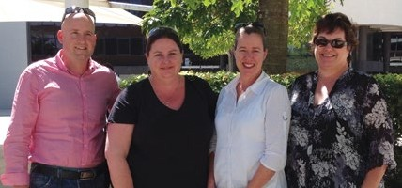

From left to right: Regional office-based Fair Work Inspectors Steven Williams, Melissa King, Kim O’Connell and Jenny Crook

#### Exceeding complaint handling expectations

The FWO increased the number of wage and conditions complaints resolved in less than 90 days from 68 per cent in 2011–12 to 84 per cent in 2012–13.

#### Table 16: Complaints finalised within 90 days by month (KPI = 80%)

|  |  |  |  |  |  |  |  |  |  |  |  |  |
| --- | --- | --- | --- | --- | --- | --- | --- | --- | --- | --- | --- | --- |
|  | **Jul** | **Aug** | **Sep** | **Oct** | **Nov** | **Dec** | **Jan** | **Feb** | **Mar** | **Apr** | **May** | **Jun** |
| 2012–13 | 78% | 82% | 83% | 81% | 80% | 79% | 86% | 89% | 85% | 86% | 88% | 88% |
| 2011–12 | 61% | 57% | 59% | 60% | 62% | 66% | 73% | 72% | 73% | 73% | 74% | 73% |

This increase in the agency’s performance can be attributed to:

* the greater use of alternative and less formal dispute resolution services, which have enabled complaints to be resolved more quickly
* evaluating claims and evidence about individual complaints as soon as they are received, identifying the appropriate path to resolve each case
* establishing specialist subject-based national compliance teams to address allegations of serious non-compliance (see page 30)
* using a wider range of enforcement tools such as letters of caution, compliance notices, infringements notices and small claims litigations (for more information on small claims see page 38)
* investing in operational staff capability and training to increase technical knowledge and experience enabling   
  Fair Work Inspectors to assess and investigate complaints more effectively.

The FWO is optimistic that the investigation key performance indicator will remain high throughout 2013–14 as a result of these measures.

## RESPONDING TO WORKPLACE DISCRIMINATION

Together with the agency’s educational activities, the FWO’s compliance measures encourage workplaces to adhere to workplace discrimination laws and aim to protect vulnerable groups from exploitation in the workplace.

In 2012–13 the FWO initiated three discrimination litigations and entered into three enforceable undertakings. The FWO received 235 complaints relating to workplace discrimination in 2012–13, with 14 per cent falling outside the agency’s jurisdiction.

Of the 235 complaints received and assessed, 76 cases were referred to the specialist general protection area for further investigation. General protections also address matters relating to industrial action, freedom of association, right of entry and duress.

The most common discrimination complaints investigated in 2012–13 involved pregnancy (28 per cent), physical or mental disability (21 per cent) and family/carer responsibilities (11 per cent). This compares with disability (25 per cent), pregnancy (21 per cent) and race (13 per cent) in 2011–12.

The FWO is empowered to investigate discrimination as   
defined under the Fair Work Act, and only where state and   
federal laws do not exclude the operation of the Fair Work Act.

As a result, many complaints received were outside the FWO’s jurisdiction.

**Table 17: Discrimination complaints and outcomes**

**2012–13 2011–12 2010–11**

|  |  |  |
| --- | --- | --- |
| Complaints received | 2351 | 1 040 1 171 |
| Calls taken by Infoline | 1 179 | 1 746 2 709 |
| Outside the FWO’s jurisdiction | 14% | 28% 43% |
| Matters proceeding to investigation | 76 | 182 294 |
| Discrimination matters filed in court | 3 | 2 2 |
| Executed enforceable undertakings | 3 | 3 1 |

1 Fewer discrimination complaints were referred for investigation   
because from 1 July 2012 only those complaints assessed as within   
the scope of the Fair Work Act were recorded as discrimination   
complaints. Previously all complaints alleging discrimination were   
registered as discrimination complaints and forwarded for assessment.

## ACHIEVING OUTCOMES THROUGH ENFORCEABLE UNDERTAKINGS

Enforceable undertakings were an important voluntary   
enforcement mechanism in 2012–13.

The FWO bolstered its use of enforceable undertakings,   
with 12 employers acknowledging they had contravened   
workplace laws and providing the agency with a written   
commitment to undertake certain actions. Commitments   
included rectifying non-compliance, apologising to affected workplace participants and revamping workplace policies and procedures.

The 12 enforceable undertakings finalised in 2012–13   
provided more than $6.7 million in back-pay to employees. Summaries and copies of the enforceable undertakings   
are available fr[om fairwork.gov.au](http://www.fairwork.gov.au/).

Case study

Protecting the vulnerable from pregnancy discrimination

After informing her boss she was pregnant, a Melbourne retail assistant in her early 20s had her work hours significantly reduced and was told to accept this or resign.

The assistant’s work hours were reduced from up to 27 hours per week to just seven. She subsequently resigned in what the FWO considered to be ‘constructive dismissal’ of the employee under workplace discrimination laws.

Constructive dismissal occurs when employees resign because their employer’s behaviour has become so intolerable or has made life so difficult that the employee has no other choice. Since the resignation was not truly voluntary, it is effectively a termination.

Owner-operator of Shawna Pty Ltd, Hui Zhou, admitted to the breaches after workplace laws were explained. Zhou, a Chinese immigrant, agreed to corrective actions in an enforceable undertaking with the FWO.

Copies of the enforceable undertaking have been made available in both English and Mandar[in on fairwork.gov](http://www.fairwork.gov.au/).au – the first time this has occurred.



Zhou also placed an advertisement detailing the breaches in *The Daily Chinese Herald* newspaper, as part of the enforceable undertaking’s terms. The ad is intended to raise awareness of pregnancy discrimination laws among the Chinese community in Australia.

Under the Fair Work Act, it is unlawful to discriminate against employees on a range of grounds, including pregnancy, race, colour, sex, sexual preference, age, physical or mental disability, marital status and family or carer responsibilities.

Discriminatory behaviour can include dismissing or threatening to dismiss an employee, reducing an employee’s hours, or denying training and promotion opportunities.

The enforceable undertaking required Shawna Pty Ltd to apologise to the employee and compensate her, paying her $2 000 for economic and non-economic loss suffered. The company also had to develop processes to ensure

it complied with workplace laws in the future, provide annual professional workplace relations training for Shawna directors, and prominently display a public notice detailing its breaches of workplace laws at the business premises.

**Discriminatory behaviour can include dismissing or threatening to dismiss an employee, reducing an employee’s hours, or denying training and promotion opportunities.**

## FAIR WORKPLACES A JOB FOR ALL: PRO-ACTIVE COMPLIANCE DEEDS

The FWO continued to urge large and medium-sized enterprises to follow the lead set by McDonald’s in 2011–12 and take proactive steps to ensure their workforce is receiving their workplace rights and entitlements.

Working closely with organisations to identify and improve policies and practices means that the impact of the FWO’s work will continue to directly benefit future employees of these companies, and allows the companies to publicly show corporate responsibility.

Pro-active Compliance Deeds are a way businesses can work with the agency in a positive and constructive way. Entering into a deed can also benefit businesses by helping them to:

* make sure they are meeting the requirements of the Fair Work Act
* identify and minimise employment related business risks
* demonstrate they are a fair Australian workplace and an employer of choice
* address potential areas of non-compliance with the Fair Work Act.

Deeds are tailored to the needs of individual businesses and can involve:

* self-auditing of wages and record keeping
* initiatives to engage with employees to improve compliance
* looking at supply chain and franchise relationships.

All businesses that enter a deed are assigned a dedicated Fair Work Officer. The officer provides support and assistance to the business and helps it meet the outcomes of the deed. Once a deed is finalised a report is made publicly available [at fairwork.gov.au](http://www.fairwork.gov.au/).

#### Asset Industries Australia Limited

In 2012–13 major cleaning company Asset Industries Australia became the first enterprise to enter into a Pro-active Compliance Deed that focuses on ensuring compliance with workplace laws through the procurement chain.

Under the three-year Deed of Pro-active Compliance, Asset Industries Australia agreed to self-audit its own staff as well as cleaners employed through its subcontractors across Australia to ensure it complies with workplace laws.

The company has agreed to correct any underpayments identified within 30 days and establish mechanisms for its own staff and those employed by contractors to raise concerns about their workplace entitlements. It will report the outcomes of the audits to the FWO annually.

#### McDonald’s Australia Limited

McDonald’s Australia completed the first self-audit and the FWO is confident other major employers will follow its lead.

McDonald’s self-audited the pay packets of 8 500 of its 85 000-strong national workforce for pay periods in 2009 and 2010. Conducted across McDonald’s regional and metropolitan restaurants, the audits found 100 per cent compliance for wages paid in 2009 and 97 per cent compliance for wages in 2010. The report on the outcomes of the McDonald’s deed is a[vailable on fairwork.gov.au](http://www.fairwork.gov.au/).

The overall standard of the company’s record keeping was   
high. Under the deed, McDonald’s accepted responsibility for developing systems and processes to maintain ongoing compliance with Commonwealth workplace laws.

# DELIVERABLE 3: LITIGATING, WHERE NECESSARY, TO ENFORCE COMPLIANCE WITH WORKPLACE LAWS

## SNAPSHOT OF ACTIVITIES IN 2012–13

* Addressed serious, wilful and repeated non-compliance with the start of 50 litigations.
* Achieved court ordered penalties totalling $1 654 570 in the 45 litigation cases decided.

The FWO reserves the use of civil penalty litigation to address the most serious and repeated contraventions. In most instances, the FWO prefers to use voluntary compliance measures to address non-compliance with Australian workplace laws.

The FWO’s litigation policy (Guidance Note 1 – Litigation Policy), a[vailable at fairwork.gov.au](http://www.fairwork.gov.au/), guides decisions on commencing litigations, including a public interest test.

Other factors considered in litigation decisions include:

* the need to deter others from similar contraventions
* the involvement of vulnerable workplace participants, such as foreign or young workers
* whether workplace participants suffered significant consequences as a result of the contravention
* whether there was a need for judicial clarification of workplace laws.

The FWO’s litigation activities are transparent, accountable, constructive and effective and are not made capriciously. The FWO is a model litigant with civil penalty litigation only pursued when necessary in accordance with the agency’s mandate of ensuring compliance with Australian workplace laws.

As well as protecting the rights of Australian workers, the FWO is also aware of the wider ramifications of creating a level playing field for Australian businesses with successful litigations helping to negate the unfair advantage employers may gain by underpaying employees.

In 2012–13 the FWO generally began litigation as a result of alleged offenders refusing to rectify non-compliance issues voluntarily, or when serious or repeated contraventions were involved.

In 2012–13 the FWO initiated 50 litigations – 45 were decided in court, resulting in court-ordered penalties totaling $1 654 570. A schedule of total penalties imposed is in Table 18.

#### Table 18: Civil penalty litigations

|  |  |  |
| --- | --- | --- |
|  | **2012–13** | **2011–12 2010–11 2009–10 Total** |
| Civil penalty litigations commenced | 50 | 51 55 53 209 |
| Decisions | 45 | 37 39 57 178 |
| Penalties | $1 654 570 | $1 536 143 $2 165 965 $2 019 756 $7 376 434 |

#### Table 19: Enforceable undertakings

|  |  |  |
| --- | --- | --- |
|  | **2012–13** | **2011–12 2010–11 2009–10 Total** |
| Enforceable undertakings entered into | 12 | 8 11 4 35 |
| Underpayments recovered | $671 358 | $1 434 224 $2 243 540 $330 701 $4 679 823 |

#### Table 20: Types of breaches where civil penalty litigation was launched and enforceable undertakings accepted

|  |  |  |
| --- | --- | --- |
|  | **2012–13** | **2011–12** |
| Types of breaches | Litigation commenced Enforceable undertakings  accepted | Litigation commenced Enforceable undertakings  accepted |
| Adverse action | 2 2 | 5 0 |
| Discrimination | 3 3 | 0 3 |
| Failure to pay fairness test compensation and failure to make and keep pay records | 0 0 | 0 1 |
| General protections | 0 0 | 2 0 |
| Sham contracting | 1 0 | 4 0 |
| Wages and conditions | 40 7 | 40 4 |
| Failure to comply with a compliance notice | 4 0 | 0 0 |
| Total | 50 12 | 51 8 |

As in previous years, most cases were litigation matters relating to the underpayment of wages and entitlements, representing 80 per cent of all proceedings begun. A list of the types of breaches litigated is provided in Table 20.

In 2012–13 the FWO also initiated proceedings in   
other types of matters and on occasion with the purpose   
of seeking clarity on the operation of less established   
areas of workplace law, including those relating to   
adverse action, discrimination, sham contracting and  
procurement chain liability.

A number of significant litigations were decided in   
2012–13. Further information on these is a[vailable on fairwork.gov.au](http://www.fairwork.gov.au/).

Case studies Significant penalty for sham contracting

A NSW fruit and vegetable shop prosecuted by the FWO was fined $166 848 for engaging in sham contracting and underpaying its shop assistants between 2006 and 2010.

EA Fuller & Sons Pty Ltd, which operates the fruit and vegetable shop in Bellingen, admitted to underpaying five casual employees a total of $82 475.

The casual employees were paid flat hourly rates, leading to the underpayment of their casual loadings and penalty rates for weekend, overtime and public holiday work.

The Federal Circuit Court sitting in Sydney also found the company knowingly misclassified two employees as independent contractors. One was underpaid $60 827 over the three-and-a-half years she worked at the store.

This is known as sham contracting, when employers deliberately or recklessly deny employees their rightful wages and entitlements by classifying them as ‘contractors’ rather than employees. It is a serious offence.

The other underpaid employees were females aged between 18 and 20 at the time, including a Korean national who spoke little English. She was paid just $6 an hour and underpaid $13 928 over six months.

Judge Rolf Driver said Eric Fuller, the company director and part-owner, and the company itself had been careless and disregarded their obligations. The company was fined $139 040, while the employer was fined a further $27 808.

Fair Work Inspectors first discovered the underpayments and record-keeping breaches when they investigated employee complaints. Mr Fuller subsequently rectified the underpayments.

‘There is a need to send a message to the community, and particularly employers, that employers must provide their employees with the correct entitlements and steps should be taken to understand and comply with those entitlements,’ Judge Driver said.

‘The court regards the sham contracting contraventions as particularly serious and recognises the damage that sham contracting can have to the Australian economy and other employers generally.’

Protecting young workers

The FWO took action against Revolution Martial Arts Pty Ltd after discovering 17 staff at the fitness centre were underpaid a total of $67 320 between July 2009 and April 2012.

More than $64 000 of the underpayments related to 12 trainees, aged between 15 and 21, who were only paid between 73 cents and $2.74 an hour.

The company deducted club membership and administration fees from the trainees’ wages without authorisation, resulting in the low hourly rate. The trainees, who were completing Certificates in Sports or Fitness, were entitled to be paid between $8 and $16 an hour. A teenage male trainee suffered the largest individual underpayment of $12 349.

Some of the Revolution Martial Arts employees also didn’t receive their annual leave entitlements, and workplace laws relating to employment records were also breached.

The former operator of the fitness centre, David Auty, and his company, didn’t rectify the underpayments until after the FWO initiated legal proceedings.

As a result of the FWO’s litigation in the Melbourne Federal Magistrates Court, Auty was fined $7 656. His company was fined a further $38 280.

Auty had already been investigated in 2006 and had been advised about minimum entitlements and restrictions on making deductions from employees’ wages by the Office of Workplace Services, a predecessor agency of the FWO.

Judge Turner agreed that Auty was aware of his obligations, including as a result of the 2006 investigation.

‘The breaches are serious, the employees were young and vulnerable,’ Ms Turner said.

The FWO is committed to standing up for young workers and taking action where necessary. This group can be especially vulnerable because they are often not fully aware of their workplace rights and can be reluctant to complain.

**‘There is a need to send a message to the community, and particularly employers, that employers must provide their employees with the correct entitlements and steps should be taken to understand and comply with those entitlements.’**

#### Progressing small claims matters more efficiently

The FWO works closely with the courts to help private citizens seek court orders for contraventions of the Fair Work Act.

The small claims procedure is contained in section 548 of the Fair Work Act and can be used for amounts of up to $20 000. The procedure cannot be used if an applicant is seeking a pecuniary penalty order against the respondent.

Matters involving the small claims procedure are run in an informal manner, as the court is not bound by any rules of evidence or procedure. Legal representation is generally not allowed in a small claims procedure unless the court agrees.

A Fair Work Inspector or lawyer from the FWO may seek leave

to appear as a ‘Friend of the Court’. In this capacity they   
do not act for either party, but instead can assist the court on points of law or raise awareness of important aspects of the case.

A typical complaint dealt with under the small claims procedure might involve a dispute about one or more of the following elements:

* annual leave
* payment in lieu of notice
* wages or allowances.

During 2012–13, 50 small claims applications were heard before the Federal Magistrates Court. A total of $179 298   
was ordered in favour of applicants.

#### Table 21: Small claims heard and amounts awarded

|  |  |  |
| --- | --- | --- |
|  | **2012–13** | **2011–12 2010–11** |
| State | Small claims Total amount heard awarded | Small claims Total amount Small claims Total amount heard awarded heard awarded |
| Victoria | 10 $6 173 | 46 $109 966 36 $86 174 |
| Australian Capital  Territory | 1 $998 | 4 $3 363 0 0 |
| Queensland | 11 $20 829 | 12 $25 393 0 0 |
| New South Wales | 24 $129 711 | 21 $90 563 2 Settled at mediation |
| Western Australia | 4 $21 587 | 9 $37 661 0 0 |
| **TOTAL** | **50**  **$179 298** | **92**  **$266 946**  **38**  **$86 174** |

Management & accountability

**SECTION 4**



**co**

# CORPORATE GOVERNANCE

Corporate governance covers the rules, relationships, systems and processes by which the FWO applies the resources entrusted to it.

The corporate governance practices of the FWO ensure the agency maintains high standards of accountability and well- defined performance management.

The Executive Committee oversees these practices with support from the following management committees:

* Audit Committee
* Contracts Committee
* Diversity Council
* Health and Safety Committee
* IT Projects and Capital Expenditure Sub-committee
* Recruitment Committee.

## EXECUTIVE COMMITTEE

The FWO’s Executive Committee provides corporate leadership and strategic direction for the agency, as well as overseeing financial management and business performance.

Under its charter, the Executive Committee is responsible for leadership of the organisation, including:

* modelling best practice decision making, to encourage an agency culture that values consultation, participation and transparency
* developing and overseeing the implementation of the agency’s strategic plan
* establishing and monitoring agency systems of fraud control and accountability
* ensuring the agency complies with relevant legislation
* reviewing the agency’s performance against agreed key performance indicators
* identifying and managing strategic risk
* consulting on matters of strategic significance to the agency.

**Executive Committee members**

As at 15 July 2013

As at 30 June 2013*

*Natalie James*

Fair Work Ombudsman





*Michael Campbell*Group Manager, Operations

* Acting Fair Work Ombudsman



*Alfred Bongi* Group Manager, Knowledge Services



*Bill Loizides*Group Manager, Education, Communications and Partnership

## AUDIT COMMITTEE

The FWO and Fair Work Building and Construction operate a joint Audit Committee.

The Audit Committee provides independent assurance, advice and assistance to the FWO on:

* risk management procedures
* risk and control frameworks
* external accountability, including financial statements
* legislative compliance
* internal and external auditing processes.

The FWO complies with the Australian Government’s *Commonwealth Fraud Control Guidelines 2011* in relation to fraud assessment, prevention, reporting, detection, investigation, litigation, data collection and other associated issues.

The FWO has taken all reasonable measures to minimise the risk of fraud and to investigate and recover the proceeds of fraud against the agency.

## CONTRACTS COMMITTEE

The Contracts Committee ensures that the procedures followed for procuring major supplies and services, and for managing significant contracts are consistent with the Commonwealth Procurement Rules.

## DIVERSITY COUNCIL

The FWO’s Diversity Council was established in 2012–13 to advise on diversity matters and make recommendations to the agency’s Executive Committee on encouraging diversity in the workforce.

More information about workplace relations diversity initiatives is on page 46. See Appendix A on page 116 for statistics on the FWO’s culturally and linguistically diverse staff.

## HEALTH AND SAFETY COMMITTEE

The FWO and Fair Work Building and Construction operate a joint Health and Safety Committee.

The Health and Safety Committee reports to the Executive Committee on policy matters concerning the work health and safety of agency employees as set out under the *Health and Safety Arrangements 2012–15*.

See Appendix B on page 117 for more information about the FWO’s work health and safety outcomes.

## IT PROJECTS AND CAPITAL EXPENDITURE SUB-COMMITTEE

The IT Projects and Capital Expenditure Sub-Committee provides high level strategic governance of major IT and capital expenditure projects, and reports to the Executive Committee.

*Mark Scully* Group Manager, Finance and Corporate

**

*Steve Ronson*

* Acting Group

Manager, Operations



*Janine Webster*

Chief Counsel



*Tom O’Shea* Executive Director, Policy and Media



*Giorgina Strangio* Executive Director, Human Resources

## RECRUITMENT COMMITTEE

The Recruitment Committee, established in 2011–12, ceased operation in March 2013. The FWO continues to manage staffing numbers, labour-related expenditure and recruitment procedures with oversight and approval by relevant senior executives.

# EXTERNAL SCRUTINY

## JUDICIAL DECISIONS OR ADMINISTRATIVE REVIEWS

There were no judicial decisions or administrative reviews or findings that affected the FWO’s operations in 2012–13.

## COMMONWEALTH OMBUDSMAN REVIEWS

During 2012–13 the number of Commonwealth Ombudsman reviews of investigations by the FWO, decreased by 37 per cent.

No adverse findings were made in the five formal reviews conducted. For more information see Table 22.

#### Table 22: Commonwealth Ombudsman reviews

|  |  |  |
| --- | --- | --- |
|  | **2012–13** | **2011–12 2010–11** |
| Commonwealth Ombudsman investigations | 5 | 13 17 |
| Number relating to the FWO | 5 | 12 17 |
| Adverse findings | 0 | 0 1 |

## FREEDOM OF INFORMATION

The FWO received 101 freedom of information (FOI) access requests in 2012–13 and finalised 102 requests. There were six outstanding requests at 30 June 2013.

The FWO created a dedicated FOI team in 2012–13. The team uses proactive education measures, including delivering training to increase knowledge of FWO staff about the agency’s FOI responsibilities and promote the use of FWO’s Guidance Note 2 – Document Access Policy, available from [fairwork.gov.au](http://www.fairwork.gov.au/).

See Appendix C on page 118 for more information about FOI and the FWO’s Information Publication Scheme.

## DECISIONS BY THE AUSTRALIAN INFORMATION COMMISSIONER

Following a request for review under section 54M of the *Freedom of Information Act 1982* in April 2012, the OAIC undertook a full merits review of a decision by the FWO to release documents relating to a FWO investigation. In May

2013 Freedom of Information Commissioner, Dr James Popple, affirmed the FWO’s decision.

## AGENCY CAPABILITY REVIEWS

No capability review of the FWO was undertaken in 2012–13.

## QUALITY ASSURANCE

As part of its internal Quality Assurance (QA) Program, in 2012–13 FWO commenced five QA initiatives involving a structured system of assessing and measuring FWO’s customer facing performance.

## REVIEWS OF FWO INVESTIGATIONS

The FWO ensures that parties to an investigation receive information on their right to a review if they have a complaint about the process or outcome.

#### Table 23: Review received and reviews finalised 2012–13

**Received Finalised**

Infoline, Dispute Resolution and

Compliance Work Group reviews

319 309

The FWO received 319 requests for a review of an investigation in 2012–13 and finalised 309 reviews. These requests make up around one per cent of the 26 574 complaints the FWO finalised for the year.

# MANAGEMENT OF HUMAN RESOURCES

The FWO prides itself on striving to be a model Australian workplace committed to developing a flexible and high performing workforce.

The agency remained committed to supporting diversity, offering flexible work arrangements and facilitating open communication and consultation. These practices fostered respect in the workplace and strengthened the agency’s organisational culture.

Building a harmonious, cooperative and productive workforce allowed the FWO to work effectively and cohesively to deliver the agency’s core functions to advise, assist and, where necessary, enforce within the workplace community.

In 2012–13 the FWO:

* established an Employee Engagement Framework and action plan and developed and implemented a range of initiatives to foster a positive workplace culture
* established a Mental Health Working Group to generate ideas for initiatives and tools to support good mental fitness at work
* won an Australian Human Resources Institute (AHRI) award for being ‘inclusive workplace of the year’ and was a finalist in the CEO Diversity Champion award (see page 47)
* won the Queensland Defence Reserves Employer award and pledged support for reservists by signing an MOU with the Department of Defence (see page 44)
* implemented a range of support mechanisms for employees who are victims of domestic or family violence, and worked towards being accredited by White Ribbon for taking active and effective steps to promote a safe workplace for women
* entered into an MOU with Fair Work Building and Construction to provide payroll, financial processing and health case management services
* using an in-house team of trainers, developed and delivered 49 training courses to FWO employees, equating to 11 704 hours of training.

## RECRUITMENT

In 2012–13 the FWO undertook 38 external recruitment processes (excluding graduate recruitment) resulting in a total of 73 employment offers. This is a 15 per cent increase in employment offers compared to the 62 offers made in 2011–12.

The FWO attracted a high volume of applications from candidates, with an average of 56 applicants per external job advertisement.

The FWO remained committed to supporting flexible work practices. With the exception of the Graduate Program, all other vacancies were advertised as full-time or part-time in 2012–13. The percentage of part-time employees increased to 20 per cent, up from 18 per cent in 2011–12. See Appendix A on page 114 for more staffing information.

Case study

FWO pledges support for

Defence Reservists

In October 2012 the FWO received an award from the Defence Reserve Support Council (Qld) for its support for Defence Reservists.

The FWO has been actively engaged with the council to ensure that reservists and employers are aware of their rights and obligations for reserve service with the Australian Defence Force. The agency developed a fact sheet available fr[om fairwork.gov](http://www.fairwork.gov.au/).au to help parties concerned.

The FWO has also formalised its own commitment to Australia’s Defence Reservists by signing a memorandum of understanding MOU with the Defence Force.

Former Fair Work Ombudsman, Nicholas Wilson, signed the memorandum – which serves as a formal agreement between the two agencies – at a ceremony in March 2013.

‘Reservists make a valuable contribution to the community by playing a supportive security role at major Australian events and providing assistance during natural disasters such as floods, cyclones and emergency rescue operations,’ Mr Wilson said.

‘This agreement recognises the significant security and emergency-relief role reservists play and what employers can do to help them. By signing this MOU, I hope to encourage other employers to consider reservists when they are hiring and to actively support them through their workplace policies and practices.

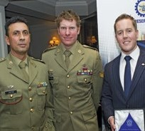

‘Reservists make a valuable contribution to workplaces and often bring additional skills and maturity with them as a result of their diverse experiences and I am very pleased to have several working in my agency.’

Head Cadet, Reserve and Employer Support Division within the Department of Defence, Major General Paul Brereton, signed the MOU on behalf of Defence.

‘I believe that the Fair Work Ombudsman’s actions will assist Defence in its efforts to build stronger and more effective relationships with industry,’ Major General Brereton said.

More than 700 employers across the country have pledged their support for the Australian Defence Force Reserves by entering into similar agreements.

**‘I believe that the Fair Work Ombudsman’s actions will assist Defence in its efforts to build stronger and more effective relationships with industry.’**  
Major General Brereton  
From left to right: Lieutenant Colonel Russell Jacob CSC (and FWO Employee), Corporal Daniel Keighran VC and Michael Campbell

.

### Case studies

##### From trainee to ongoing position in a FWO first

In late 2011 the FWO created a dedicated traineeship position for a person with a disability. The position was initially offered as a non-ongoing traineeship in the Workplace Complaints Registration and National Assisted Voluntary Resolution team.

The National Disability Recruitment Coordinator provided valuable assistance in establishing the traineeship by liaising with Disability Employment Service (DES) providers to source a suitable field of applicants and providing expertise and advice during the selection process.

The candidates were also supported during the recruitment process by their DES providers. Nathaniel Cervelli was the successful candidate, and in February 2012 he accepted the offer of a 12-month non-ongoing traineeship during which time he would undertake a workplace-based Certificate III in Business.

Nathaniel’s long-term DES case manager provided tailored disability awareness training to his team. Nathaniel was highly regarded by his colleagues and peers and successfully completed the Certificate III.

As a result the FWO became the first APS agency to offer an ongoing position by using the *Public Service Commissioner’s Directions 1999* on employing a person with a disability who, while having a capacity for the role, would find it difficult to compete in a merit selection process (under clause 4.3b).

In late 2012 Nathaniel accepted an offer of ongoing employment at the FWO and continues to make a significant contribution to the outcomes of the agency.

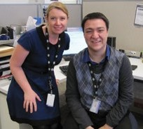

### Graduates win outstanding achievement awards

The 2012 graduate group joined FWO at the end of January and completed five-month rotations in two branches. During the year they attended training facilitated by the Australian Public Service Commission (APSC) in Canberra, submitted assignments and completed a major project in teams of four,   
to receive their Diploma in Government.

The major project involved submitting a 15-page report and a 90-second video detailing strategies they recommended:

* for engagement with young Aboriginal and Torres Strait Islander workers
* to raise awareness of the FWO among employees with disability.

In a first for a single APS department or agency, FWO graduates were awarded both the Major Project Video Presentation Award and the Major Project Outstanding Achievement Award for their project titled ‘Investigating strategies for engagement with young Aboriginal and Torres Strait Islander workers’.

In addition, the Diversity Council agreed to sponsor the recommendations from both projects.

**In late 2011 the FWO created a dedicated traineeship position for a person with a disability.**From left to right: Tina Donohue and Nathaniel Cervelli

.

#### Workplace diversity

The FWO values diversity, recognising the contribution employees with diverse backgrounds and experiences make to enhancing the agency’s organisational culture.

The FWO has made considerable progress in workplace diversity and inclusion, specifically in its employment and participation rates and in its commitment to a flexible workplace. Major achievements include:

* implementing an annual Reconciliation Action Plan
* creating various diversity and inclusion-related staff networks and forums
* continuing to participate in the APSC Indigenous Pathways Programs
* implementing the FWO’s first Diversity Action Plan
* developing a FWO Indigenous Employment Strategy and associated action plan
* being one of the first agencies to enact special measure provisions within the Public Service Commissioner’s Directions 1999 to engage a trainee with a disability in an ongoing position
* being one of the first APS agencies to participate in the AFL Sports Ready Indigenous school-based trainee program, which provides a young Indigenous person with access to a traineeship, mentoring and career advice, and practical work experience to help ease the transition into the workforce
* achieving gender parity at senior executive ranks in December 2012. Between July 2009 and June 2012 the number of women in senior executive positions steadily increased. In 2009, 23 per cent of senior executive staff were female – by 30 June 2013 this had increased to 57 per cent.

|  |  |  |
| --- | --- | --- |
| Table 24: Executive and senior executive staff by gender as at 30 June 2013 | | |
|  | **2012–13** | **2011–12 2010–11** |
|  | **Female Male** | **Female Male Female Male** |
| SES Band 2 | 1 4 | 2 3 0 2 |
| SES Band 1 | 5 4 | 5 4 4 7 |
| EL2 | 17 25 | 15 25 14 28 |
| EL1 | 61 31 | 58 38 60 39 |
| Total | 84 64 | 80 70 78 76 |

In 2012–13 two Indigenous Australians were engaged as part of the Indigenous Traineeship Program. The number of staff who identify as being from a culturally or linguistically diverse background also increased from 163 to 210.

The FWO recognised that multilingual staff are an effective means of delivering accessible information to people from culturally and linguistically diverse backgrounds. To capitalise on this expertise, the FWO maintained a register of multilingual staff willing to assist with language and interpreting services.

#### Table 25: Workplace diversity 2010–13 as at 30 June 2013

|  |  |  |
| --- | --- | --- |
|  | **2012–13** | **2011–12 2010–11** |
| Female | 509 | 514 586 |
| People from culturally and linguistically diverse backgrounds | 210 | 163 152 |
| People from Aboriginal and Torres Strait Islander backgrounds | 8 | 7 2 |
| People with disabilities | 23 | 27 24 |
| Total staff | 809 | 827 952 |

Case study

Award for inclusive workplace of the year

The FWO’s commitment to supporting diversity was formally recognised in June 2013, when the agency received the Australian Human Resources Institute (AHRI) Inclusive Workplace of the Year award.

The AHRI Diversity Awards recognise individuals and organisations that demonstrate excellence in their contributions to workplace diversity and inclusion. The FWO was one of six finalists in the Inclusive Workplace of the Year category and, due to the calibre of the nominees, the judging panel selected two winners – the FWO and IBM Australia. Nicholas Wilson, previously the Fair Work Ombudsman, was one of four finalists in the ‘Diversity Champion (CEO)’ category.

The Inclusive Workplace of the Year category was judged on eight criteria:

* human rights
* health and wellbeing
* innovation
* leadership
* culture
* impact and outcomes
* sustainability
* measurement.

The judging panel noted, ‘The FWO submitted a comprehensive application which, supported by evidence, exceeded all eight criteria. Of particular note was the breadth of the diversity strategy and policies delivered through a variety of practical applications, which were all supported by strong measurement practices showing positive impact and outcomes for the organisation.’

The FWO was delighted to receive this award, and is justifiably proud of its achievements in developing and maintaining a workplace culture in which the diverse backgrounds, skills, talents and views of all employees are valued and encouraged.

A workforce that reflects the diversity of the community it serves is also better equipped to educate and work with a diverse range of clients.

**A workforce that reflects the diversity of the community it serves is also better equipped to educate and work with a diverse range of clients.**

From left to right: Mark Scully, Giorgina Strangio, Michael Campbell, Sandra Mackay, Su Kearns, Gary Absolom, Ellen Georges and Alfred Bongi.

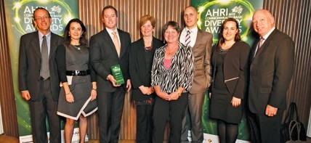

## STAFF DEVELOPMENT

The FWO promotes a culture of continuous learning and improvement. In 2012–13 capability development focused on enhancing technical skills via accredited, online and face-to-face delivery of technical training and IT system skills development within the Infoline, with the introduction of the new telephony system. Other areas of focus included presentation, project management and resilience skills.

Highlights of training completed in 2012–13 include:

* 47 staff were awarded nationally accredited qualifications based on recognition of prior learning in Certificate
* IV in Government ( Workplace Relations), Certificate IV in Government (Investigation) and Certificate IV in Government (Project management)
* 143 staff were trained in 19 enabling skill programs on topics such as practical resilience, presentation skills and dealing with difficult behaviours
* 56 staff participated in four workplace performance training courses on topics such as call control, managing difficult behaviours and team leader development
* technical training was delivered on a number of matters relating to core operational areas, including interpreting industrial instruments and investigations.

In 2012–13, $959 699 of the FWO’s total expenditure was dedicated to learning and development initiatives, including the delivery of 11 704 participant training hours to staff nationally. This equates to 1.9 per cent of the agency’s total expenditure on salaries and wages.

As part of the development of employees, the FWO implemented two entry level programs in 2012–13, which included 12 participants on the Graduate Program and seven participants on the Indigenous Traineeship program.

## REWARDS AND RECOGNITION

The FWO values and recognises the contribution of high performing individuals and teams who work hard to further   
the FWO’s aim of achieving compliance in the Australian workplace community.

The FWO’s Annual Achievement Awards rewarded   
outstanding work performance, service and dedication to the agency’s goals and the community. Business units were also encouraged to establish their own awards programs, and many units created awards to suit their specific environments, celebrating individual achievement.

## EMPLOYEE ENGAGEMENT

Effective consultation practices and genuine involvement   
from staff in decision making helps ensure new ideas work effectively in practice and lead to productive outcomes for   
the agency.

The agency has been focusing on improving levels of engagement since 2010 when the first FWO agency survey   
was conducted.

Following the most recent survey in October 2012, the   
agency established an engagement project team, with representatives from each business area working to develop, implement and monitor an Employee Engagement Framework and action plan. The framework has given the FWO a   
structured approach to increasing employee engagement   
levels.

The FWO encourages ongoing discussions about   
engagement at agency and business area level, as part of business-as-usual activities and to promote and monitor initiatives that improve engagement.

#### Table 26: Training programs delivered from 2010–11 to 2012–13

**Training program Sessions completed Participants**

|  |  |  |  |  |
| --- | --- | --- | --- | --- |
|  | 2012–13 | 2011–12 2010–11 | 2012–13 | 2011–12 2010–11 |
| Accredited qualifications (1) | 4 | 15 5 | 47 | 113 57 |
| Enabling skills program (2) | 19 | 23 47 | 143 | 261 285 |
| Technical induction program | 9 | 6 13 | 52 | 63 102 |
| Technical training | 61 | 28 29 | 1001 | 294 286 |
| Workplace performance training (3) | 4 | 85 45 | 56 | 868 467 |
| Systems training | 58 | 16 152 | 332 | 181 1 803 |

1 Certificate IV in Government (Workplace Relations) and Certificate IV in Government (Investigations).

2 Programs included presentation skills, Diploma in Project Management, giving and receiving feedback, equal opportunity and discrimination.

3 Includes anti-discrimination training, non-technical Fair Work Act training, corporate induction, judgment and decision making.

#### Table 27: Employee Engagement Survey results 2010–2012

**Overall engagement**

**Job engagement**

**Organisation engagement**

|  |  |  |  |  |  |  |
| --- | --- | --- | --- | --- | --- | --- |
|  | **2012** | **2011 2010** | **2012** | **2011 2010** | **2012** | **2011 2010** |

**Per cent positive Per cent positive Per cent positive**

|  |  |  |  |  |  |  |
| --- | --- | --- | --- | --- | --- | --- |
| FWO | 47 | 47 44 | 52 | 50 48 | 58 | 64 56 |
| Australian benchmark | 34 | 36 | 46 | 43 | 41 | 46 |
| Australian Federal  Government average | 37 | – | 44 | – | 47 | – |
| High performing benchmark | 58 | 53 | 69 | 59 | 65 | 65 |

## AGENCY CONSULTATIVE FORUM

The Agency Consultative Forum, established under the FWO Enterprise Agreement 2011–2014, facilitates open communication and consultation across the agency.

It includes 16 representatives – management and employees, including two who represent the Community and Public Sector Union – with members drawn from each branch and major metropolitan location, along with regional representation.

# PURCHASER-PROVIDER ARRANGEMENTS

The FWO’s procurement policies are consistent with the *Financial Management and Accountability Act 1997* and the Commonwealth Procurement Rules (CPRs).

The FWO applies the following criteria to all procurement activities:

* value for money
* encouraging competition
* efficient, effective and ethical use of resources
* accountability and transparency.

The FWO’s primary strategy for obtaining value for money is to access existing Commonwealth panels or coordinated contract arrangements and cluster with the Department of

Education, Employment and Workplace Relations (DEEWR) and other larger Australian Government agencies, where applicable, when procuring goods and services.

In 2012–13 the FWO purchased information technology services and a number of other administrative functions from DEEWR on a fee-for-service basis through an MOU.

All FWO procurements with an estimated value of between $15 001 and $80 000 (including GST ) are subject to a supplier evaluation process to ensure value for money is achieved. Procurements with an estimated value of $25 000 or above must be reviewed by the FWO’s Contracts Committee to ensure value for money.

Procurements with an estimated value greater than $80 000 are subject to open approach to the market, in line with the mandatory requirements of the CPRs. They must be reviewed by the FWO’s Contracts Committee to ensure value for money.

All open approaches to the market are advised on the AusTender website. All purchases greater than $10 000 (including GST ) or more are reported in AusTender.

Wherever possible, small and medium-sized enterprises are encouraged to tender for the FWO’s business.

The FWO has an annual procurement plan outlining expected major procurement activity. This is published on the AusTender website in accordance with the CPRs.

To help monitor and report contracting activities, a contracts register is maintained. The FWO also lists contracts valued at $100 000 or more which have not been fully performed or which have been entered into during the previous 12 months on the FWO’s website, in accordance with the amended Senate Order of 26 June 2003.

# CONSULTANTS

The FWO engaged consultants where it required specialist expertise or when independent research, review or assessment was required. Consultants were typically engaged to investigate or diagnose a defined issue or problem, carry out reviews or evaluations, or provide independent advice, information or creative solutions to assist in the FWO’s decision making.

Before engaging consultants, the FWO took into account the skills and resources required for the task, the skills available internally and the cost-effectiveness of engaging external expertise. The decision to engage a consultant was made in accordance with the *Financial Management and Accountability Act 1997* and related regulations including the CPRs.

In 2012–13, 10 new consultancy contracts were entered into involving total actual expenditure of $725 000. In addition, three ongoing consultancy contracts were active during 2012–13, involving total actual expenditure of $156 000.

Information on the value of contracts and consultancies is available on the AusTender website, tenders.gov.au. See Appendix E on page 119 for more information on the FWO’s advertising and market research.

#### Table 28: Consultancy contract spending 2010–13

|  |  |  |
| --- | --- | --- |
|  | **2012–13** | **2011–12 2010–11** |
| Number of new consultancy contracts | 10 | 5 16 |
| Value | $0.725 million | $0.445 $0.832 million million |

# CONTRACTS

## CONTRACTS GREATER THAN $100 000

No contract of $100 000 or more (including GST ) was let in 2012–13 by the FWO that did not provide for the Auditor-General to have access to the FWO’s premises.

## EXEMPT CONTRACTS

No contract in excess of $10 000 (including GST ) or a standing offer has been exempted by the Chief Executive of the FWO from being published in AusTender in 2012–13 on the basis that it would disclose exempt matters under the *Freedom of* *Information Act 1982*.

# GRANTS PROGRAMS

The FWO administers the Community Based Employment Advisory Services Grants Program (CBEAS).

# ANALYSIS OF FINANCIAL PERFORMANCE

The FWO’s financial results for 2012–13 are outlined in Section 5, page 51.

The net result of the agency’s operations in 2012–13 was a loss of $7.089 million.

This result includes $7.289 million of depreciation and amortisation expenditure that does not form part of the departmental operating appropriation of the agency (revenue from government). After adjusting for depreciation and amortisation, the FWO operated within its approved funding level in 2012–13.

The FWO maintained sufficient cash through the year to fund its operations. There are adequate funds held in the Official Public Account as undrawn appropriations, which will be used to pay employee entitlements and other payables as, and when, they fall due.

Financial statements

**SECTION 5**



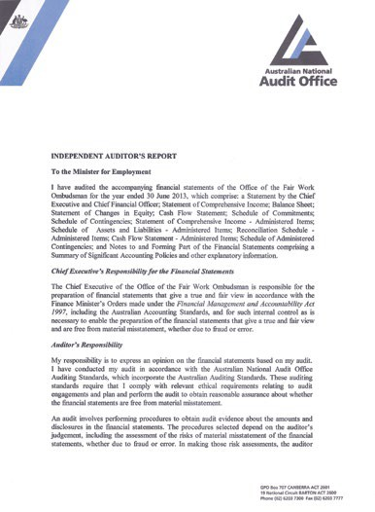

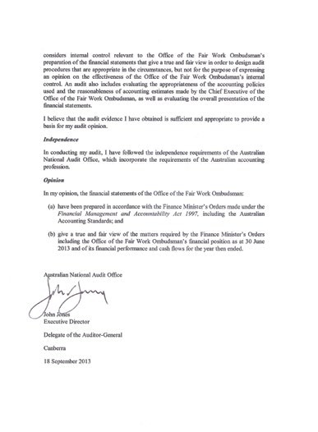

Mark Scully signatureNatalie James signature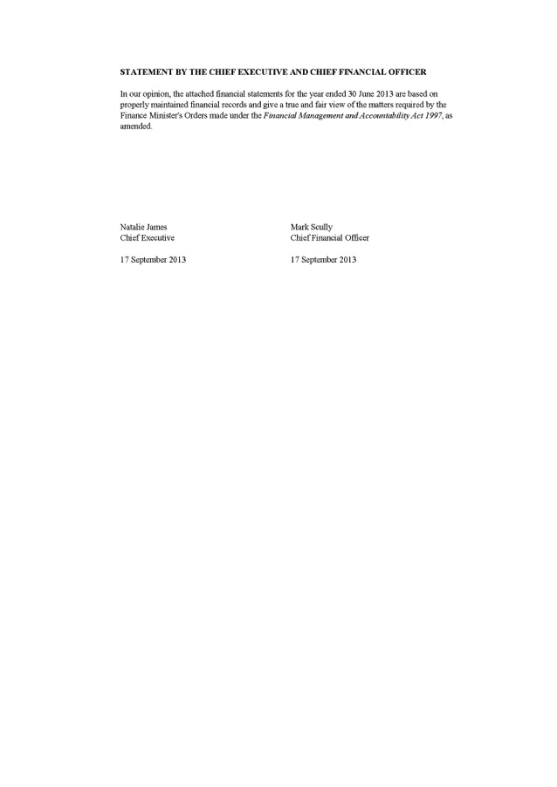

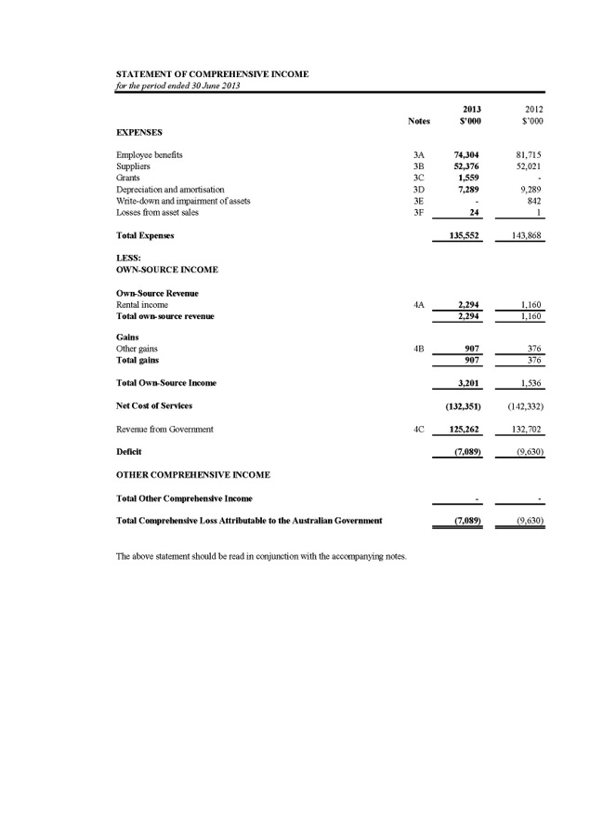

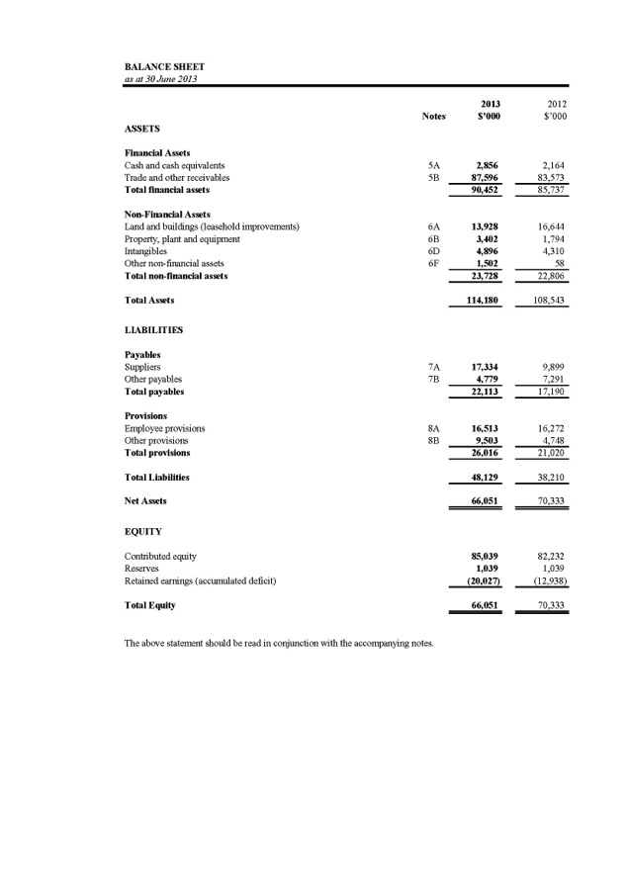

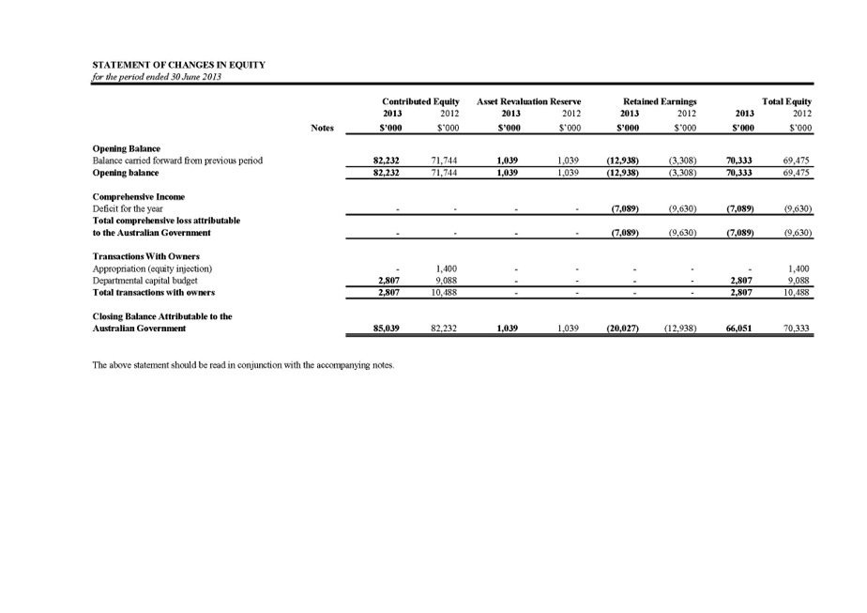

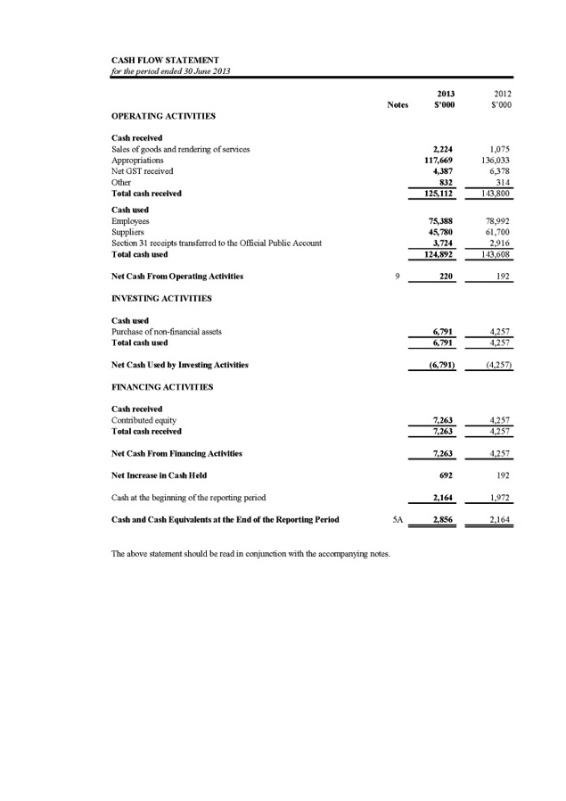

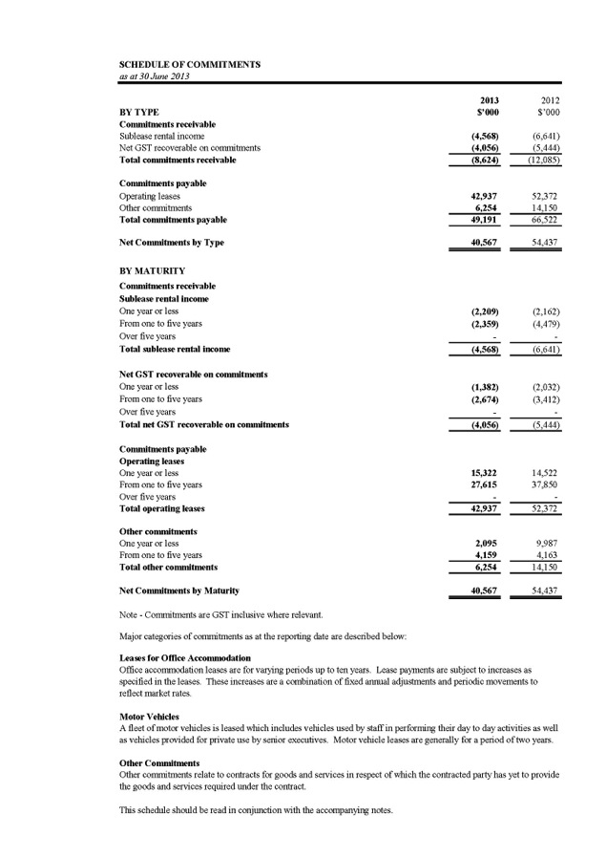

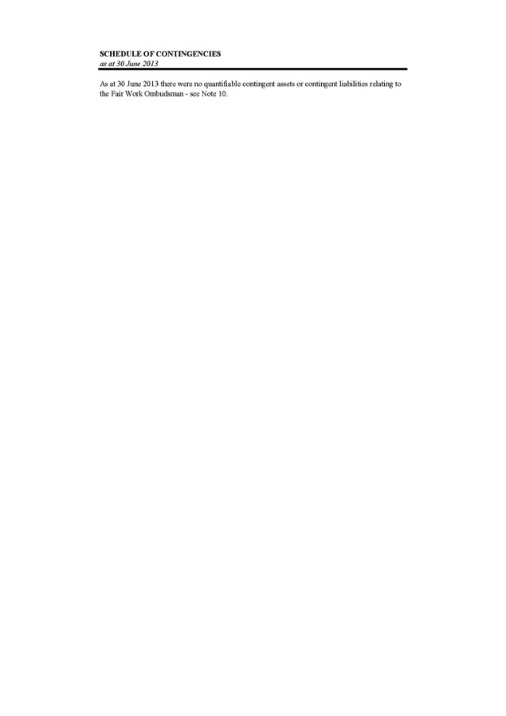

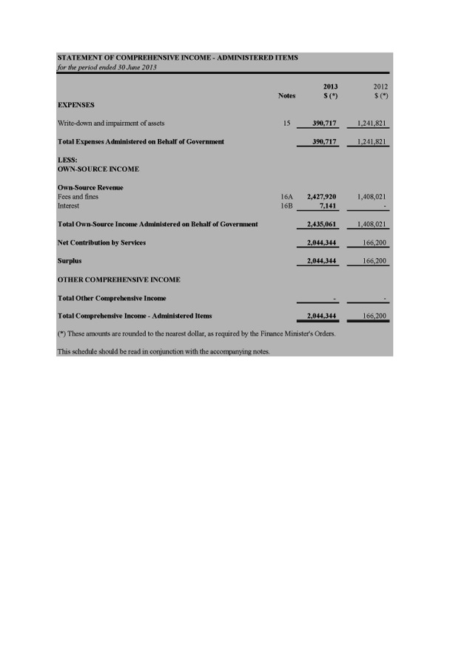

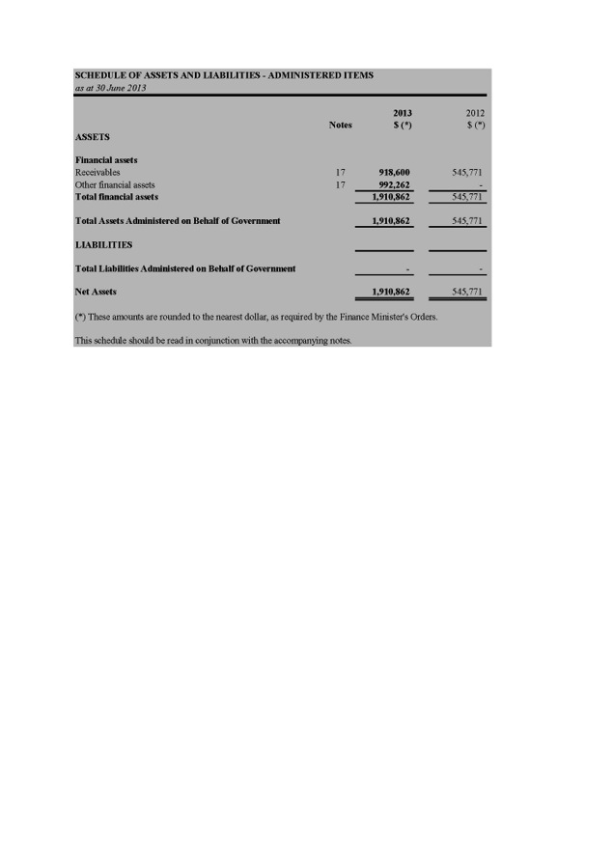

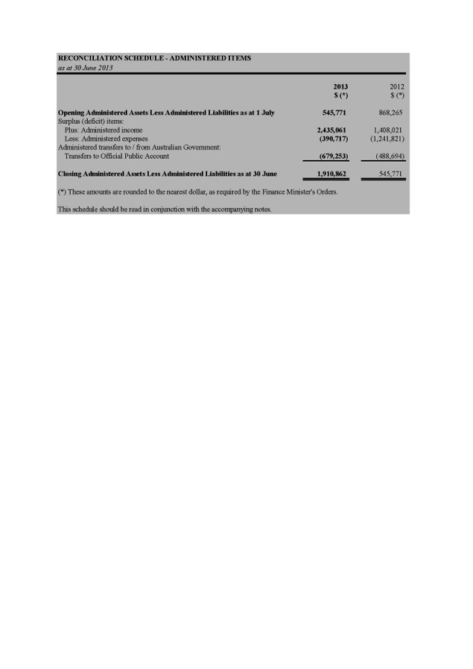

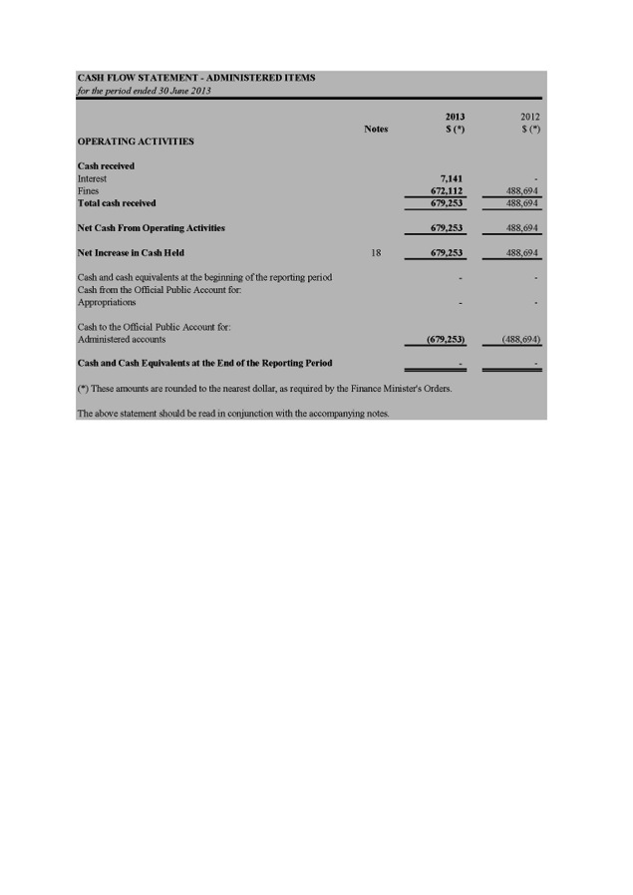

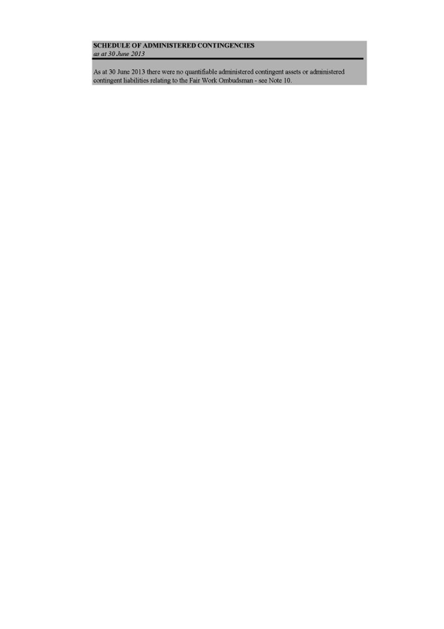

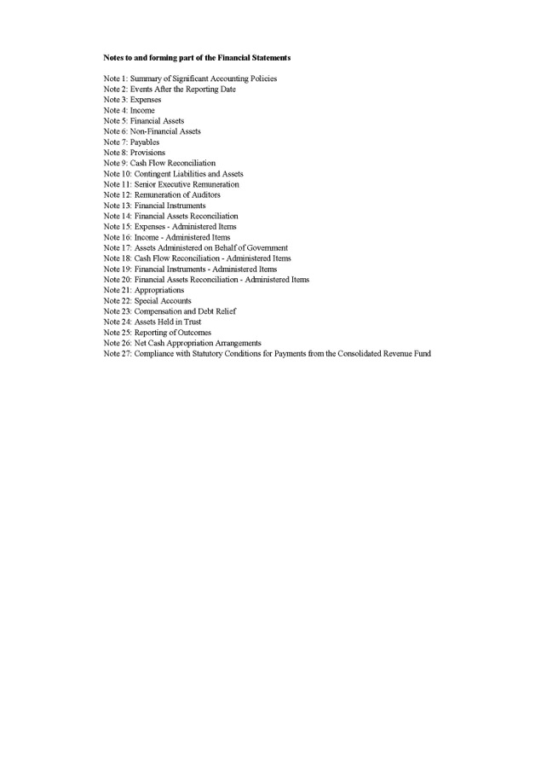

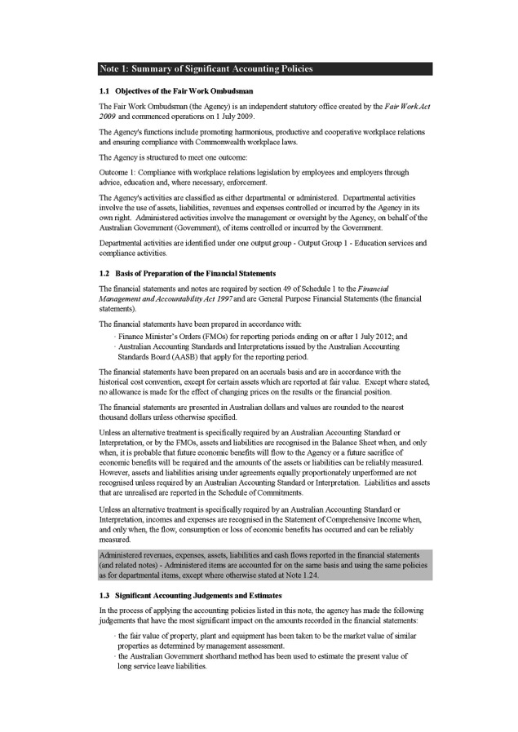

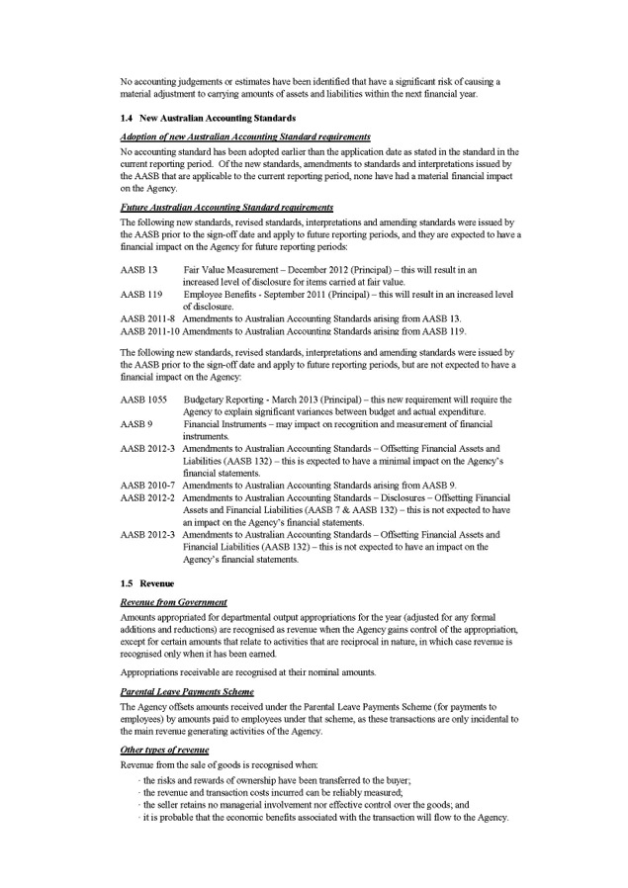

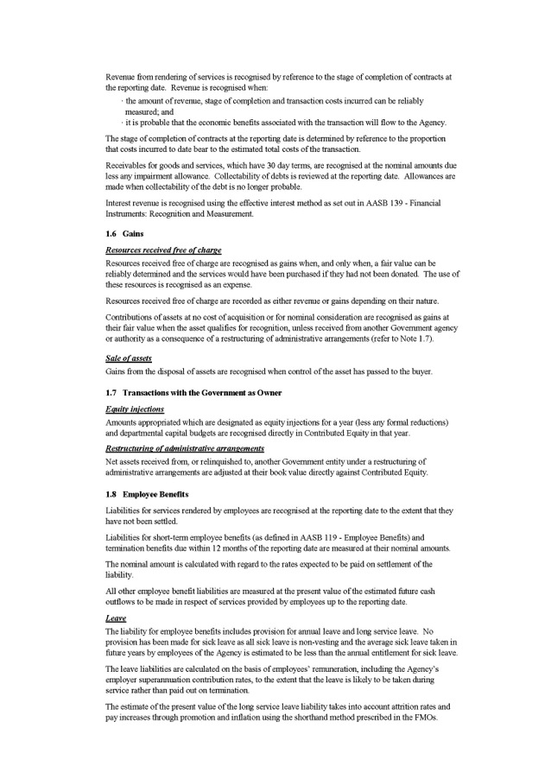

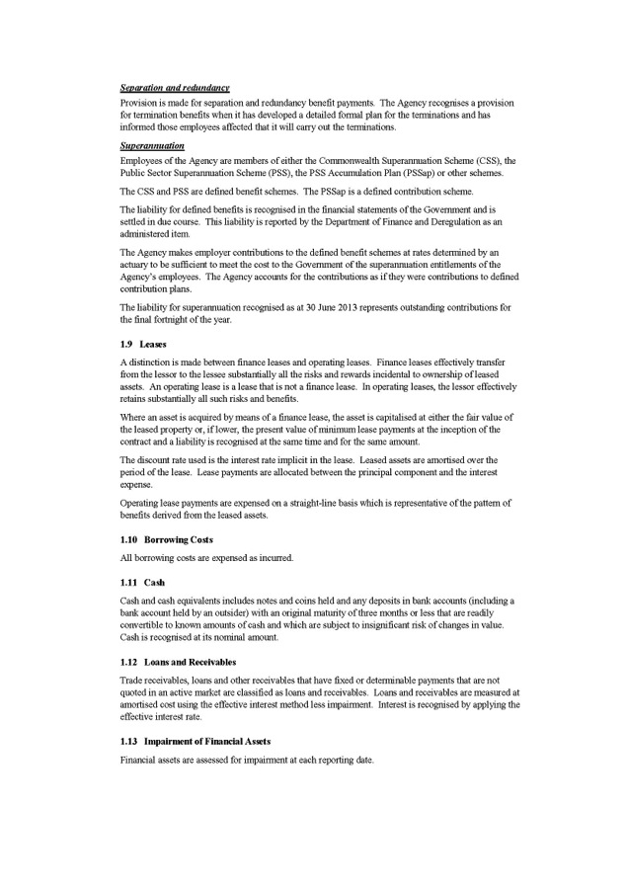

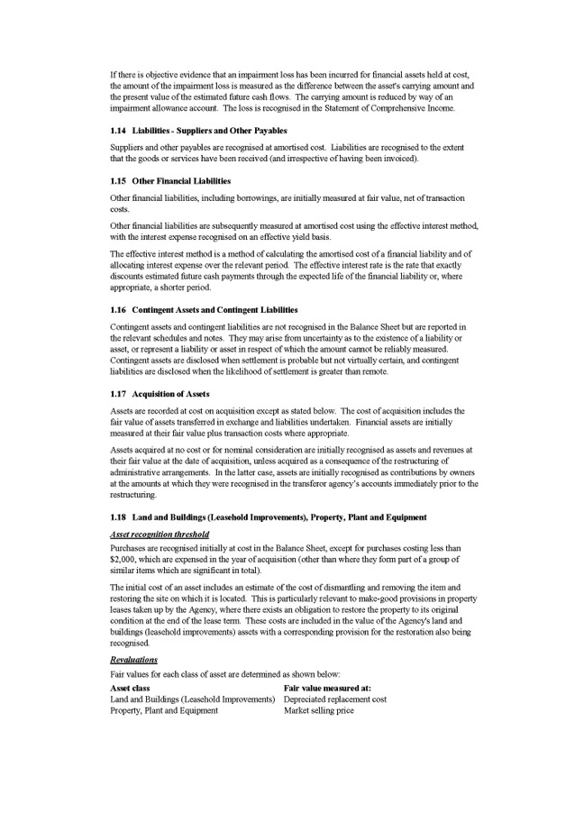

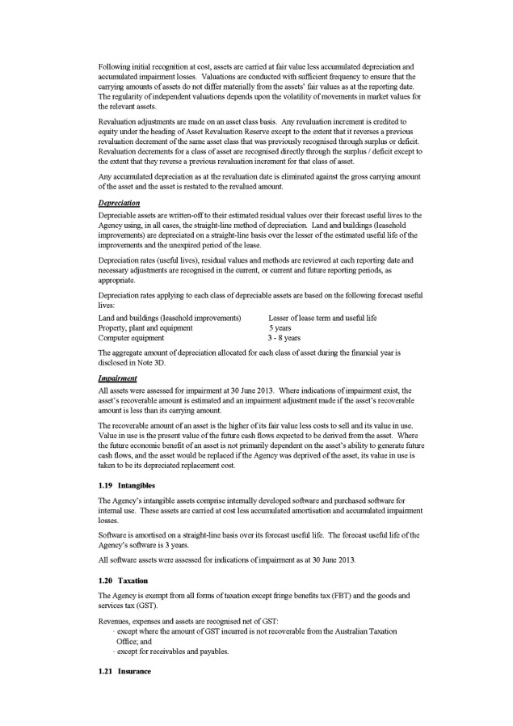

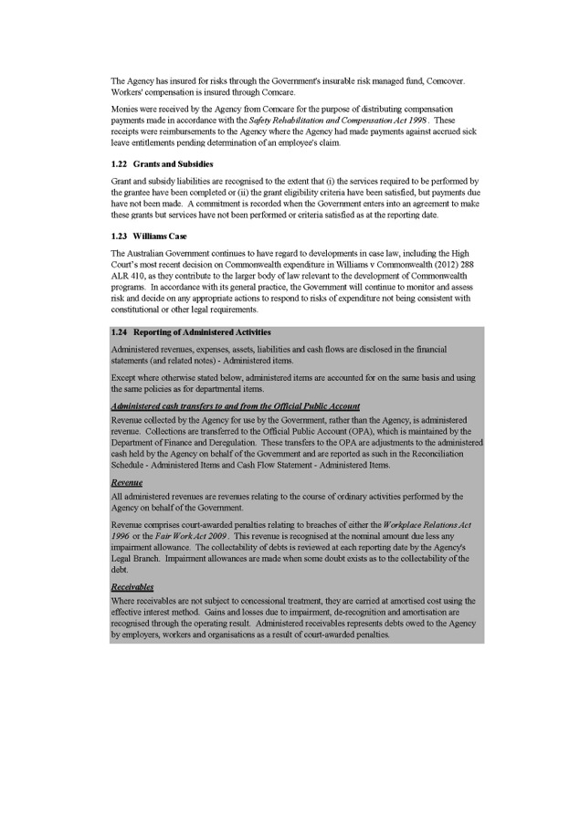

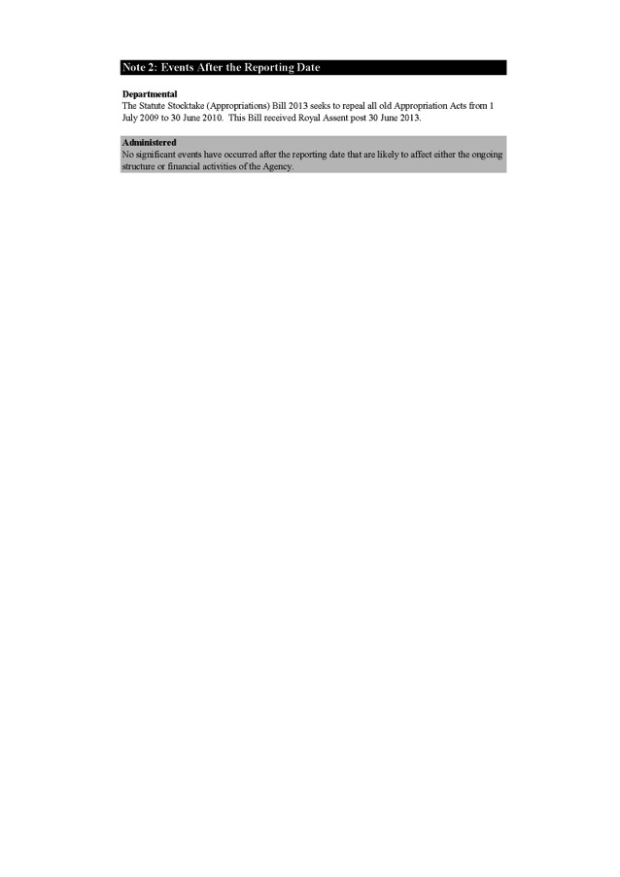

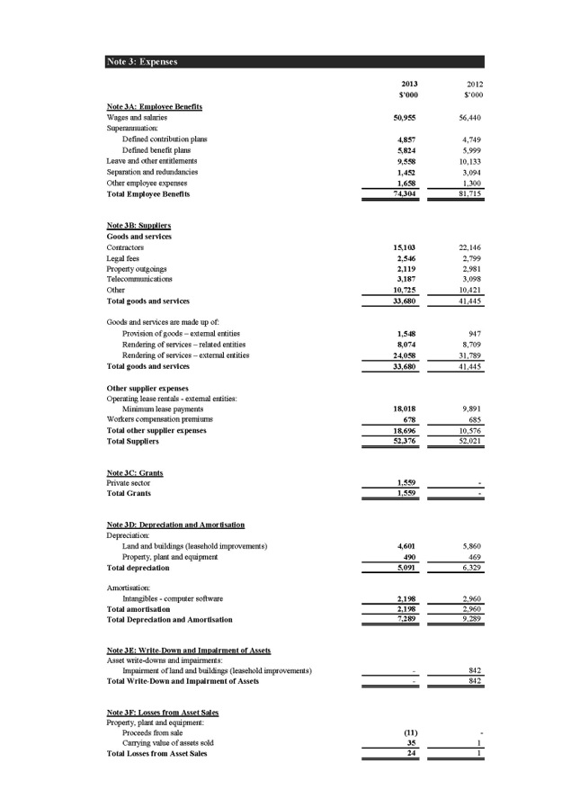

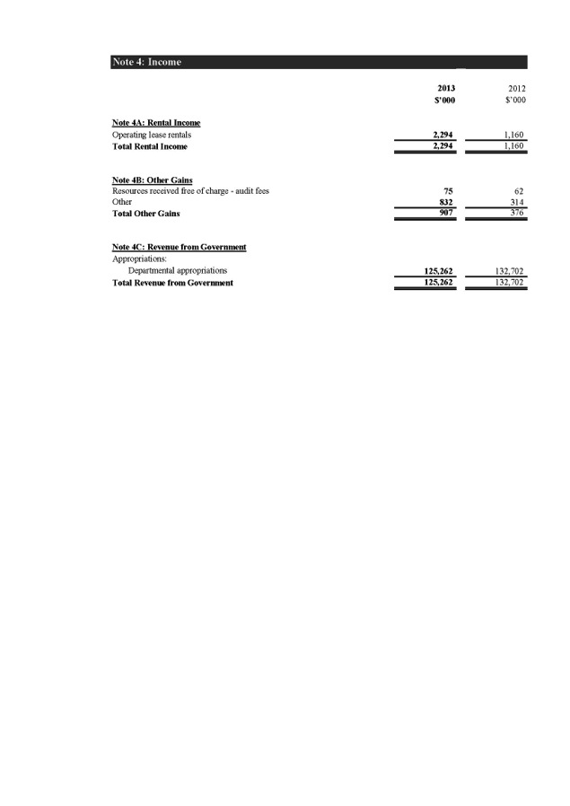

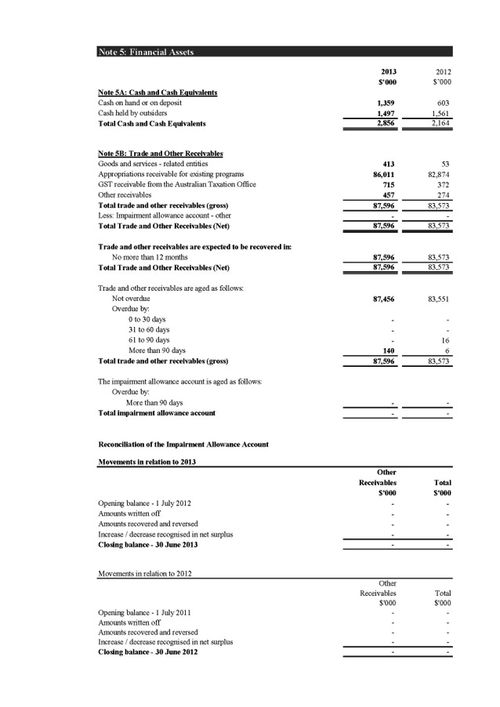

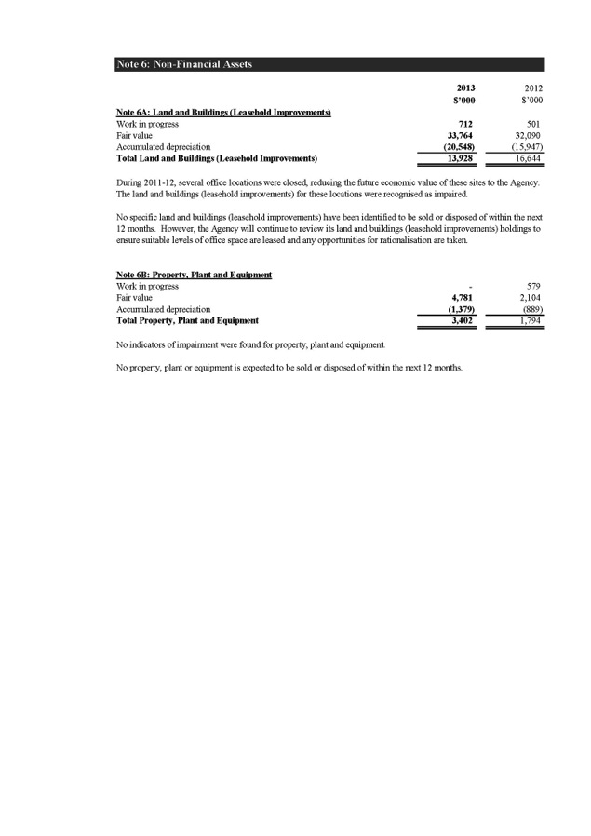

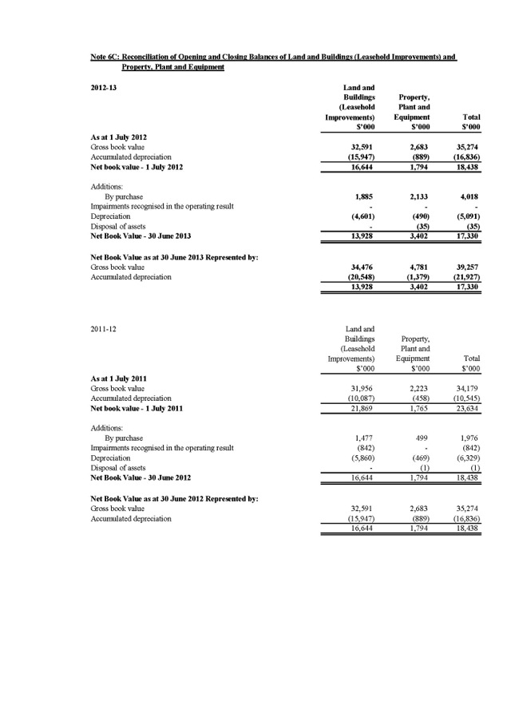

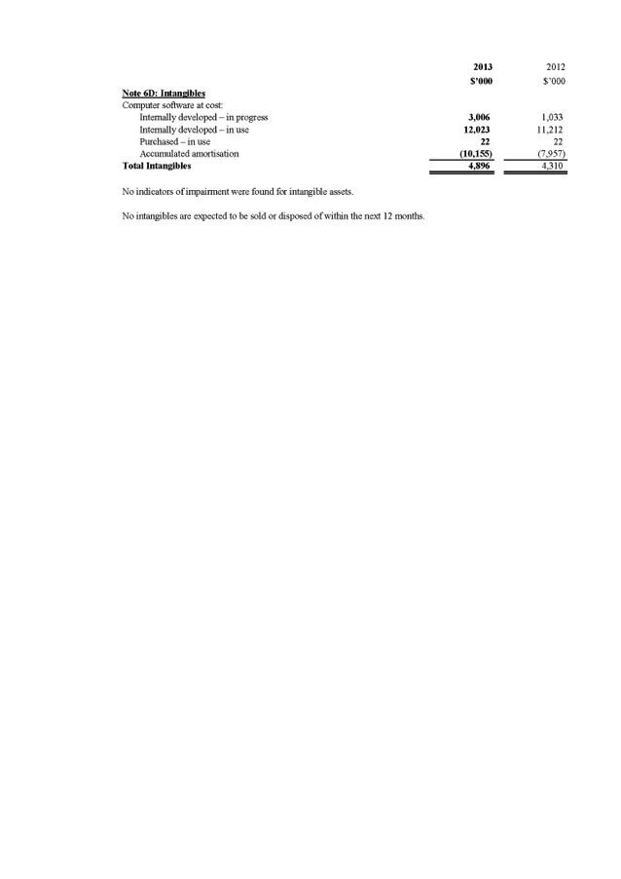

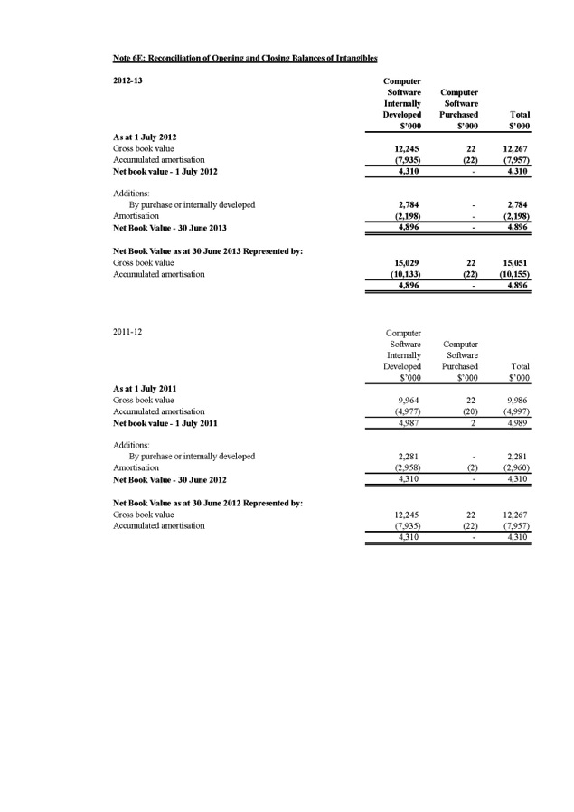

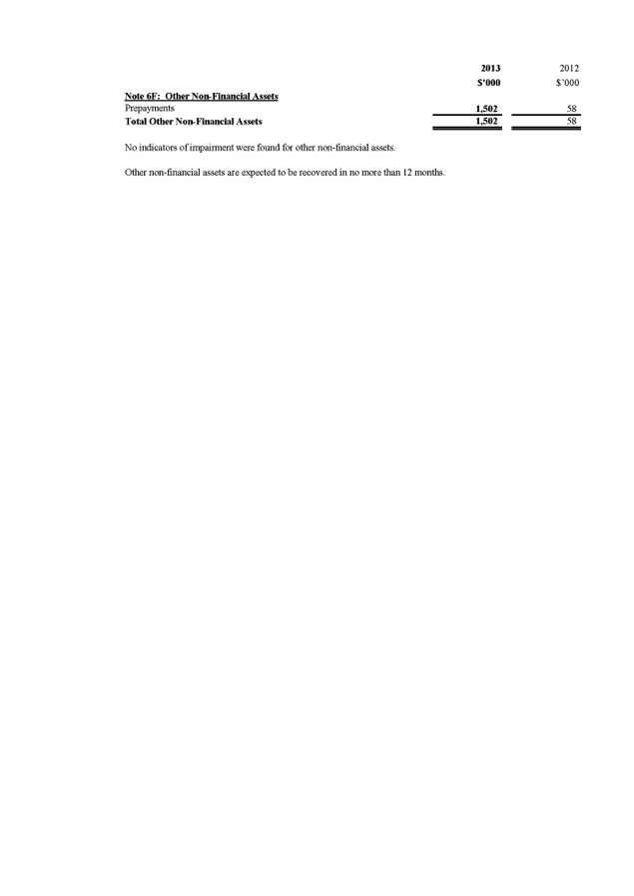

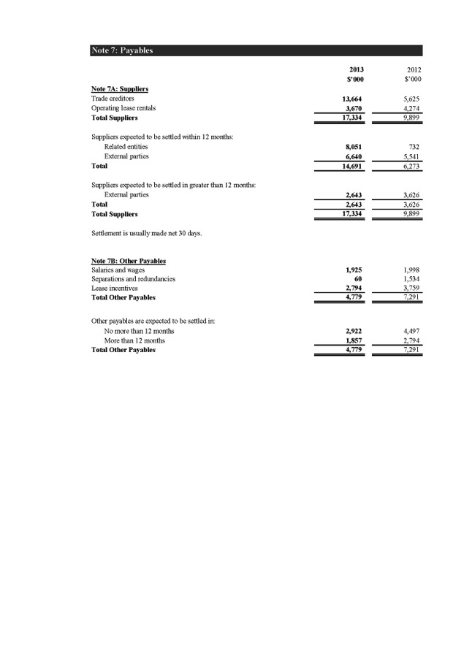

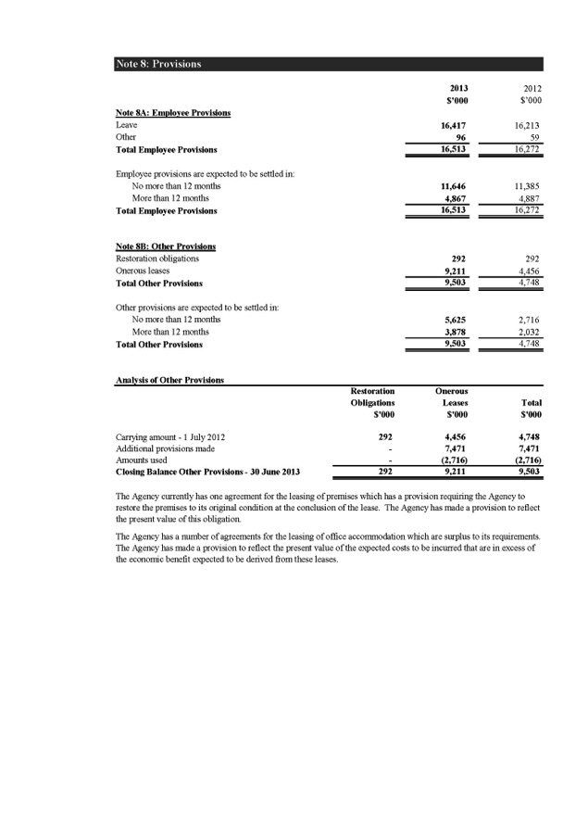

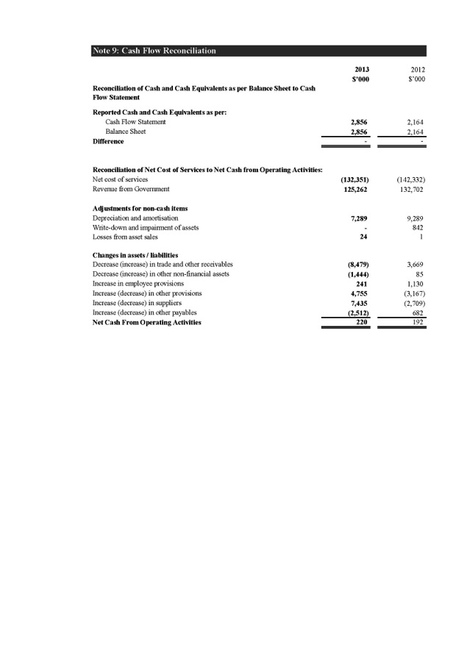

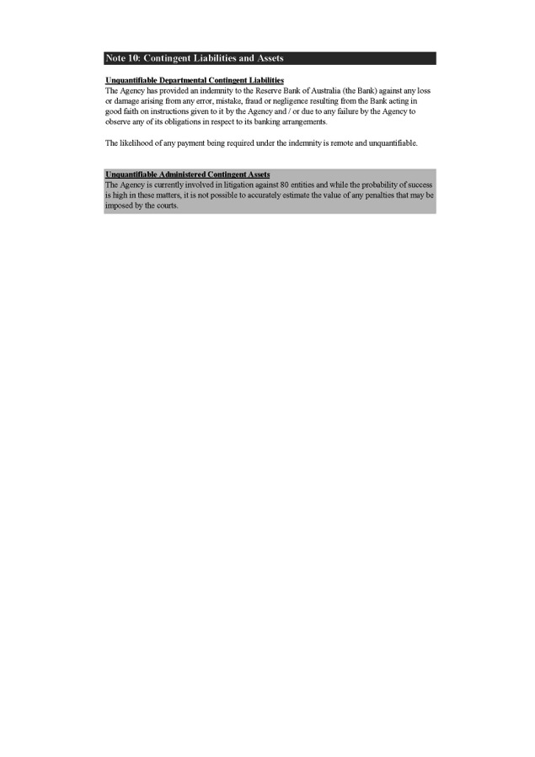

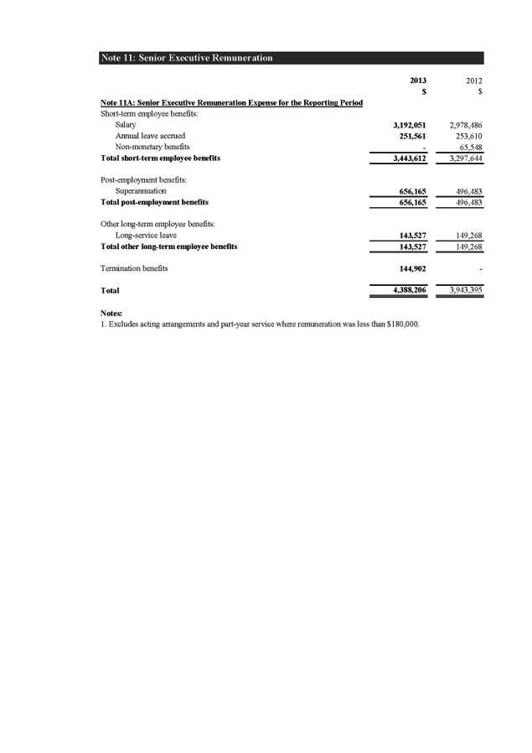

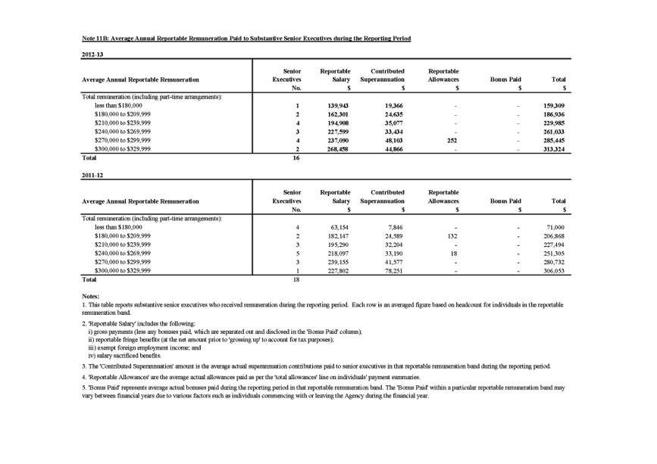

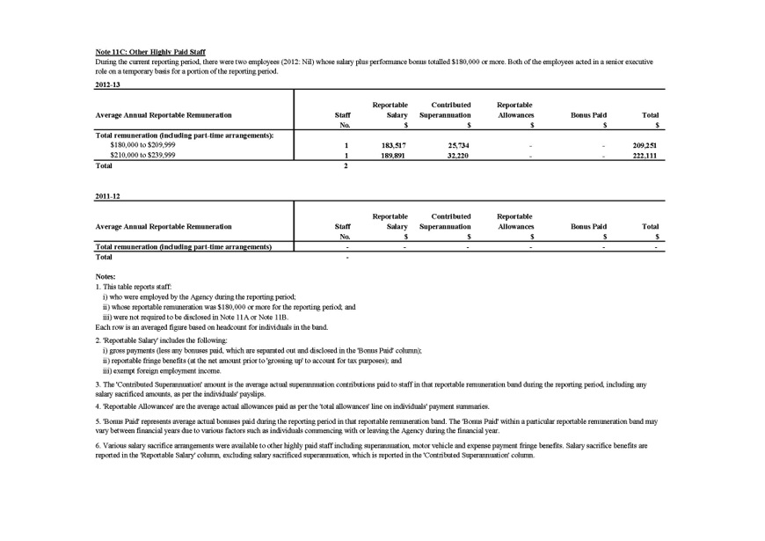

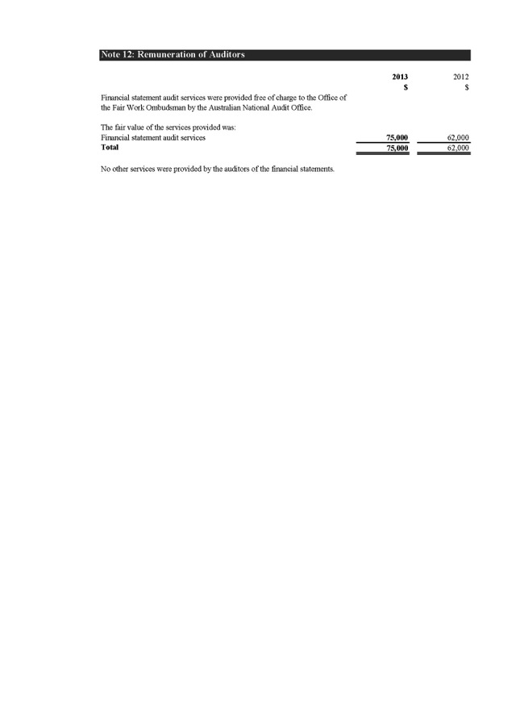

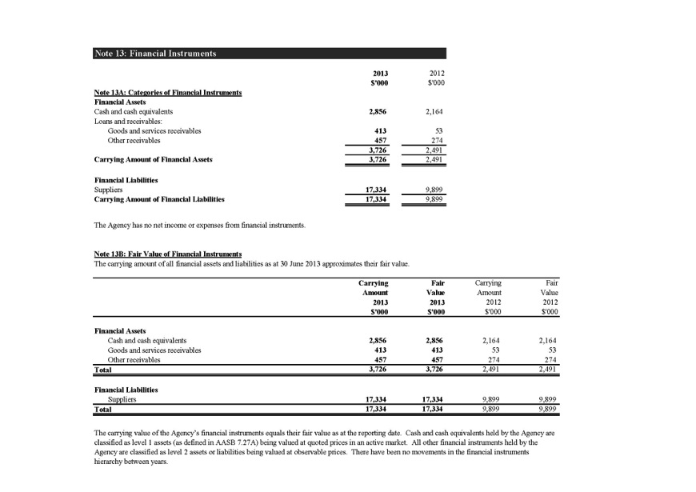

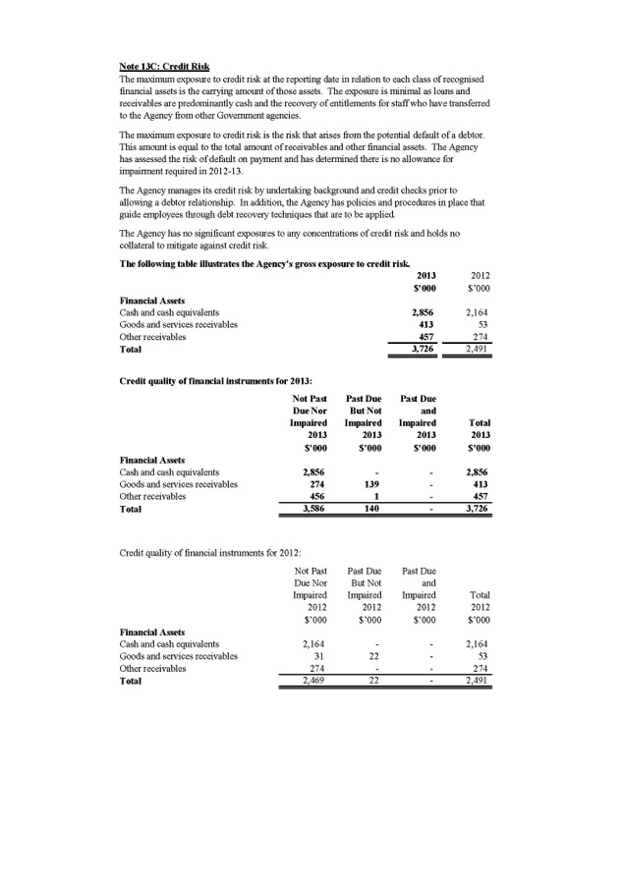

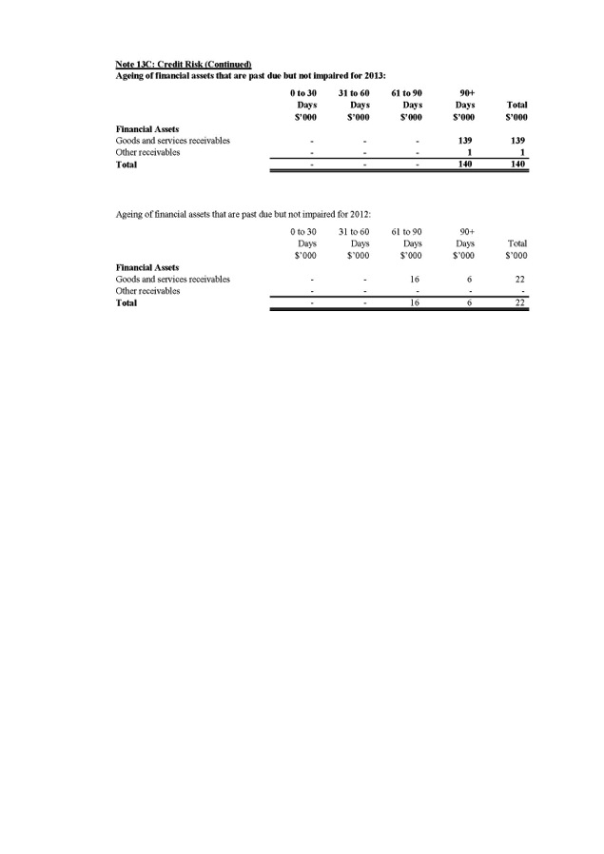

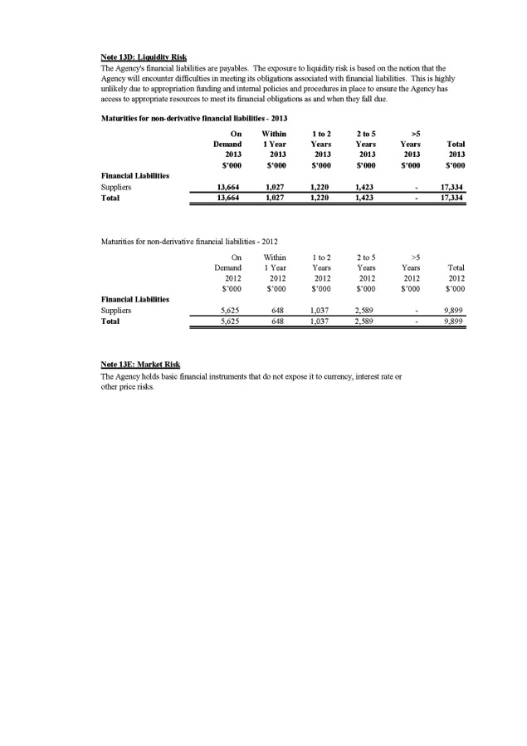

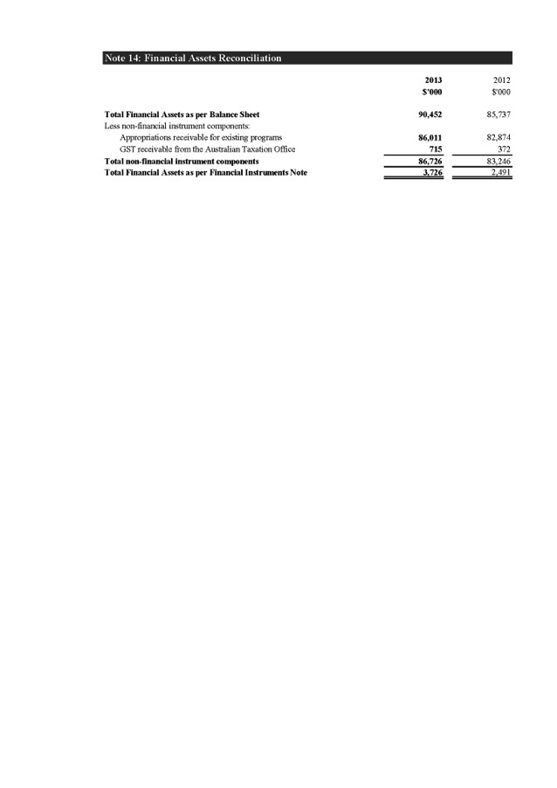

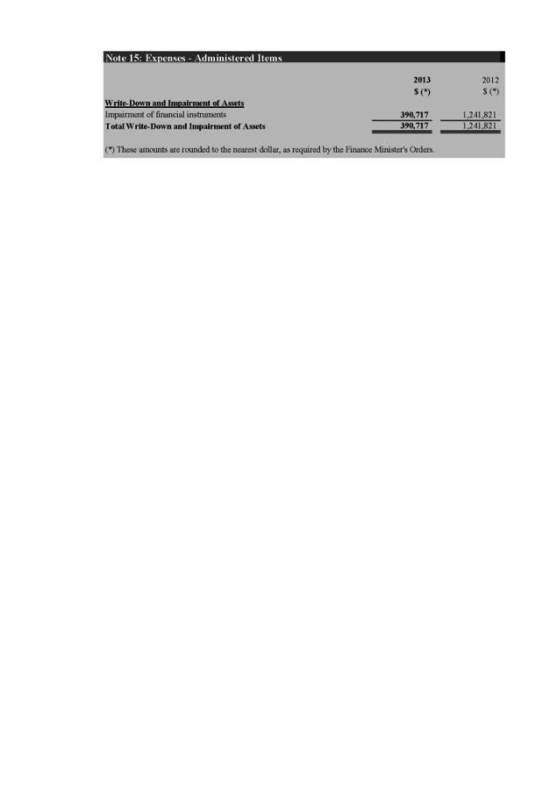

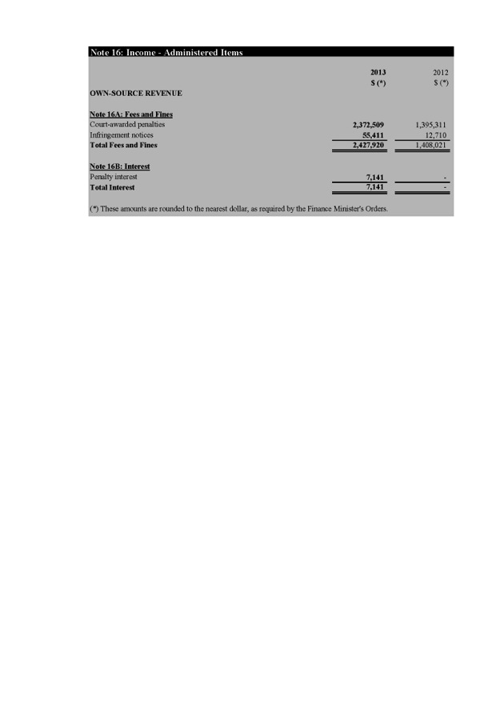

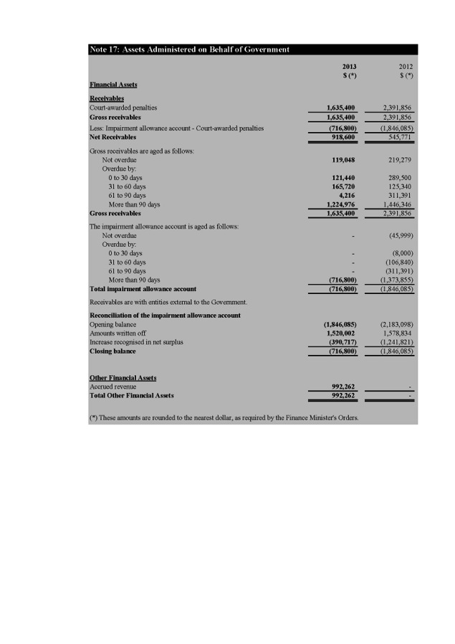

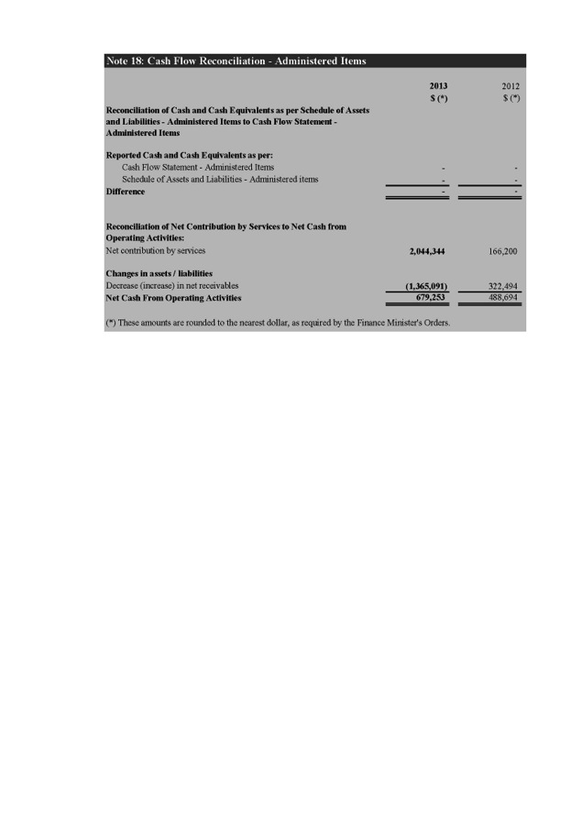

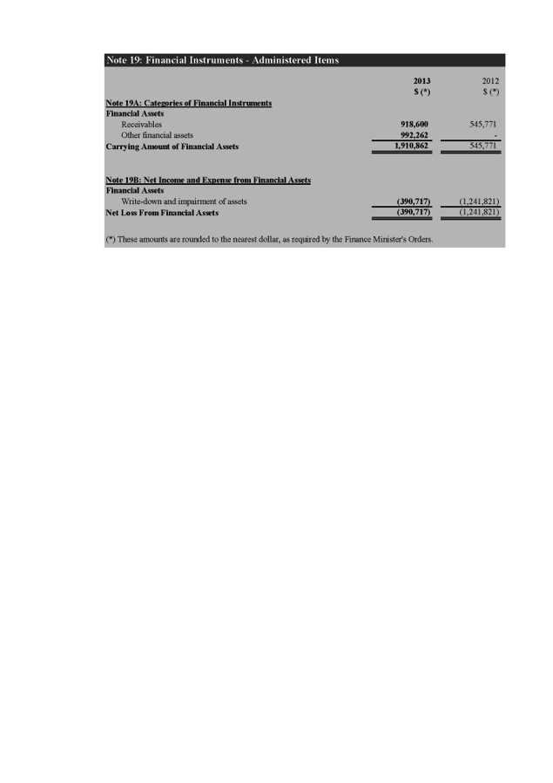

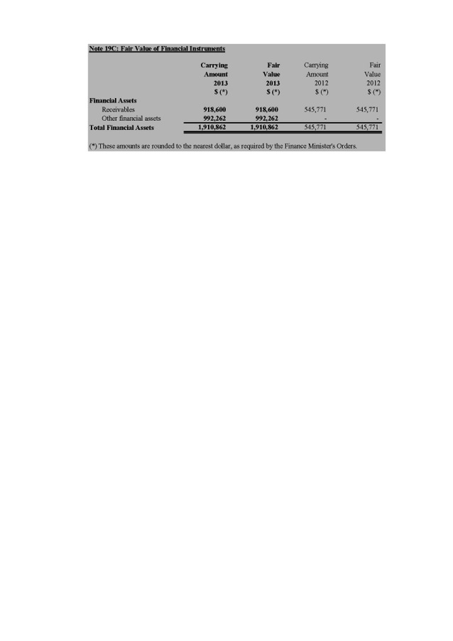

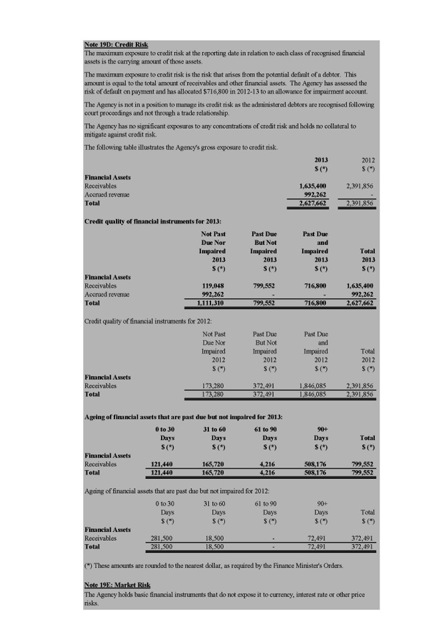

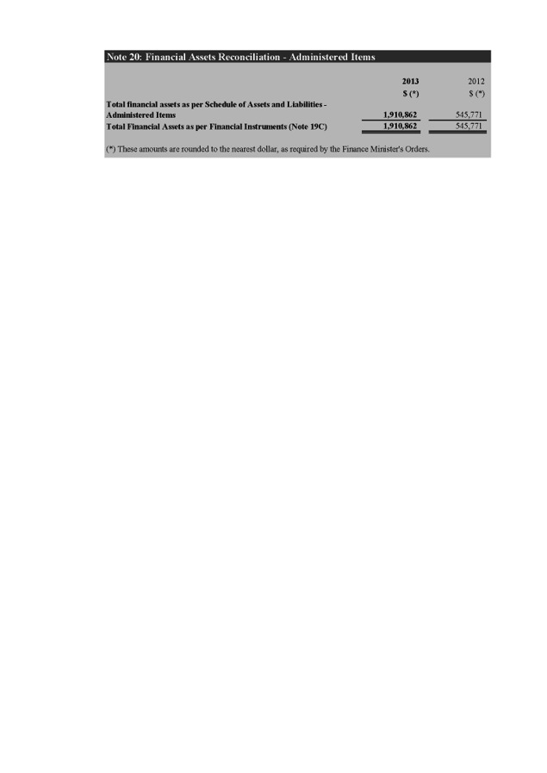

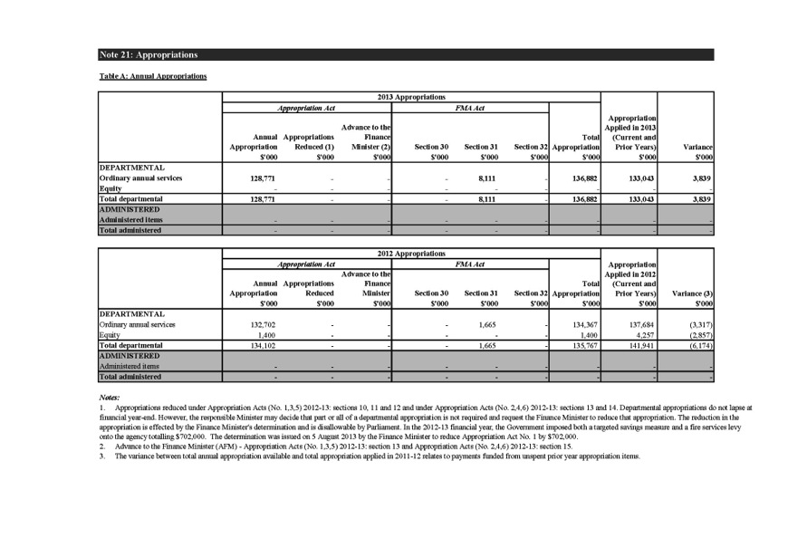

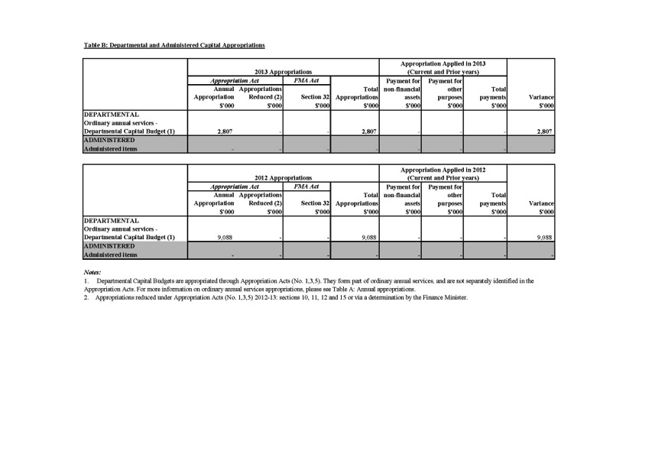

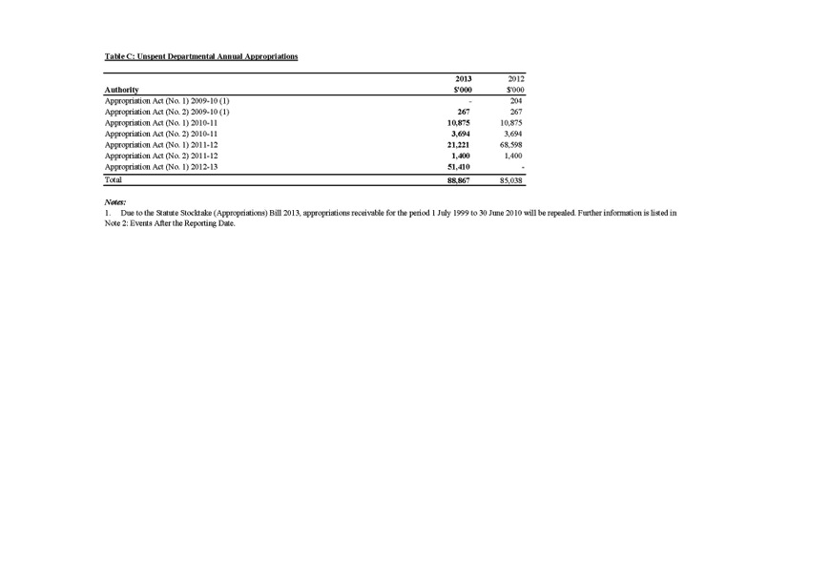

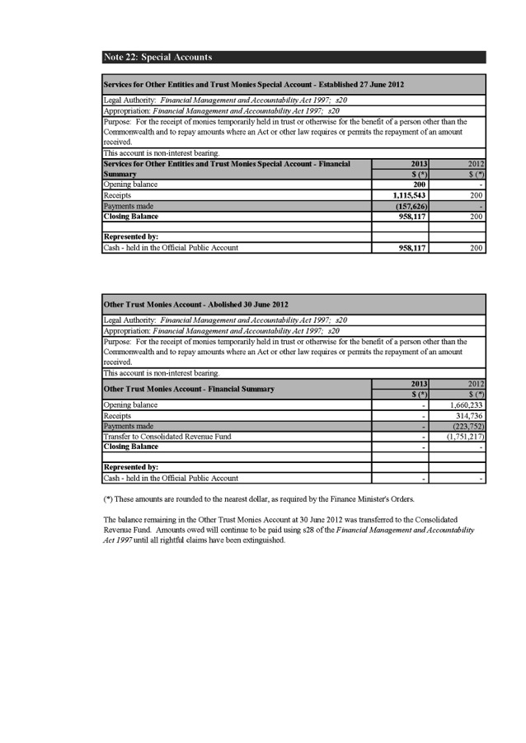

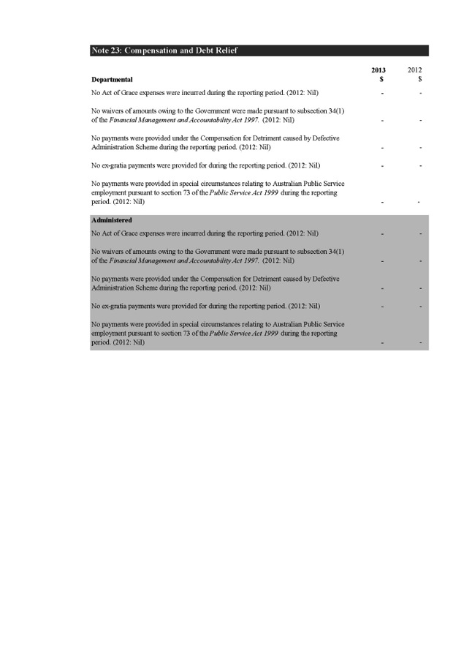

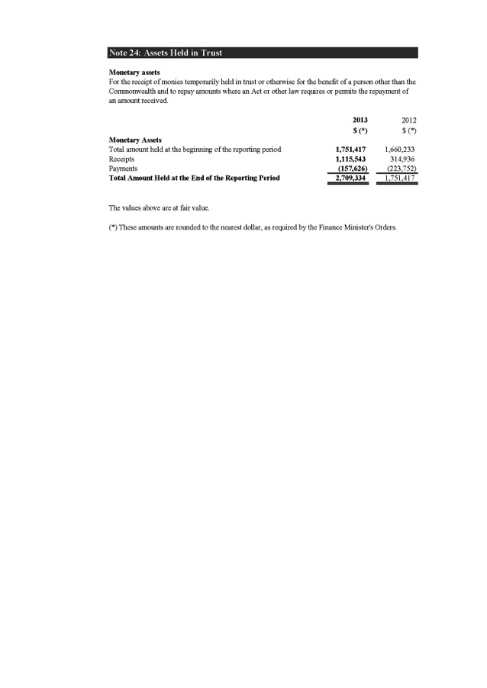

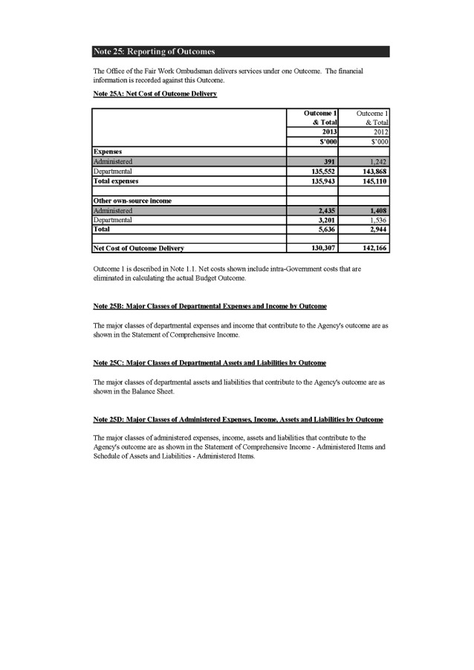

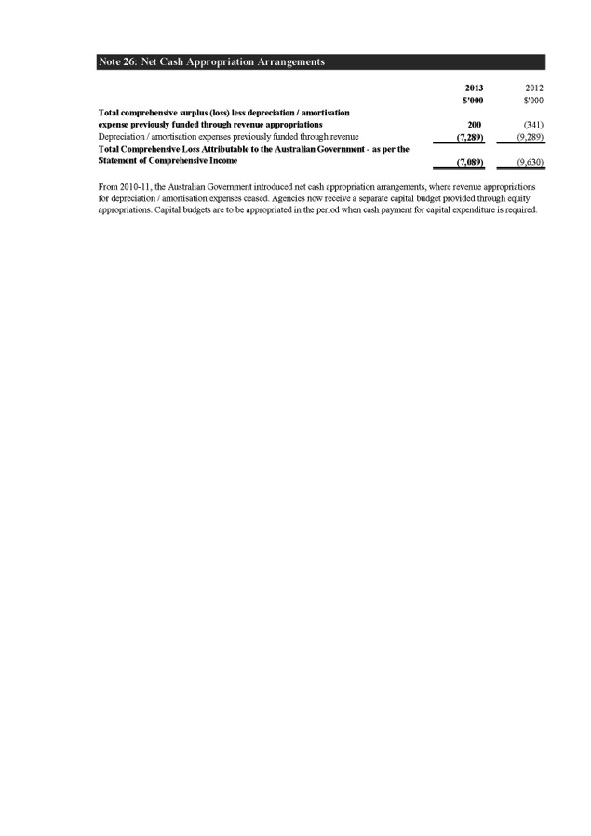

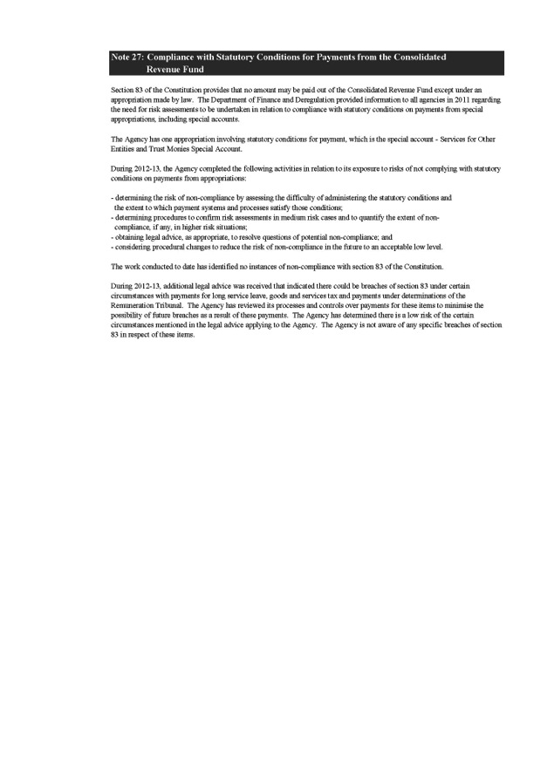

### Appendices

**SECTION 6**



# APPENDIX A: STAFFING PROFILE

#### Table 29: Staff by classification 2010–13

|  |  |  |
| --- | --- | --- |
| **Classification** | **2012–13** | **2011–12**  **2010–11**  **2009–10** |
| APS1 | 1 | 1 0 0 |
| APS2 | 7 | 11 5 1 |
| APS3 | 115 | 133 188 233 |
| APS4 | 158 | 166 211 216 |
| APS5 | 222 | 222 234 227 |
| APS6 | 158 | 144 160 141 |
| EL1 | 92 | 96 99 99 |
| EL2 | 42 | 40 42 40 |
| SES Band 1 | 9 | 9 11 10 |
| SES Band 2 | 5 | 5 2 3 |
| **Total** | **809** | **827 952 970** |

Note: Excludes the Fair Work Ombudsman

#### Table 30: Employees by classification and location at 30 June 2013

|  |  |  |  |  |  |  |  |  |  |
| --- | --- | --- | --- | --- | --- | --- | --- | --- | --- |
| **Classification** | **ACT** | **NSW** | **VIC** | **QLD** | **SA** | **WA** | **NT** | **TAS** | **Total** |
| APS 1 | 0 | 0 | 0 | 0 | 1 | 0 | 0 | 0 | 1 |
| APS 2 | 1 | 1 | 1 | 0 | 3 | 1 | 0 | 0 | 7 |
| APS 3 | 3 | 47 | 32 | 22 | 3 | 8 | 0 | 0 | 115 |
| APS 4 | 9 | 61 | 34 | 16 | 29 | 7 | 2 | 0 | 158 |
| APS 5 | 12 | 64 | 72 | 38 | 17 | 10 | 0 | 9 | 222 |
| APS 6 | 15 | 52 | 47 | 18 | 13 | 10 | 1 | 2 | 158 |
| EL 1 | 16 | 25 | 32 | 5 | 8 | 4 | 0 | 2 | 92 |
| EL 2 | 6 | 11 | 15 | 3 | 6 | 1 | 0 | 0 | 42 |
| SES Band 1 | 2 | 4 | 2 | 0 | 1 | 0 | 0 | 0 | 9 |
| SES Band 2 | 2 | 0 | 2 | 0 | 1 | 0 | 0 | 0 | 5 |
| **Total** | **66** | **265** | **237** | **102** | **82** | **41** | **3** | **13** | **809** |

Note: Excludes the Fair Work Ombudsman

#### Table 31: Ongoing full-time and part-time employees by gender and location at 30 June 2013

|  |  |  |  |  |  |  |  |  |  |
| --- | --- | --- | --- | --- | --- | --- | --- | --- | --- |
| **Classification** | **ACT** | **NSW** | **VIC** | **QLD** | **SA** | **WA** | **NT** | **TAS** | **Total** |
| Female full-time | 29 | 120 | 102 | 41 | 40 | 16 | 1 | 8 | 357 |
| Female part-time | 11 | 42 | 42 | 24 | 14 | 8 | 0 | 0 | 141 |
| **Total female** | **40** | **162** | **144** | **65** | **54** | **24** | **1** | **8** | **498** |
| Male full-time | 23 | 87 | 82 | 35 | 25 | 14 | 2 | 5 | 273 |
| Male part-time | 3 | 8 | 4 | 2 | 2 | 1 | 0 | 0 | 20 |
| **Total male** | **26** | **95** | **86** | **37** | **27** | **15** | **2** | **5** | **293** |
| Total female and male | 66 | 257 | 230 | 102 | 81 | 39 | 3 | 13 | 791 |

Note: Excludes the Fair Work Ombudsman

#### Table 32: Non-ongoing full-time and part-time employees by gender and location at 30 June 2013

|  |  |  |  |  |  |  |  |  |  |
| --- | --- | --- | --- | --- | --- | --- | --- | --- | --- |
| **Classification** | **ACT** | **NSW** | **VIC** | **QLD** | **SA** | **WA** | **NT** | **TAS** | **Total** |
| Female full-time | 0 | 5 | 3 | 0 | 1 | 1 | 0 | 0 | 10 |
| Female part-time | 0 | 0 | 0 | 0 | 0 | 1 | 0 | 0 | 1 |
| **Total female** | **0** | **5** | **3** | **0** | **1** | **2** | **0** | **0** | **11** |
| Male full-time | 0 | 3 | 4 | 0 | 0 | 0 | 0 | 0 | 7 |
| Male part-time | 0 | 0 | 0 | 0 | 0 | 0 | 0 | 0 | 0 |
| **Total male** | **0** | **3** | **4** | **0** | **0** | **0** | **0** | **0** | **7** |
| Total female and male | 0 | 8 | 7 | 0 | 1 | 2 | 0 | 0 | 18 |

Note: Excludes the Fair Work Ombudsman

#### Table 33: Ongoing and non-ongoing full-time and part-time employees by gender as at 30 June 2013

|  |  |  |  |  |  |  |  |  |  |
| --- | --- | --- | --- | --- | --- | --- | --- | --- | --- |
| **Classification** | **ACT** | **NSW** | **VIC** | **QLD** | **SA** | **WA** | **NT** | **TAS** | **Total** |
| Female full-time | 29 | 125 | 105 | 41 | 41 | 17 | 1 | 8 | 367 |
| Female part-time | 11 | 42 | 42 | 24 | 14 | 9 | 0 | 0 | 142 |
| **Total female** | **40** | **167** | **147** | **65** | **55** | **26** | **1** | **8** | **509** |
| Male full-time | 23 | 90 | 86 | 35 | 25 | 14 | 2 | 5 | 280 |
| Male part-time | 3 | 8 | 4 | 2 | 2 | 1 | 0 | 0 | 20 |
| **Total male** | **26** | **98** | **90** | **37** | **27** | **15** | **2** | **5** | **300** |
| Total female and male | 66 | 265 | 237 | 102 | 82 | 41 | 3 | 13 | 809 |

Note: Excludes the Fair Work Ombudsman

#### Table 34: Senior executive and executive level employees by classification and gender at 30 June 2013

|  |  |
| --- | --- |
| **Classification Female Male** | **Total** |
| EL 1 61 31 | 92 |
| EL 2 17 25 | 42 |
| SES Band 1 5 4 | 9 |
| SES Band 2 1 4 | 5 |
| Total 84 64 | 148 |

Note: Excludes the Fair Work Ombudsman

#### Table 35: Workplace diversity profile at 30 June 2013

|  |  |  |  |  |
| --- | --- | --- | --- | --- |
| **Total staff** | **Female** | **People from culturally and linguistically diverse backgrounds** | **People from Aboriginal and Torres Strait Islander backgrounds** | **People with disabilities** |
| 809 | 509 | 210 | 8 | 23 |

Note: Excludes the Fair Work Ombudsman

#### Table 36: Employee workplace agreements by classification at 30 June 2013

|  |  |
| --- | --- |
| **Classification Enterprise Common law   agreement contract** | **Total** |
| APS 1 1 0 | 1 |
| APS 2 7 0 | 7 |
| APS 3 115 0 | 115 |
| APS 4 158 0 | 158 |
| APS 5 222 0 | 222 |
| APS 6 158 0 | 158 |
| EL 1 92 0 | 92 |
| EL 2 42 0 | 42 |
| SES Band 1 0 9 | 9 |
| SES Band 2 0 5 | 5 |
| **Total** **795** **14** | **809** |

Note: Excludes the Fair Work Ombudsman

#### Table 37: Salary ranges by classification at 30 June 2013

|  |  |
| --- | --- |
| **Classification** | **Salary ranges** |
| APS 1 | $45 633 – $47 435 |
| APS 2 | $51 757 – $56 681 |
| APS 3 | $58 242 – $62 807 |
| APS 4 | $64 847 – $70 371 |
| APS 5 | $72 292 – $76 615 |
| APS 6 | $78 296 – $90 065 |
| EL 1 | $99 672 – $107 598 |
| EL 2 | $114 923 – $162 000 |
| SES Band 1 | $181 005 – $211 334 |
| SES Band 2 | $230 139 – $243 310 |

Note: Excludes the Fair Work Ombudsman

## PERFORMANCE BONUSES

No performance bonuses were paid to staff in 2012–13.

# APPENDIX B: WORK HEALTH AND SAFETY

## INITIATIVES

The FWO is committed to maintaining and improving the health and wellbeing of its employees. In 2012–13 the agency continued to deliver work health and safety services to staff, including programs to specifically support mental health and wellbeing.

In 2012–13 initiatives included:

* implementing the 2012–13 Health and Wellbeing Strategy to encourage the health and wellbeing of all employees
* delivering five practical resilience workshops
* undertaking a hazard and risk assessment to ensure the agency’s compliance with the Work Health and Safety Act 2011
* developing and implementing a rehabilitation management system that delivers effective rehabilitation to all injured employees
* establishing a Mental Health Working Group to foster mental health within the agency and help managers and employees increase their confidence in dealing with mental health situations
* undertaking an agency-wide mental health survey to gain insight into the level of awareness of mental health across the agency
* providing workstation assessments and rehabilitation case management services to meet the health, safety and rehabilitation needs of employees
* providing a vaccination program, including seasonal influenza, Q fever and hepatitis A and B
* developing mental health initiatives focused on   
  education and awareness raising, which received   
  positive feedback
* developing a Work Health and Safety for Workers module to provide refresher training for all employees and to ensure ongoing compliance with legislation.

## OUTCOMES

The establishment of the Health and Safety Arrangements 2012–15 has reinforced the agency’s dedication to, and participation in, maintaining healthy workplaces. It has   
also reinvigorated employee interest and participation in work health and safety.

Outcomes in relation to these arrangements include:

* through the Health and Wellbeing Strategy, the   
  agency raised awareness of general health and wellbeing, provided support and educational services   
  to employees, and encouraged employees to focus   
  on their own health and wellbeing
* mental health education undertaken throughout the year has been well received, and the feedback suggests the agency should continue to assist managers and employees in increasing their understanding and confidence in mental health
* active prevention initiatives such as workstation assessments and rehabilitation case management services for physical injuries have resulted in a continued reduction in body stressing injuries.

## NOTIFIABLE INCIDENTS

Under section 38 of the Work Health and Safety Act, the FWO was required to inform Comcare Australia of any notifiable accidents or dangerous occurrences arising out   
of work undertaken by any of its employees.

Four notifiable accidents and no dangerous occurrences were reported to Comcare Australia in 2012–13.

## INVESTIGATIONS

Under section 39 of the Work Health and Safety Act, the FWO was required to report any investigations conducted during the year into any of its undertakings.

One investigation into the security and threat level of the FWO’s office accommodation was conducted in 2012–13 following a security incident.

## CHANGES TO DISABILITY REPORTING IN ANNUAL REPORTS

Since 1994, Commonwealth departments and agencies have reported on their performance as policy adviser, purchaser, employer, regulator and provider under the Commonwealth Disability Strategy. In 2007–08, reporting on the employer role was transferred to the Australian Public Service Commission’s ‘State of the Service Report’ and the APS Statistical Bulletin. These reports are a[vailable at apsc.gov.au](http://www.apsc.gov.au/). From 2010–11 departments and agencies have no longer been required to report on these functions.

The Commonwealth Disability Strategy has been overtaken by a new National Disability Strategy 2010–20, which sets out a 10-year national policy framework to improve the lives of people with disability, promote participation and create a more inclusive society. A high-level two-yearly report will track progress against each of the six outcome areas of the strategy and present a picture of how people with disability are faring. The first of these reports will be available in 2014, and will be available at fahcsia.gov.au.

The Social Inclusion Measurement and Reporting Strategy agreed by the government in December 2009 will also include some reporting on disability matters in its regular ‘How Australia is Faring’ report and, if appropriate, in strategic change indicators in agency annual reports.   
More detail on social inclusion matters can be found at [socialinclusion.gov.au](http://socialinclusion.gov.au/).

# APPENDIX C: INFORMATION PUBLICATION SCHEME

Under the *Freedom of Information Act 1982* the FWO is required to publish certain infor[mation on fairwork.gov](http://www.fairwork.gov.au/).au as part of an Information Publication Scheme (IPS), such as the agency’s organisational structure, its functions and decision-making powers, certain statutory appointments, annual reports and information routinely provided to FOI applicants and the federal parliament.

This information is curr[ently published on fairwork.gov.au](http://www.fairwork.gov.au/), under ‘About Us’ and ‘Freedom of information’.

[fairwork.gov](http://www.fairwork.gov.au/).au also includes an IPS Agency Plan setting out what information is published under the IPS, how and to whom it is published and how the agency otherwise complies with its IPS requirements.

The IPS is currently under review by the FOI team.

# APPENDIX D: ECOLOGICALLY SUSTAINABLE DEVELOPMENT AND ENVIRONMENTAL PERFORMANCE

The FWO is committed to and encourages the efficient use of energy resources.

Through its philosophy of rethink, reduce, reuse, repair and recycle, the FWO builds strong environmental awareness across the agency and progressively implements policies and work practices that minimise the agency’s waste, energy and water consumption, and greenhouse emissions.

In 2012–13 the FWO developed an Environmental Management policy that draws on principles in the Australian National Audit Office’s *Public Sector Better Practice Guide 2012*, and an Environmental Management Action Plan, targeting ongoing reductions in carbon emissions by 2016. The initial focus of the plan is to target specific areas of the agency with the greatest potential for carbon emission reductions.

The purpose will be to establish baseline reporting as a means of accurately recording future savings in the areas of ICT sustainability, fleet management, travel, waste recycling and energy consumption.

In 2012–13 the FWO:

* piloted a waste audit, and implemented a waste   
  recycling program in the FWO’s Canberra office
* reduced the agency’s total vehicle fleet
* implemented Print on Demand, requiring staff to swipe   
  their ID card to print
* moved to 100 per cent carbon neutral paper for internal printing
* significantly reduced the FWO’s property size, and fit outs to meet government standards
* donated more than 50 computers and accessories to the Computer Technology for Schools Program
* participated in the Close the Loop program for toner cartridge recycling
* recycled more than 17 kilograms of mobile phones, batteries and accessories.

# APPENDIX E: ADVERTISING AND MARKET RESEARCH

Details of payments made to market research and advertising organisations by the FWO in 2012–13 are listed in Table 38.

Where the total amount paid to an organisation is less than $12 100, details have not been included, consistent with the *Commonwealth Electoral Act 1918*.

No advertising campaigns were undertaken by the FWO in 2012–13.

#### Table 38: Market research, direct mail and media advertising contracts over $12 100 in 2012–13

|  |  |  |
| --- | --- | --- |
| **Organisation** | **Service provided** | **Total $ paid in** |
|  |  | **2012–13** |
|  |  | **(GST inclusive)** |
| **Media advertising organisations** |  |  |
| Universal McCann | Communication campaigns | 99 857 |
| Adcorp | Recruitment advertising | 26 804 |

# APPENDIX F: SUMMARY OF RESOURCES

#### Table 39: Expenses and resources for Outcome 1

**Outcome 1: Compliance with workplace relations legislation by employees and employers through advice, education and where necessary enforcement.**

**Budget 2012–13  
  
$’000**

**Actual  
Expenses  
2012–13  
$’000**

**Variation  
  
  
$’000**

#### Program 1: Education services and compliance activities

Departmental expenses

1. (b) (a-b)

Ordinary annual services (Appropriation Bill No.1) 136,548 132,351 4,197

Revenue from independent sources (Section 31) 100 3,201 (3,101)

Total for Program 1 136,648 135,552 1,096

Total expenses for Outcome 1 136,648 135,552 1,096

**2012–13**

Average staffing level (number) 722

Note: Budget information reflects budgets as set out in the Portfolio Budget Statements 2012–13.

#### Table 40: Agency Resource Statement 2012–13

|  |  |  |
| --- | --- | --- |
|  | **Actual Payments**  **Available Made**  **Appropriations**  **for 2012–13 2012–13**  **$’000 $’000** | **Balance**  **Remaining**  **2012–13**  **$’000** |
|  | (a)  (b) | (a-b) |
| **Ordinary annual services**  **Departmental outputs**  Departmental outputs |  | |
| 193,778 133,043 | 60,735 |
| **Total ordinary annual services** | **193,778 133,043** | **60,735** |
| **Other services**  **Departmental non-operating**  Equity injections  Departmental capital budget | 5,362 – | 5,362 |
| 22,770 – 22,770 | |
| **Total other services** | **28,132 –** | **28,132** |
| **Total available annual appropriations** | **221,910 133,043** | **88,867** |
| **Total appropriations excluding special account** | **221,910 133,043** | **88,867** |
| **Special account**  Opening balance  Non-appropriation receipts  Payments | – –  1,116 –  – 158 | –  1,116  (158) |
| **Total special account** | **1,116 158** | **958** |
| **Funds held by CRF** |  |  |
| Opening balance | 1,751 – | 1,751 |
| **Total funds held by CRF**  **Total net resourcing for Fair Work Ombudsman** | **1,751 –**  **224,777 133,201** | **1,751**  **91,576** |

### References

**SECTION 7**



## GLOSSARY

#### Annual wage review

A review of minimum award wages and the national minimum wage order conducted by Fair Work Australia each financial year.

#### Australian Public Service (APS) employee

A person engaged under section 22, or a person who is engaged as an APS employee under section 72, of the *Public* *Service Act 1999*.

#### Assisted Voluntary Resolution

Assists alleged wrongdoers and complainants find a fair and mutually acceptable resolution to a workplace complaint, without having to immediately resort to formal investigation.

#### Corporate governance

The process by which agencies are directed and controlled. It is generally understood to encompass authority, accountability, stewardship, leadership, direction and control.

#### Enforceable undertakings

A written commitment outlining how a person intends to rectify a contravention.

#### Enterprise agreement

An agreement made under the *Fair Work Act 2009* (on or after 1 July 2009) between one or more employers and a group of employees about terms and conditions of employment for those employees.

#### Fair Work Australia

The national workplace relations tribunal created by the *Fair Work Act 2009*. It is an independent body with power to carry out a range of functions covering: the safety net of minimum wages and employment conditions; enterprise bargaining; industrial action; dispute resolution and termination of employment.

#### General protections

Protections provided by the *Fair Work Act 2009*, relating to workplace discrimination, sham contracting, and workplace rights.

#### Individual Flexibility Agreement (IFA)

An agreement between an employer and an employee, that can vary the effect of some conditions of a modern award or enterprise agreement. The Individual Flexibility Agreement must pass the ‘Better Off Overall Test’, but does not need to be registered.

#### Industrial instruments

Sets out minimum conditions of employment for employees. Instrument types include modern awards, enterprise agreements, award-based transitional instruments, transitional minimum wage instruments and agreement-based transitional instruments.

#### Mediation

A dispute resolution process that focuses on assisting parties to reach a mutual agreement, and to resolve disagreements on their own terms.

#### Modern awards

An award made by the Australian Industrial Relations Commission as part of the award modernisation process that commenced operation on 1 January 2010. Modern awards supplement the National Employment Standards by setting out additional minimum terms and conditions that apply in a particular industry or occupation including monetary entitlements such as wages, penalty rates and allowances.

#### National Employment Standards (NES)

Ten minimum standards of employment that apply to national system employees from 1 January 2010. For a list of the NES [visit www.fairwork.gov.au/nes](http://www.fairwork.gov.au/nes).

#### Phoenixing

Involves a company intentionally accumulating debts to improve cash flow or wealth and then liquidating to avoid paying the debt. The business is then continued as another corporate entity, controlled by the same person or group and free of their previous debts and liabilities.

#### Pro-active Compliance Deed

A written commitment outlining how a business will work cooperatively with the FWO to build compliance capacity.

#### Sham contracting

Where an employer tries to disguise an employment relationship as an independent contracting relationship. This may be done to avoid having to provide employees with their proper entitlements.

#### Transitional arrangements

A process of implementing certain monetary entitlements in modern awards in five 20% increments over a four-year period from the first full pay period on or after 1 July 2010 in accordance with the model transitional provisions in a modern award.

#### Workplace discrimination

Under the *Fair Work Act 2009*, it is unlawful for an employer to discriminate against an employee or prospective employee on the basis of race, colour, sex, sexual preference, age, physical or mental disability, marital status, family or carer’s responsibilities, pregnancy, religion, political opinion, national extraction or social origin.

## ABBREVIATIONS AND ACRONYMS

AGIMO Australian Government Information

Management Office

AHRI Australian Human Resources Institute

AVR Assisted Voluntary Resolution

CALD Culturally and linguistically diverse

CBEAS Community Based Employment Advisory Services

CPSU Community and Public Sector Union

EL1 Executive Level 1

EL2 Executive Level 2

Fair Work Act *Fair Work Act 2009*

FOI Freedom of Information

FOI Act *Freedom of Information Act 1982*

FWO Fair Work Ombudsman

IFA Individual Flexibility Arrangement

IPS Information Publication Scheme

KPI Key performance indicator

MOU Memorandum of understanding

NES National Employment Standards

PBS Portfolio Budget Statements

QA Quality Assurance

SES Senior Executive Service

Work Health *Work Health and Safety Act 2011*

and Safety Act

## LIST OF REQUIREMENTS

|  |  |  |  |
| --- | --- | --- | --- |
| **Part of**  **Report** | **Description** | **Requirement** | **Page** |
|  | Letter of transmittal | Mandatory | 2 |
|  | Table of contents | Mandatory | 3 |
|  | Index | Mandatory | 127-130 |
|  | Glossary | Mandatory | 122 |
|  | Contact officer(s) | Mandatory | Inside cover |
|  | Internet home page address and Internet address for report | Mandatory | Inside cover |
| **Review by Secretary** | | | |
|  | Review by departmental secretary | Mandatory | 5-7 |
|  | Summary of significant issues and developments | Suggested | 5-7 |
|  | Overview of department’s performance and financial results | Suggested | 5-7 |
|  | Outlook for following year | Suggested | 5-7 |
|  | Significant issues and developments – portfolio | Portfolio departments – suggested | N/A |
| **Departmental Overview** | | | |
|  | Role and functions | Mandatory | 9 |
|  | Organisational structure | Mandatory | 10 |
|  | Outcome and program structure | Mandatory | 9 |
|  | Where outcome and program structures differ from PB Statements/PAES or other portfolio statements accompanying any other additional appropriation bills (other portfolio statements), details of variation and reasons for change | Mandatory | Nil to report |
|  | Portfolio structure | Portfolio departments – mandatory | N/A |

|  |  |  |  |
| --- | --- | --- | --- |
| **Part of Report** | **Description** | **Requirement** | **Page** |
| Report on Performance | | | |
|  | Review of performance during the year in relation to programs and contribution to outcomes | Mandatory | 11-38 |
|  | Actual performance in relation to deliverables and KPIs set out in PB Statements/PAES or other portfolio statements | Mandatory | 12 |
|  | Where performance targets differ from the PBS/ PAES, details of both former and new targets, and reasons for the change | Mandatory | Nil to report |
|  | Narrative discussion and analysis of performance | Mandatory | 11-38 |
|  | Trend information | Mandatory | 11-38 |
|  | Significant changes in nature of principal functions/services | Suggested | Nil to report |
|  | Performance of purchaser/provider arrangements | If applicable, suggested | 49 |
|  | Factors, events or trends influencing departmental performance | Suggested | 11-38 |
|  | Contribution of risk management in achieving objectives | Suggested | 40-42 |
|  | Social inclusion outcomes | If applicable, mandatory | Nil to report |
|  | Performance against service charter customer service standards, complaints data, and the department’s response to complaints | If applicable, mandatory | 42 |
|  | Discussion and analysis of the department’s financial performance | Mandatory | 50 |
|  | Discussion of any significant changes from the prior year, from budget or anticipated to have a significant impact on future operations. | Mandatory | Nil to report |
|  | Agency resource statement and summary resource tables by outcomes | Mandatory | 119-120 |
| **Management and Accountability** | | | |
| **Corporate Governance** | | | |
|  | Agency heads are required to certify that their agency comply with the Commonwealth Fraud Control Guidelines. | Mandatory | 41 |
|  | Statement of the main corporate governance practices in place | Mandatory | 40 |
|  | Names of the senior executive and their responsibilities | Suggested | 40-41 |
|  | Senior management committees and their roles | Suggested | 40-42 |
|  | Corporate and operational planning and associated performance reporting and review | Suggested | 40-42 |
|  | Approach adopted to identifying areas of significant financial or operational risk | Suggested | 40-42 |
|  | Policy and practices on the establishment and maintenance of appropriate ethical standards | Suggested | 40 |
|  | How nature and amount of remuneration for SES officers is determined | Suggested | 87-88 |

|  |  |  |  |
| --- | --- | --- | --- |
| **Part of**  **Report** | **Description** | **Requirement** | **Page** |
| **External Scrutiny** | | | |
|  | Significant developments in external scrutiny | Mandatory | 42 |
|  | Judicial decisions and decisions of administrative tribunals | Mandatory | 42 |
|  | Reports by the Auditor-General, a Parliamentary Committee or the Commonwealth  Ombudsman | Mandatory | Nil to report |
| **Management of Human Resources** | | | |
|  | Assessment of effectiveness in managing and developing human resources to achieve departmental objectives | Mandatory | 43-49 |
|  | Workforce planning, staff turnover and retention | Suggested | 43-49 |
|  | Impact and features of enterprise or collective agreements, individual flexibility arrangements (IFAs), determinations, common law contracts and AWAs | Suggested | 43-49 |
|  | Training and development undertaken and its impact | Suggested | 48 |
|  | Work health and safety performance | Suggested | 117 |
|  | Productivity gains | Suggested | Nil to report |
|  | Statistics on staffing | Mandatory | 43-49,  114-117 |
|  | Enterprise or collective agreements, IFAs, determinations, common law contracts and AWAs | Mandatory | 116 |
|  | Performance pay | Mandatory | 117 |
| **Assets management** | | | |
|  | Assessment of effectiveness of assets management | If applicable, mandatory | Nil to report |
| **Purchasing** | | | |
|  | Assessment of purchasing against core policies and principles | Mandatory | 49-50 |
| **Consultants** | | | |
|  | The annual report must include a summary statement detailing the number of new consultancy services contracts let during the year; the total actual expenditure on all  new consultancy contracts let during the year (inclusive of GST ); the number of ongoing consultancy contracts that were active in the reporting year; and the total actual expenditure in the reporting year on the ongoing consultancy contracts (inclusive of GST ). The annual report must include a statement noting that information on contracts and consultancies is available through the AusTender website. | Mandatory | 50 |
| **Australian National Audit Office Access Clauses** | | | |
|  | Absence of provisions in contracts allowing access by the Auditor-General | Mandatory | Nil to report |

|  |  |  |  |
| --- | --- | --- | --- |
| **Part of**  **Report** | **Description** | **Requirement** | **Page** |
| **Exempt contracts** | | | |
|  | Contracts exempt from the AusTender | Mandatory | Nil to report |
| **Financial Statements** | | | |
|  | Financial Statements | Mandatory | 51-112 |
| **Other Mandatory Information** | | | |
|  | Work health and safety (Schedule 2, Part 4 of the Work Health and Safety Act 2011) | Mandatory | 117 |
|  | Advertising and Market Research (Section 311A of the Commonwealth Electoral Act 1918)  and statement on advertising campaigns | Mandatory | 119 |
|  | Ecologically sustainable development and environmental performance  (Section 516A of the  Environment Protection and Biodiversity Conservation Act 1999) | Mandatory | 118 |
|  | Compliance with the agency’s obligations under the Carer Recognition Act 2010 | If applicable, mandatory | Nil to report |
|  | Grant programs | Mandatory | 50 |
|  | Disability reporting – explicit and transparent reference to agency level information available through other reporting mechanisms | Mandatory | 118 |
|  | Information Publication Scheme statement | Mandatory | 118 |
|  | Spatial reporting – expenditure by program between regional and non-regional  Australia | If applicable, mandatory | Nil to report |
|  | Correction of material errors in previous annual report | If applicable, mandatory | Nil to report |
|  | Agency Resource Statements and Resources for Outcomes | Mandatory | 119-120 |
|  | List of Requirements | Mandatory | 123-126 |

## INDEX

#### A:

accidents and dangerous occurrences, 117

accountability and management, 39-50 administrative reviews or findings, 42 advertising, 119

Agency Consultative Forum, 49

Agency Resource Statement, 120 agency survey, 48-49

Annual Achievement Awards, 48

Annual Wage Review, 23,122 apprentices and trainees, 30, 37 assistance and advice, 4, 18-19

key performance indicators, 12, 19, 32, 40

Assisted Voluntary Resolution, 24-27, 122

Audit Committee, 40-41

audits, 4, 9, 24-25, 28-30, 34

Australian National Audit Office, 52-53, 90, 118

average staffing level, 119

awards and recognition, 48

#### B:

Best Practice Guides, 13, 15

breaches, types of, 36

#### C:

campaigns,

*see* compliance audits

civil penalty litigation,

*see* litigation

classification of staff, 114-117

clerical workers, 30

common law contract

staff employed under, 116

Commonwealth Ombudsman, 9, 42, 125

Community and Public Sector Union, 49,123

compliance audits, 28-30

complaints and investigations, 24-34

discrimination, 32

compliance, 24-38

consulting services (consultants), 50, 125

contact centre, 16, 18-19

key performance indicator, 12, 19, 32, 40

contractors, 34, 37

Contracts Committee, 40, 41

corporate governance, 40-42, 122, 124

court decisions, 35-38

culturally and linguistically diverse backgrounds

people from, 21, 22, 33, 37 staff, 46, 116

Customer Service Charter, 9

#### D:

dangerous occurrences and accidents,

117

Department of Education, Employment and Workplace Relations, 49

depreciation, 50, 55, 72, 75, 79, 85, 111

disability

staff, 45-46, 118, 126

workplace discrimination, 33 discrimination, 32

enforceable undertakings, 32-33, 122

diversity in workplace, 41, 46-47, 116

#### E:

ecologically sustainable development, 118, 126

education seminars and events, 21, 31 education services, 12-23

*see also* assistance and advice; campaigns; training

email services, 12-16, 18-19 employment conditions,

*see* wages and conditions

employment templates, 15

enforceable undertakings, 32

workplace discrimination, 33

environmental performance, 118, 126

Executive Committee, 40-41

expenditure,

*see* finance

external scrutiny, 42, 125

#### F:

Facebook, 15, 23

fact sheets, 13, 15

Fair Work Building and Construction, 41, 43

Fair Work Infoline, 16, 18-19

key performance indicators, 12 performance against customer service timeframes, 19

Fair Work Ombudsman, 1, 9-10

committee membership, 40-41 review of the year, 6-7

Federal Magistrates Court, 37-38

female staff, 46, 115-116

financial recoveries from compliance activities, 24-25, 29-30, 33, 35, 37-39

campaigns, 29-30

civil penalties, 35

financial statements, 52-112

fines,

*see* litigation

foreign language information, 21-23, 33

multilingual staff, 46

foreign workers education, 21-23, 33

litigation, 37

fraud control, 41

freedom of information, 42

full-time staff, 115

FWO Enterprise Agreement, 49, 116, 122

#### G:

gender of staff, 46, 115-116

governance, 40-42

graduate program, 43, 45, 48

#### H:

hair and beauty industry, 4, 14, 28, 30

Health and Safety Committee, 40-41 health and wellbeing, 47, 117

hospitality industry, 4, 28, 29, 30

human resource management, 43-49

#### I:

independent contractors,

*see* contractors

Indigenous Traineeship Program, 46, 48

Indigenous staff, 46, 116

industry based website segments, 14

Infoline,

*see* Fair Work Infoline

Information Publication Scheme, 118 information technology,

*see* online tools and services

internal audit, 41

internships, 19-20

investigations,

*see* complaints and investigations

#### J:

James, Natalie, 6-7, 9-10, 40

judicial decisions,

*see* litigation

#### K:

key performance indicators, 12, 19, 24

#### L:

large employers, 21

learning and development,

*see* staff training and development

legal actions,

*see* litigation

litigation, 35-38

Live Chat services, 18

location of offices, Inside cover

location of staff, 114-115

#### M:

male staff, 115-116

management and accountability, 39-50 market

research organisations, payments to, 119

media advertising organisations, 119 media coverage, 21, 23

*see also* social media

mediation, 6, 9, 24-26, 38, 122 memorandum of understanding, 7, 43-44, 49

migrants,

*see* culturally and linguistically diverse backgrounds, people from

mission statement, 9

#### N:

national campaigns,

*see* campaigns

National Disability Recruitment

Coordinator, 45

National Employer Program, 21

National Franchise Program, 21

non-ongoing staff, 115

#### O :

ongoing staff, 115

online tools and services, 13-23

eNewsletter, 15

key performance indicators, 12

PayCheck Plus, 15-16 operating result, 50

organisation and structure, 10

organisational profile, 9

outcome and output, 9

expenses and resources, 119

report on performance, 11-38

overseas workers,

*see* foreign workers

#### P:

part-time staff, 115 penalties,

*see* litigation

performance and development,

*see* staff training and development

performance bonuses, 117

performance indicators, 12, 19

performance report, 11-38

phoenixing, 19, 122

portfolio budget statements, 9

pregnancy discrimination, 22, 32, 33 procurement, 49

procurement chains, 34, 36

program, 9, 12

expenses and resources, 119

purchasing,

*see* procurement

#### Q:

qualifications, staff, 48

#### R:

recruitment, 43, 45

Recruitment Committee, 42

recycling, 118

regional campaigns,

*see* state and territory campaigns remuneration,

*see* wages and conditions

research, 19-20

resources,

*see* finance; staff

reviews of investigations, 42

#### S:

safety, 41, 117

seminars,

*see* education seminars and events

sham contracting, 36-37, 122

small claims procedure, 38

social media, 15, 21-23, 28

staff, profile, 114-117

average level, 119

health and wellbeing, 117

staff recruitment, 43

staff training and development, 48

staff satisfaction and engagement, 48-49 state and territory campaigns, 28-30

key performance indicators, 12

state and territory offices, Inside cover student,

*see* young worker

#### T:

templates, 15

tenders and contracts,

*see* procurement

Torres Strait Islanders,

*see* Indigenous Australians trainees and apprentices, 30, 37

translated information, 21-23, 33

Twitter, 23

#### U:

underpayments,

*see* wages and conditions

unions, 13, 19, 28

Community and Public Sector Union, 49

University of Adelaide, 19-20

unpaid work trials, 19-20

#### V:

vision statement, 9

voluntary compliance, 24-34

voluntary resolution, 24-34

#### W:

wages and conditions

compliance audit findings, 25, 28-30

enforceable undertakings, 32-33, 35-36

Fair Work Infoline calls, 16, 18

litigation, 35-38

online tools, 13-23

staff remuneration, 117

website,

*see* online tools and resources

Wilson, Nicholas, 7, 9, 44, 47

work health and safety, 41, 117

workplace agreements, 116

workplace discrimination,

*see* discrimination

workplace diversity, 46-47, 116

#### Y:

young workers, 13, 16, 20, 21, 23, 30, 35, 37

YouTube, 23

Fair Work Infoline 13 13 94

[**www.fairwork.gov.au**](http://www.fairwork.gov.au/)